Unit 7 Lesson 2: Points on the Coordinate Grid

WU Notice and Wonder: A Point (Warm up)

Student Task Statement
What do you notice? What do you wonder?
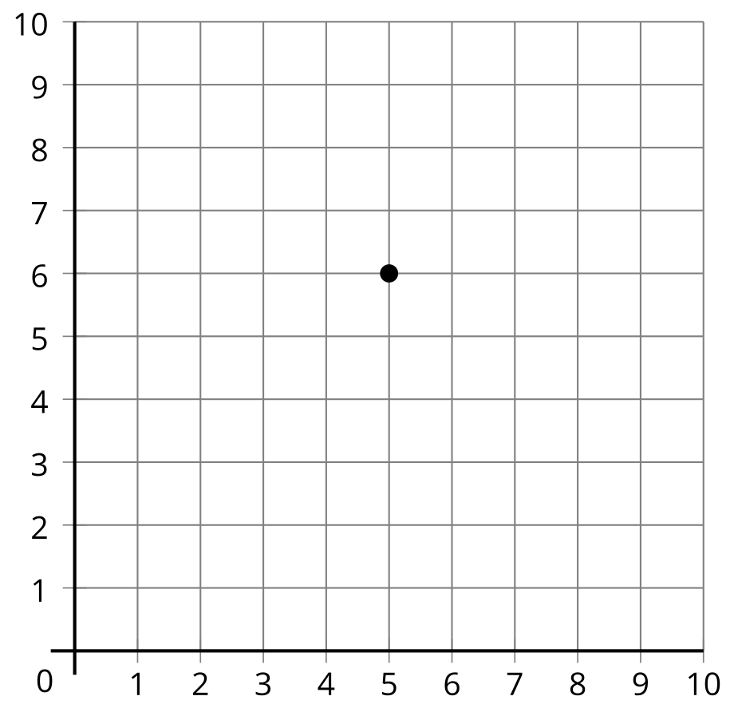

1 What’s the Point?

Student Task Statement
- Play 2 rounds of What’s the Point so each partner gets a chance to draw.
  - Sit back to back with your partner.
  - Partner A: Choose a card. Then, describe the location of the point to your partner.
  - Partner B: Draw the point on the blank coordinate grid.
  - Compare the card with your partner’s diagram.
  - Discuss: What’s the same? What’s different?
- 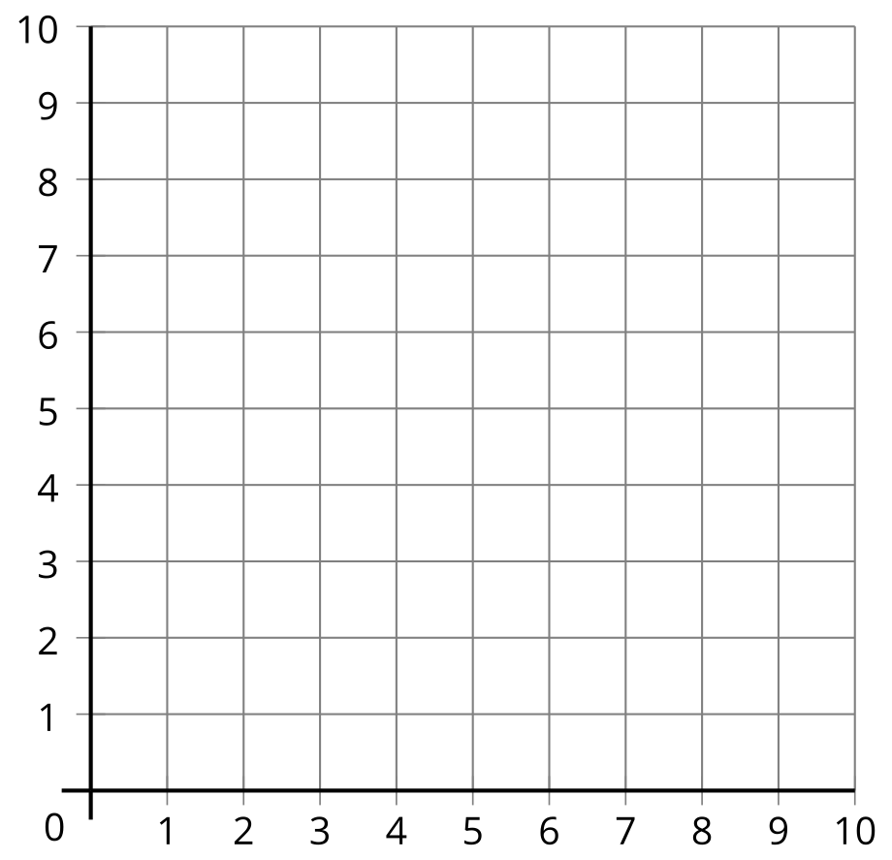
- Use words to explain the location of the point on the grid.
- 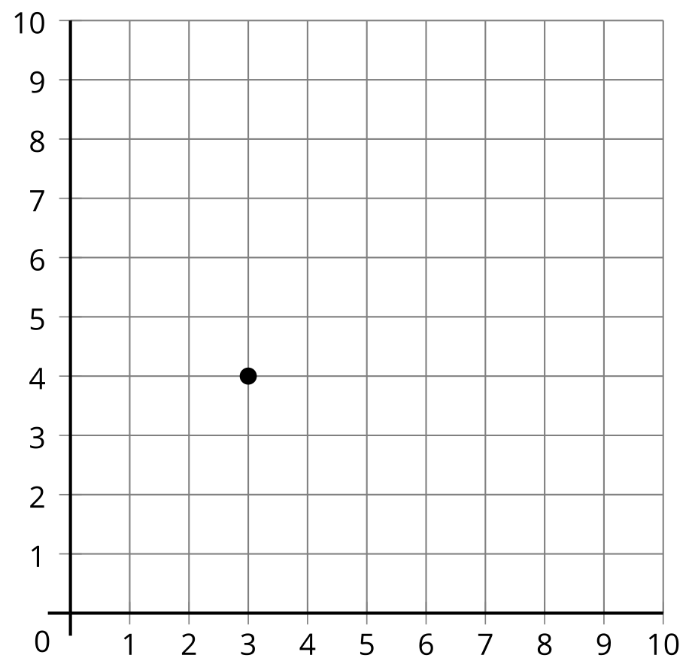

2 Plot and Label Points

Student Task Statement
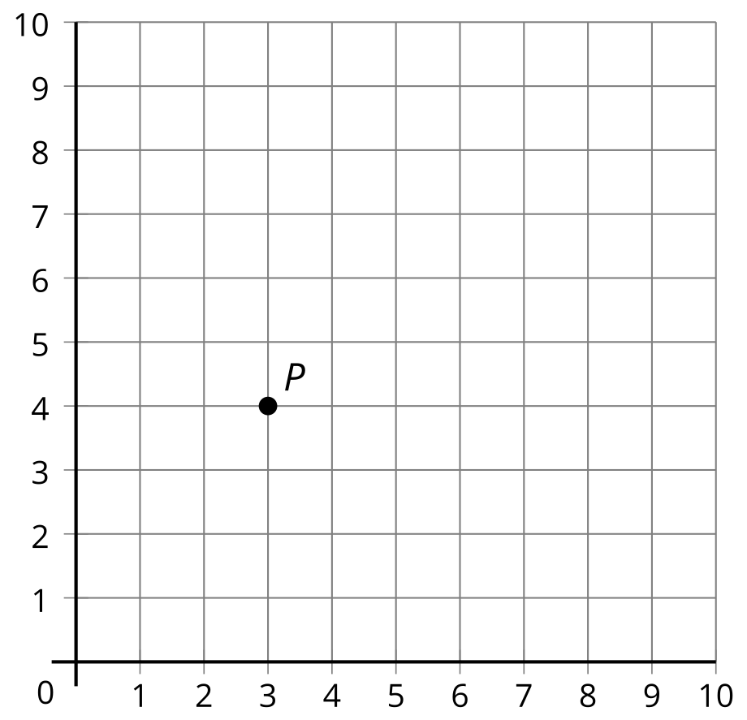
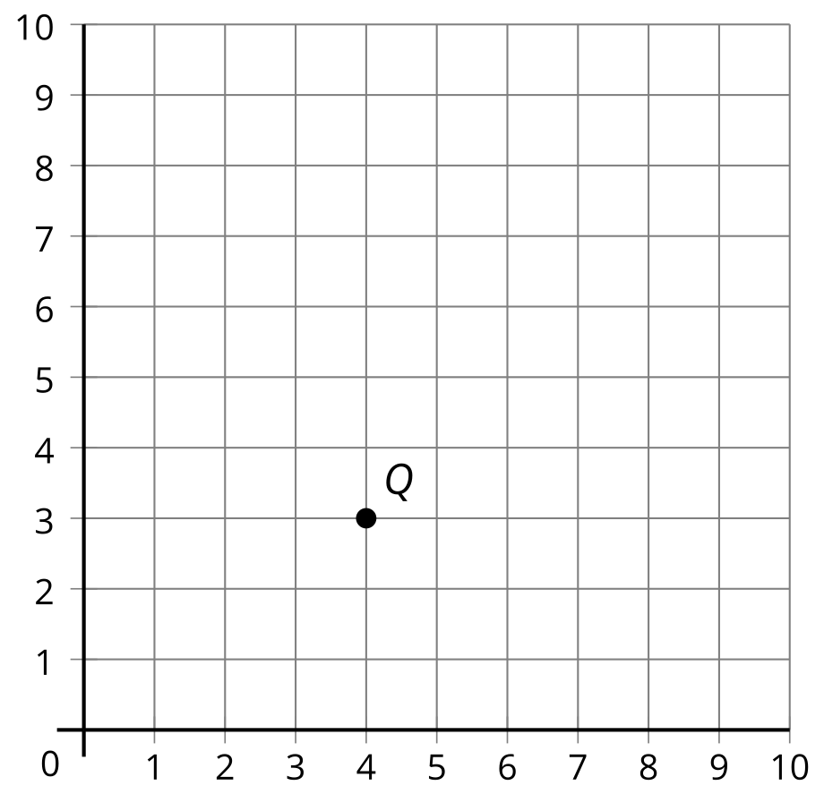
- List the coordinates for each point.
- 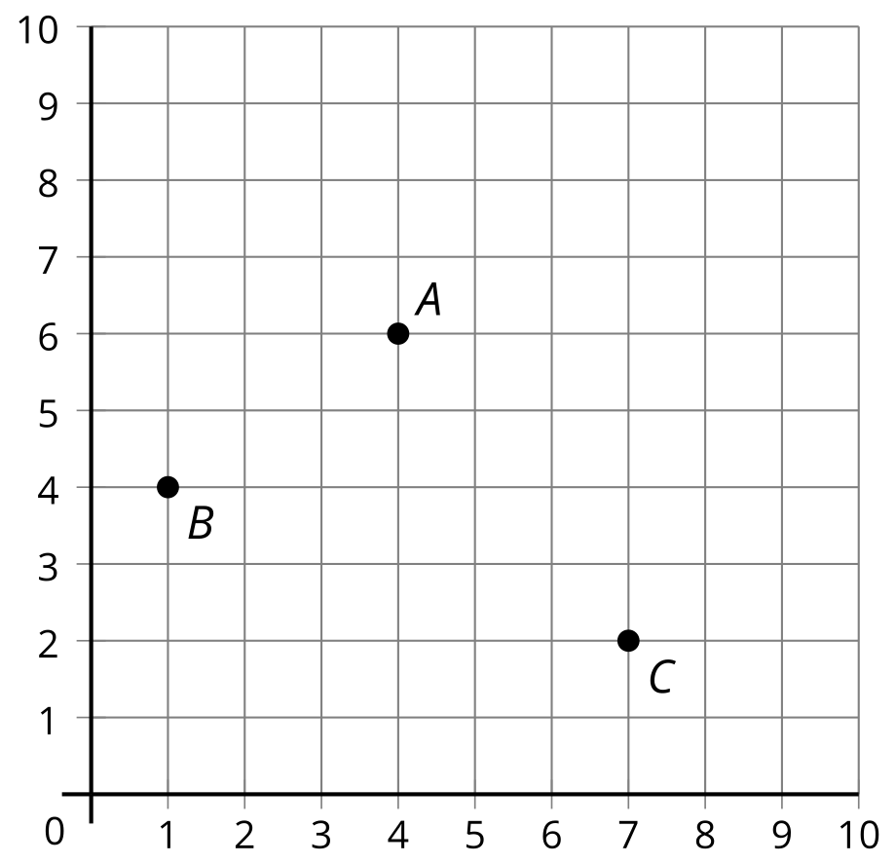
 | - coordinates
- $A$ | - ( ___ , ___)
- $B$ | - ( ___ , ___)
- $C$ | - ( ___ , ___)
- Plot points $D$, $E$, $F$ on the same grid.
 | - coordinates
- $D$ | - $\left(6,4\right)$
- $E$ | - $\left(2,5\right)$
- $F$ | - $\left(8,3\right)$
© CC BY 2021 Illustrative Mathematics®

