Lesson 9: Solve Story Problems
- Let’s look at different ways to show what happened in a story problem.

Warm-up: How Many Do You See: Finger Addition
How many fingers do you see?
How do you see them?

9.1: Markers at School
There were 4 markers at school.
Elena brought 3 more markers to school.
How many markers are at school now?

9.2: Balls at Recess
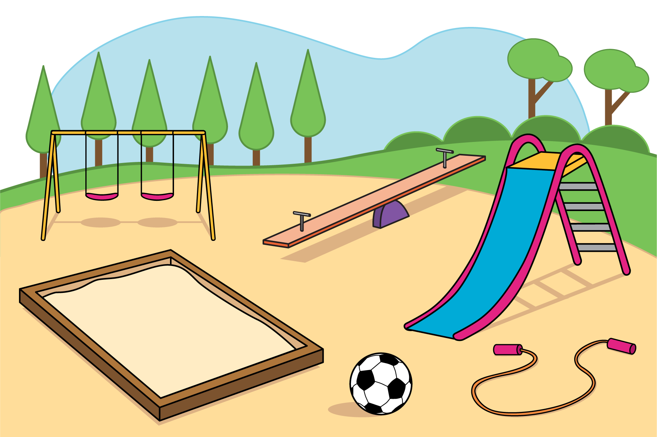
There were 5 balls on the playground.
Diego brought 5 of the balls inside.
How many balls are on the playground now?

9.3: Introduce Math Fingers, Add 2 Hands
Choose a center.
Math Fingers
Math Stories
Subtraction Towers
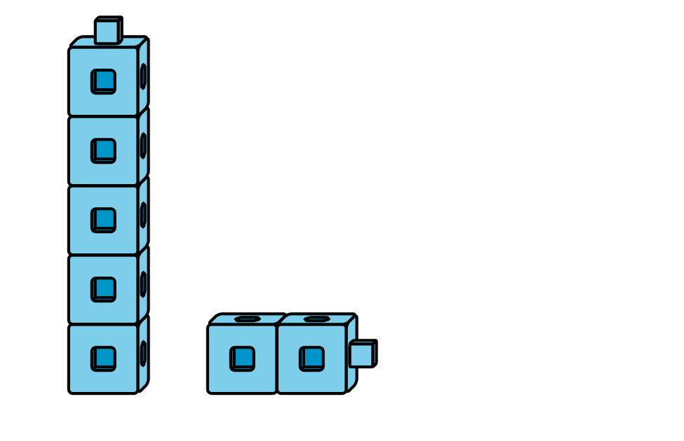
5-frames
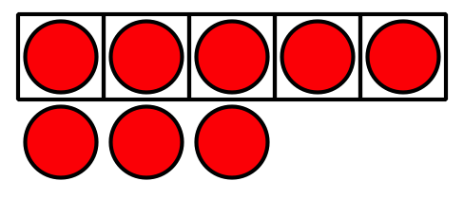
Build Shapes
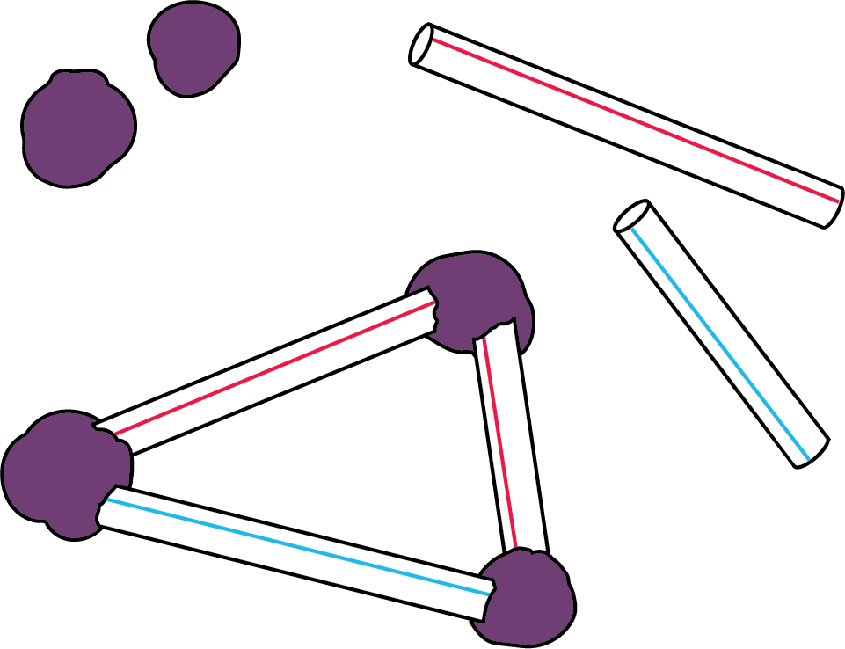
Counting Collections
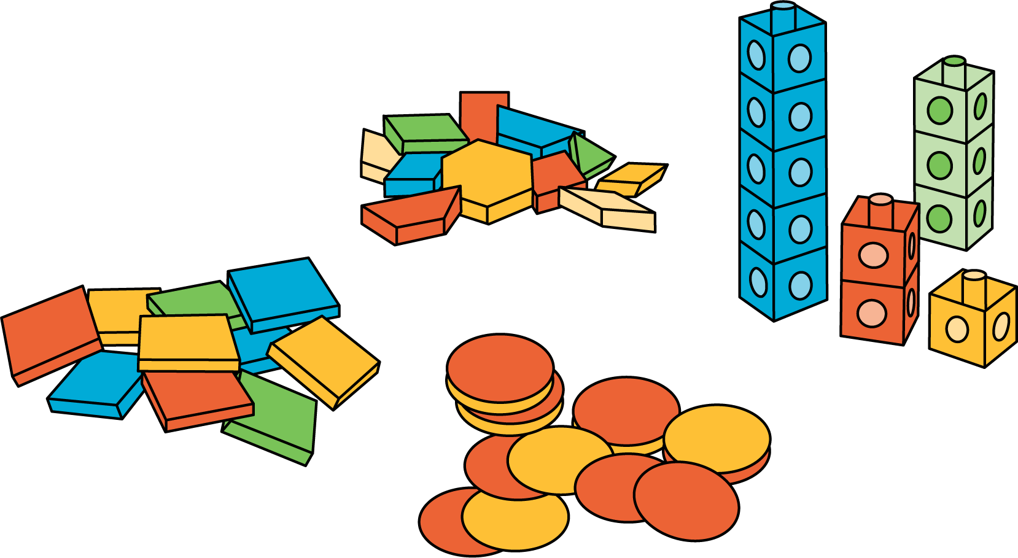
© CC BY 2021 Illustrative Mathematics®

