Unit 4 Lesson 9: Show Me Your Number

WU Which One Doesn’t Belong: Tens and Ones (Warm up)

Student Task Statement
Which one doesn’t belong?
A
B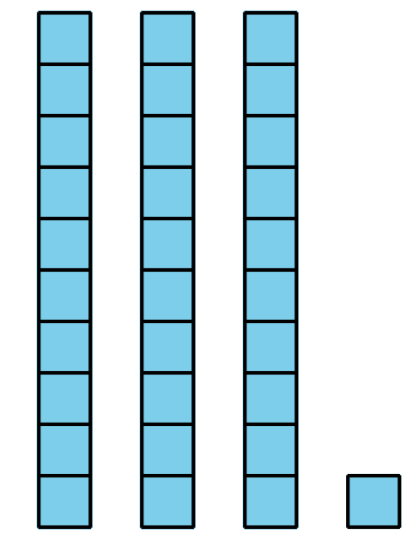
C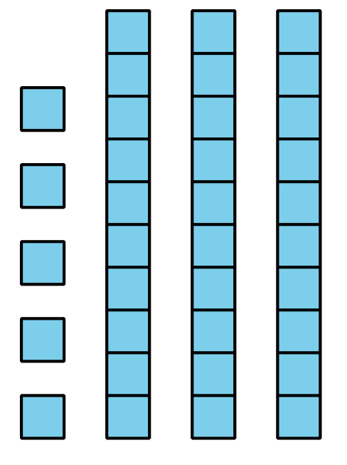
D

1 Create a Collection

Student Task Statement
Show your number in as many ways as you can.
Our number: __________

2 Show Collections In Many Ways

Student Task Statement
Show each collection in as many ways as you can.
Visit at least 4 collections.
Collection 1
Collection 2
Collection 3
Collection 4

3 Centers: Choice Time

Student Task Statement
Choose a center.
Grab and Count
Shake and Spill
Check It Off
© CC BY 2021 Illustrative Mathematics®

