Lesson 15 Practice Problems
- A random sample of 15 items were selected.
- 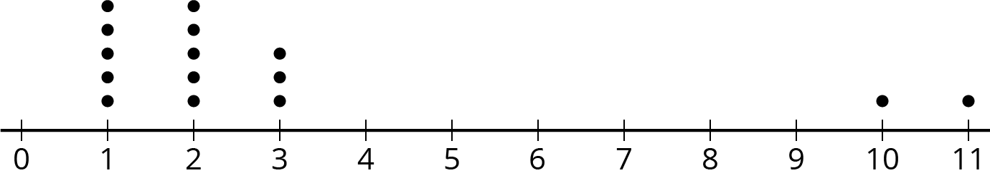
- For this data set, is the mean or median a better measure of center? Explain your reasoning.
- A video game developer wants to know how long it takes people to finish playing their new game. They surveyed a random sample of 13 players and asked how long it took them (in minutes).
- 1,235 | - 952 | - 457 | - 1,486 | - 1,759 | - 1,148 | - 548 | - 1,037
- 1,864 | - 1,245 | - 976 | - 866 | - 1,431

  - Estimate the median time it will take all players to finish this game.
  - Find the interquartile range for this sample.
- Han and Priya want to know the mean height of the 30 students in their dance class. They each select a random sample of 5 students.
  - The mean height for Han’s sample is 59 inches.
  - The mean height for Priya’s sample is 61 inches.
- Does it surprise you that the two sample means are different? Are the population means different? Explain your reasoning.
- Clare and Priya each took a random sample of 25 students at their school.
  - Clare asked each student in her sample how much time they spend doing homework each night. The sample mean was 1.2 hours and the MAD was 0.6 hours.
  - Priya asked each student in her sample how much time they spend watching TV each night. The sample mean was 2 hours and the MAD was 1.3 hours.
  - At their school, do you think there is more variability in how much time students spend doing homework or watching TV? Explain your reasoning.
  - Clare estimates the students at her school spend an average of 1.2 hours each night doing homework. Priya estimates the students at her school spend an average of 2 hours each night watching TV. Which of these two estimates is likely to be closer to the actual mean value for all the students at their school? Explain your reasoning.
© CC BY Open Up Resources. Adaptations CC BY IM.

