Unit 8 Lesson 8 Cumulative Practice Problems
- The histogram summarizes the data on the body lengths of 143 wild bears. Describe the distribution of body lengths. Be sure to comment on shape, center, and spread.
- 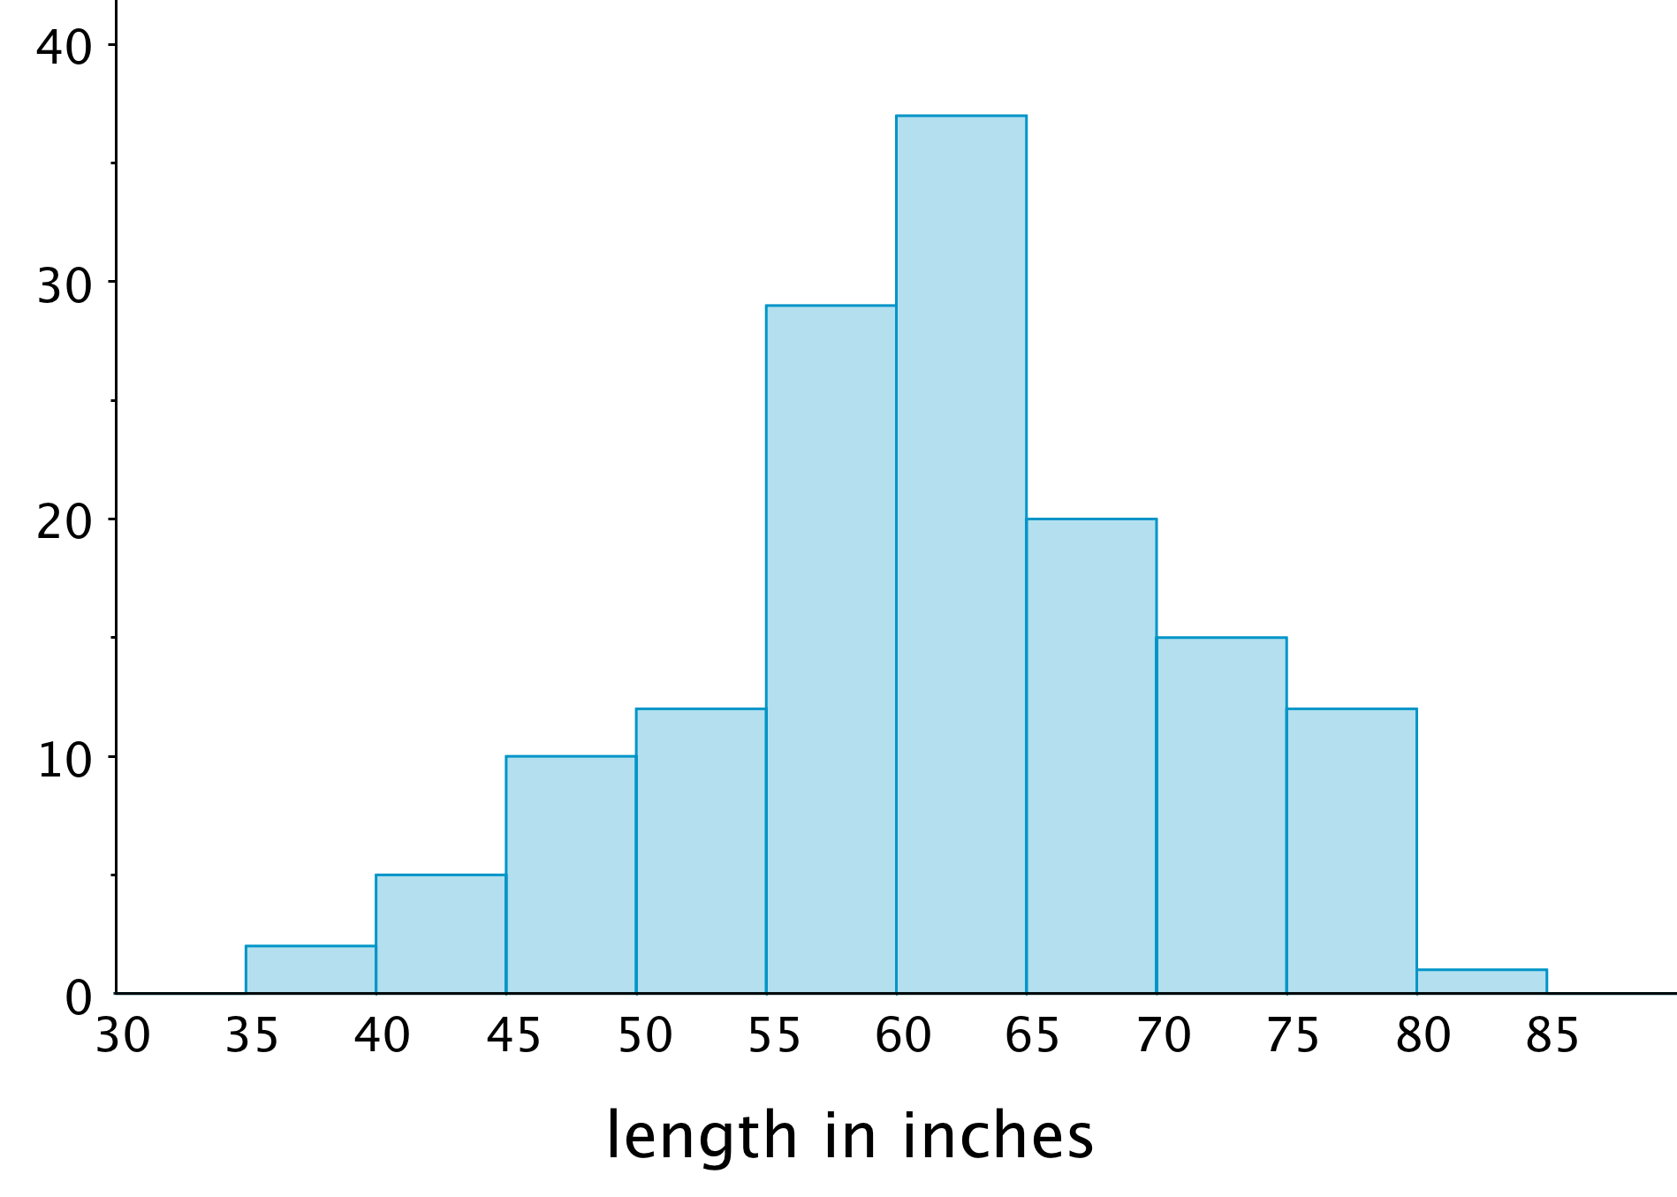
- Which data set is more likely to produce a histogram with a symmetric distribution? Explain your reasoning.
  - Data on the number of seconds on a track of music in a pop album.
  - Data on the number of seconds spent talking on the phone yesterday by everyone in the school.
- Evaluate the expression $4x^{3}$ for each value of $x$.
  - 1
  - 2
  - $\frac{1}{2}$
- (From Unit 6, Lesson 15.)
- Decide if each data set might produce one or more gaps when represented by a histogram. For each data set that you think might produce gaps, briefly describe or give an example of how the values in the data set might do so.
  - The ages of students in a sixth-grade class.
  - The ages of people in an elementary school.
  - The ages of people eating in a family restaurant.
  - The ages of people who watch football.
  - The ages of runners in a marathon.
- Jada drank 12 ounces of water from her bottle. This is 60% of the water the bottle holds.
  - Write an equation to represent this situation. Explain the meaning of any variables you use.
  - How much water does the bottle hold?
- (From Unit 6, Lesson 7.)
© CC BY Open Up Resources. Adaptations CC BY IM.

