Lesson 11 Practice Problems
- Jada measured the height of a plant in a science experiment and finds that, to the nearest $\frac{1}{4}$ of an inch, it is $4\frac{3}{4}$ inches.
  - What is the largest the actual height of the plant could be?
  - What is the smallest the actual height of the plant could be?
  - How large could the percent error in Jada’s measurement be?
- The reading on a car’s speedometer has 1.6% maximum error. The speed limit on a road is 65 miles per hour.
  - The speedometer reads 64 miles per hour. Is it possible that the car is going over the speed limit?
  - The speedometer reads 66 miles per hour. Is the car definitely going over the speed limit?
- Water is running into a bathtub at a constant rate. After 2 minutes, the tub is filled with 2.5 gallons of water. Write two equations for this proportional relationship. Use $w$ for the amount of water (gallons) and $t$ for time (minutes). In each case, what does the constant of proportionality tell you about the situation?
- (From Unit 5, Lesson 2.)
- Noah picked 3 kg of cherries. Jada picked half as many cherries as Noah. How many total kg of cherries did Jada and Noah pick?
  - $3+0.5$
  - $3−0.5$
  - $\left(1+0.5\right)⋅3$
  - $1+0.5⋅3$
- (From Unit 6, Lesson 2.)
- Here is a shape with some measurements in cm.
- 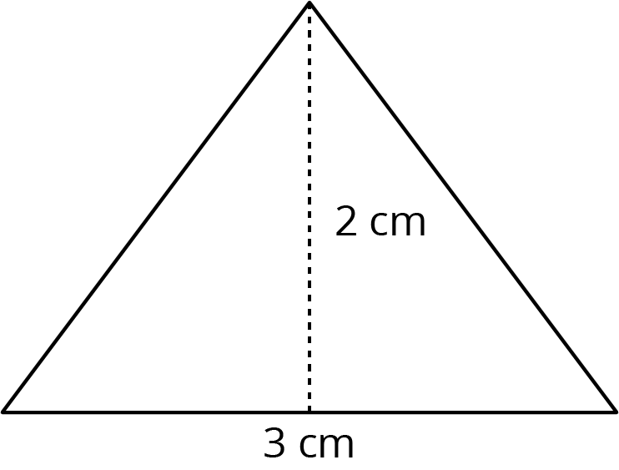
  - Complete the table showing the area of different scaled copies of the triangle.
- scale factor | - area (cm²)
  - 1
  - 2
  - 5
  - $s$
  - Is the relationship between the scale factor and the area of the scaled copy proportional?
- (From Unit 5, Lesson 15.)
© CC BY Open Up Resources. Adaptations CC BY IM.

