Unit 7 Lesson 13: Using Radians

1 What Fraction? (Warm up)

Student Task Statement
A circle with radius 24 inches has a sector with central angle $\frac{π}{3}$ radians.
- What fraction of the whole circle is represented by this sector?
- Find the area of the sector.

2 A Sector Area Shortcut

Student Task Statement
Lin and Elena are trying to find the area of the shaded sector in the image. Lin says, “We’ve found sector areas when the central angle is given in degrees, but here it’s in radians. Should I start by finding the area of the full circle?”
Elena says, “I saw someone using the formula $\frac{1}{2}r^{2}θ$ where $θ$ is the measure of the angle in radians, and $r$ is the radius. But I don’t know where that came from.”
- Compare and contrast finding sector areas for central angles measured in degrees and those measured in radians.
- Explain why the formula that Elena saw works.
- Find the area of the sector.

3 An Arc Length Shortcut

Student Task Statement
The city of Riverside has 2 straight highways extending out from its town hall (located at $T$ in the image). Several roads shaped like circular arcs connect the two highways. Exits from 1 of the highways are shown at points $A,B,C,$ and $D$.
- Create a table that shows the arc length, $ℓ$, of the connector roads as a function of the radius, $r$, of the highway.
- Plot the points from your table on the coordinate grid and connect them.
- 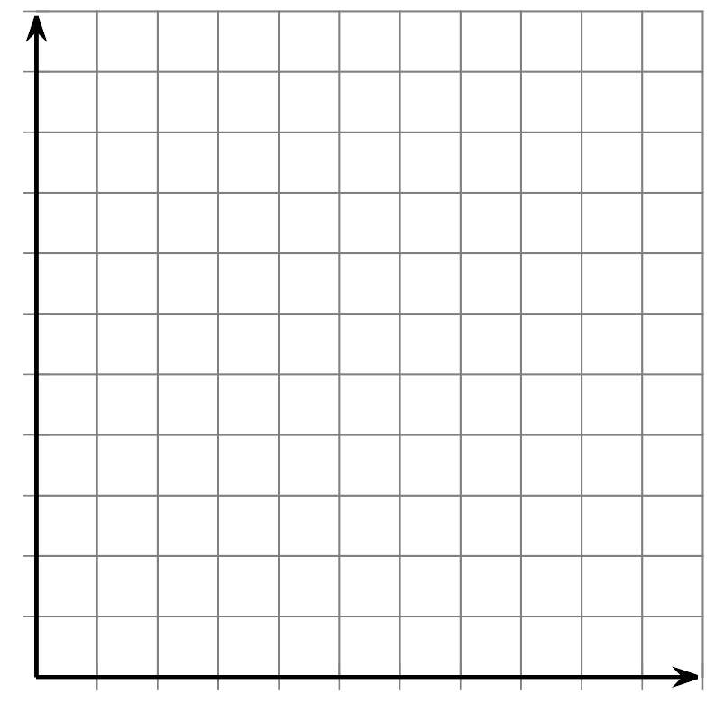
- The points should form a line. Write an equation for this line, using the variables $ℓ$ and $r$.
- What does the slope of the line mean in context of the highways and connector roads?
- The city wants to build a new arc-shaped connector road starting at point $E$ which will be an additional 6 miles past exit $D$. How long will this road be?
© CC BY 2019 by Illustrative Mathematics®

