Unit 3 Lesson 10: Putting It All Together

1 Which One Doesn’t Belong: Data Correlations (Warm up)

Student Task Statement
Which one doesn’t belong?

A
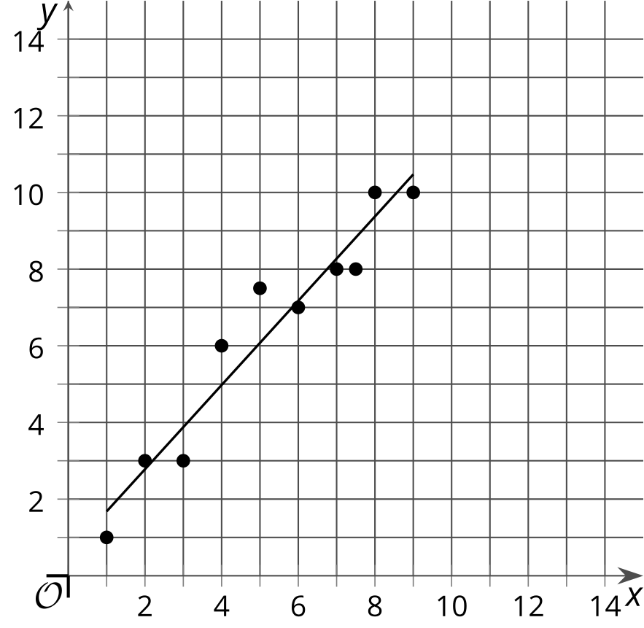

B
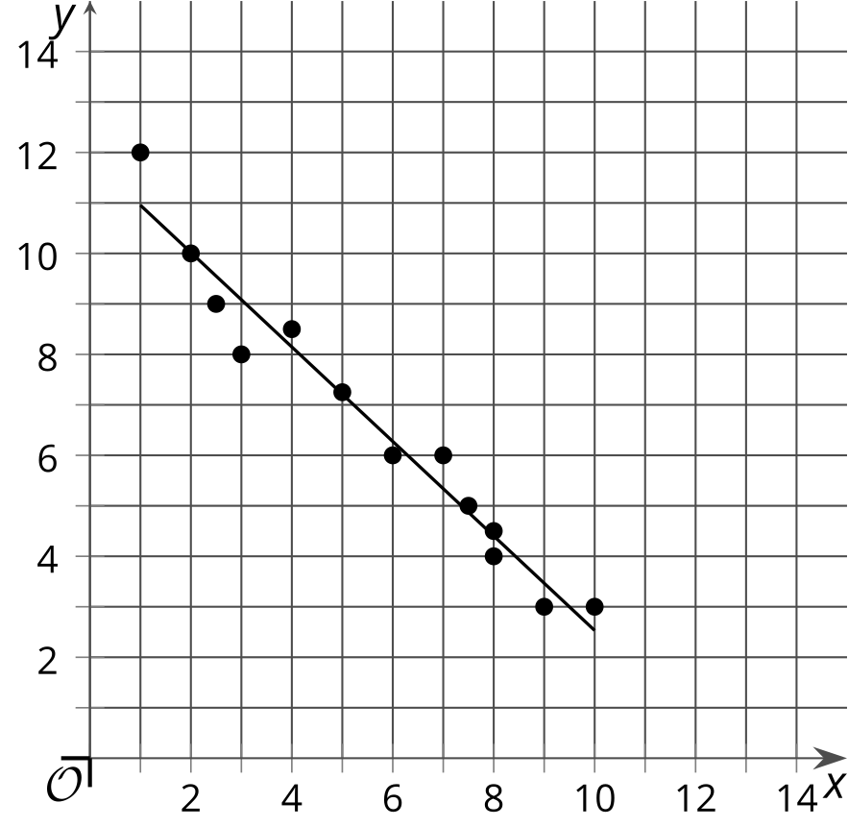

C
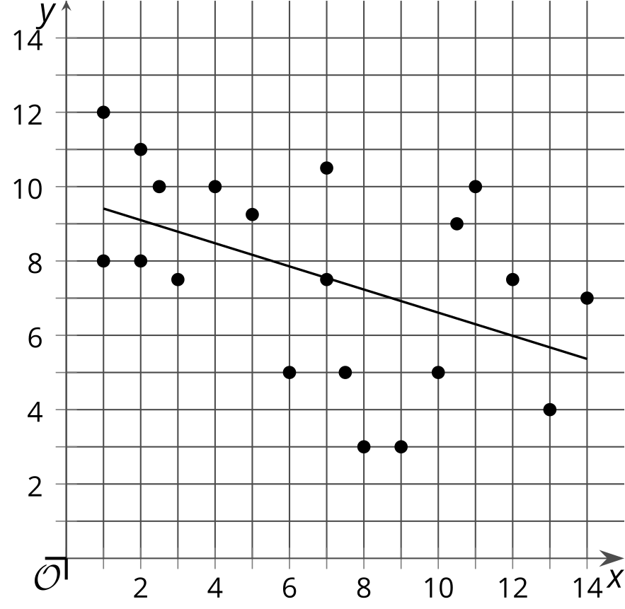

D
$x$ | $y$
3 | 6
3.75 | 8.50
7.25 | 7.50
5.50 | 11
6 | 9
8 | 10.25

2 Electric Power (Optional)

Student Task Statement
Here are Elena’s representations of the data set.
energy (kWh) | electric bill price (dollars)
500 | 50
560 | 57.60
610 | 65.10
675 | 70.25
700 | 74.80
755 | 90.66
790 | 92.34
836 | 105
892 | 150
940 | 173
932 | 182

energy (kWh) | electric bill price (dollars)
967 | 170
999 | 198
1,005 | 201.22
1,039 | 215.35
1,057 | 217
1,100 | 233
1,191 | 284.62
1,150 | 256.98
1,200 | 289.60
1,270 | 292
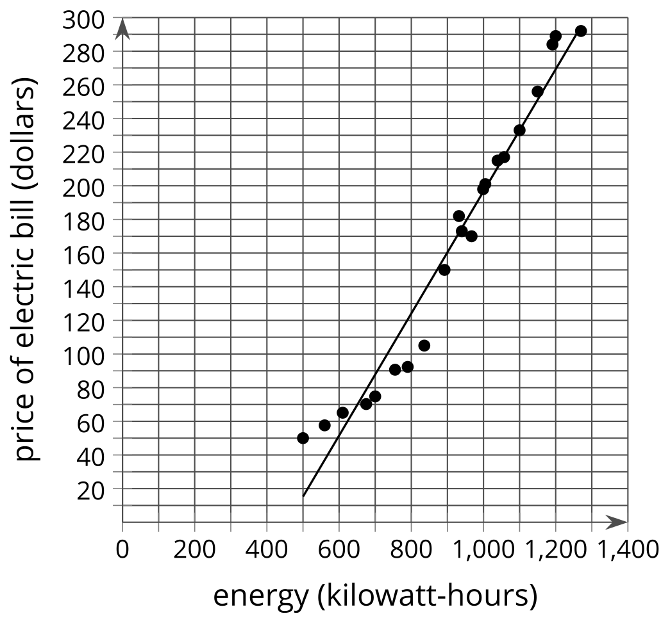
After analyzing the data, Elena concludes:
- An estimate for the correlation coefficient for the line of best fit is $r=\text{-}0.98$.
- Energy consumption and the price of electric bills have a positive relationship.
- Energy consumption and the price of electric bills have a weak relationship.
- Using the linear model, the electric bill is $260 when 1,200 kWh are consumed.
What parts of Elena’s interpretation of the data do you agree with and what parts do you disagree with? Explain your reasoning.

3 Confident Players (Optional)

Student Task Statement
Before Diego’s game, his coach asked each of his players, “On a scale of 1–10, how confident are you in the team winning the game?” Here is the data he collected from the team.
players | confidence in winning (1–10) | number of points scored in a game
Player A | 3 | 2
Diego | 6 | 10
Player B | 10 | 2
Player C | 4 | 10
Player D | 7 | 13
Player E | 5 | 6
Player F | 8 | 15
Player G | 4 | 3
Player H | 9 | 15
Player I | 7 | 12
Player J | 1 | 0
Player K | 9 | 14
Player L | 8 | 13
Player M | 5 | 8
- Use technology to create a scatter plot, a line of best fit, and the correlation coefficient.
- Is there a relationship between players’ level of confidence in winning and the amount of points they score in a game? Explain your reasoning.
- How many points does the linear model predict a player will score when his or her confidence is at a 4?
- Which players performed worse than the model predicted?
- Did Diego score better or worse than the linear model predicts?
© CC BY 2019 by Illustrative Mathematics®

