Lesson 1: Matching up to Data
- Let’s describe how to transform graphs.

1.1: Notice and Wonder: Cooling Down
What do you notice? What do you wonder?
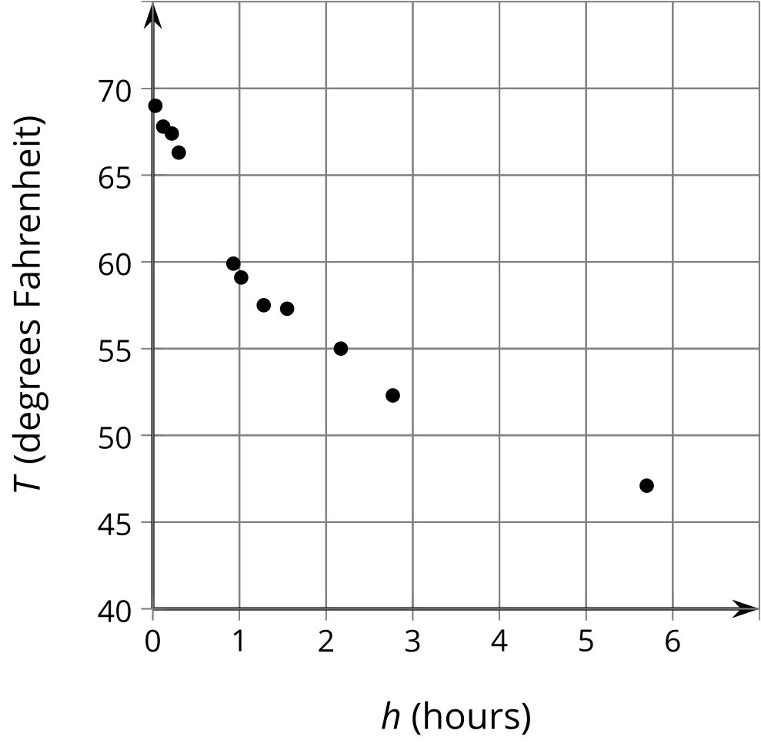

1.2: Which Function?
A bottle of soda water is left outside on a cold day. The scatter plot shows the temperature $T$, in degrees Fahrenheit, of the bottle $h$ hours after it was left outside. Here are 2 functions you can use to model the temperature as a function of time:
$f\left(h\right)=45+\frac{20}{h+0.5}$
$g\left(h\right)=45+33{\left(0.5\right)}^{h+0.5}$
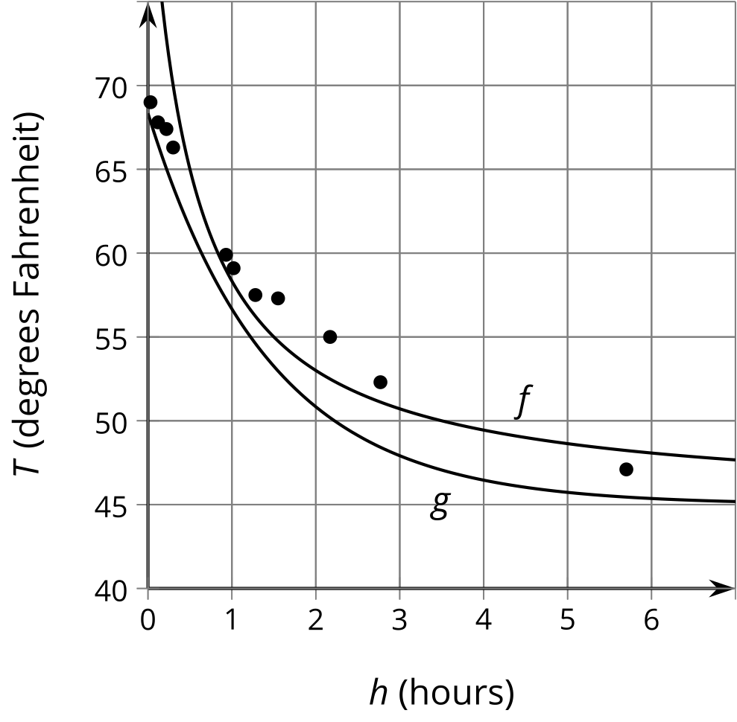
- Which function better fits the shape of the data? Explain your reasoning.
- Where do you see the 45 in the expression for each function on the graph?
- For the function you thought didn’t fit the shape of the data as well, how would you change it to fit better?

Are you ready for more?
Consider the function $a$ given by $a\left(h\right)=\frac{2}{3}{\left(h−6\right)}^{2}+46$.
- Explain how the equation defining $a$ is related to the temperature data.
- How well does $a$ model the data compared to $f$ or $g$? Explain your reasoning.

1.3: What Happened to the Graph?
Your teacher will give you a card. Take turns describing the transformation of the graph on your card for your partner to draw and drawing the transformed graph from your partner's description.

1. a.
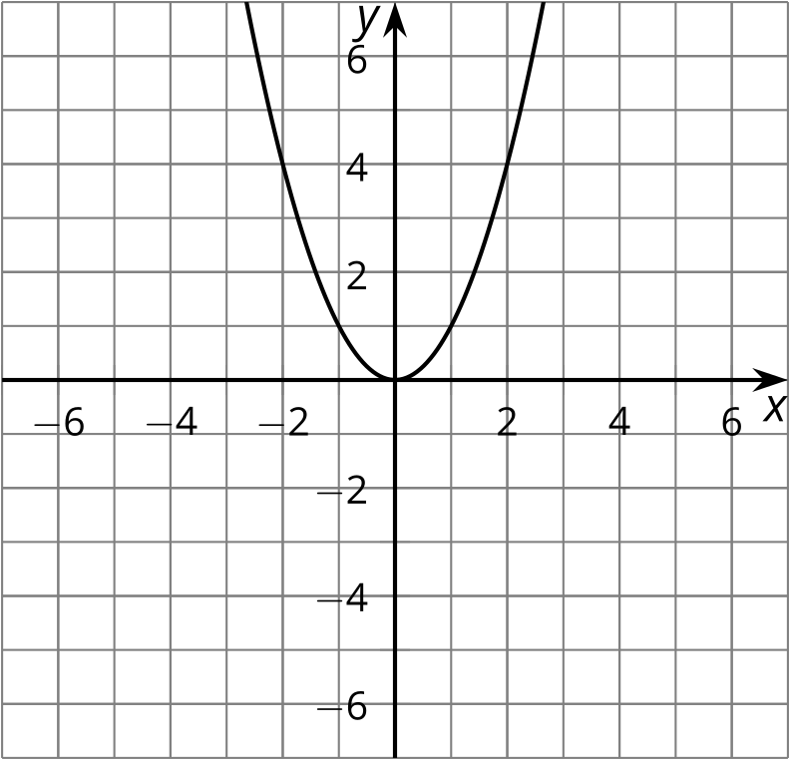

1. b.
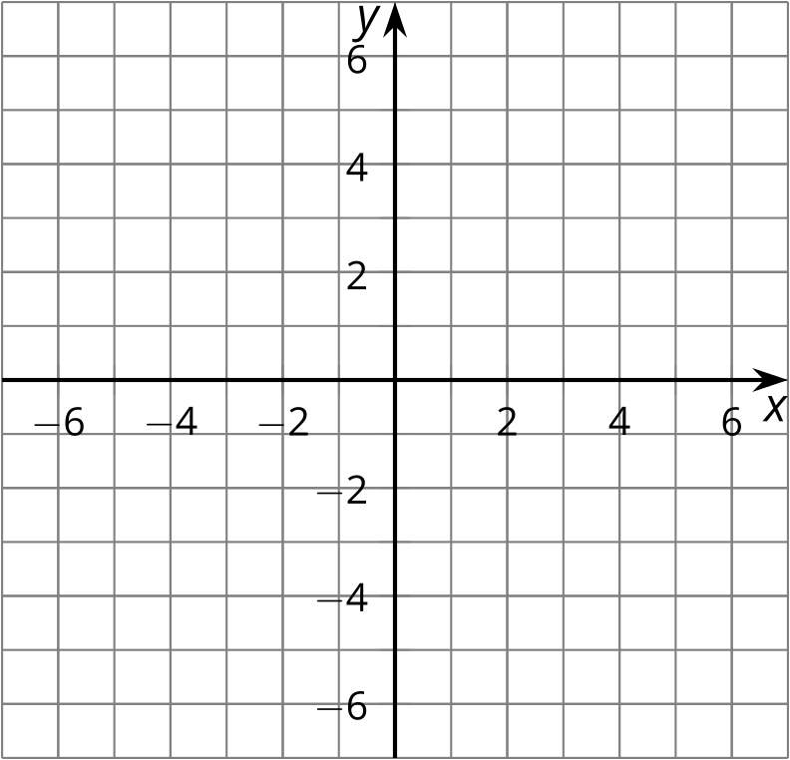

2. a.
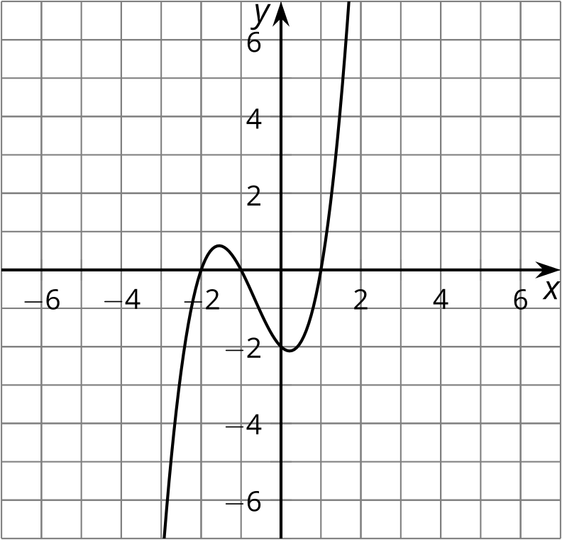

2. b.

3. a.
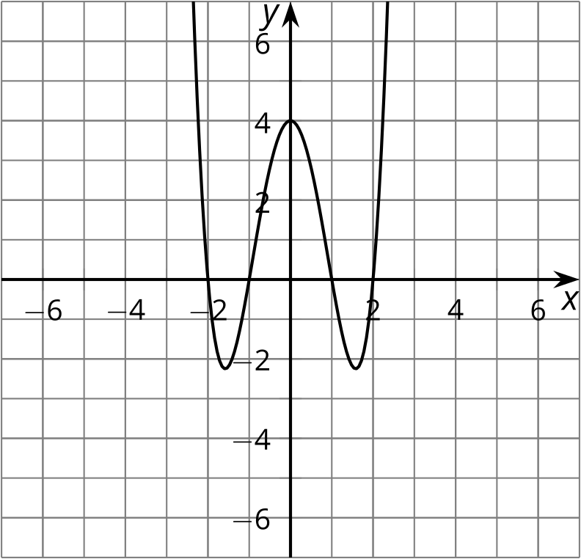

3. b.

4. a.
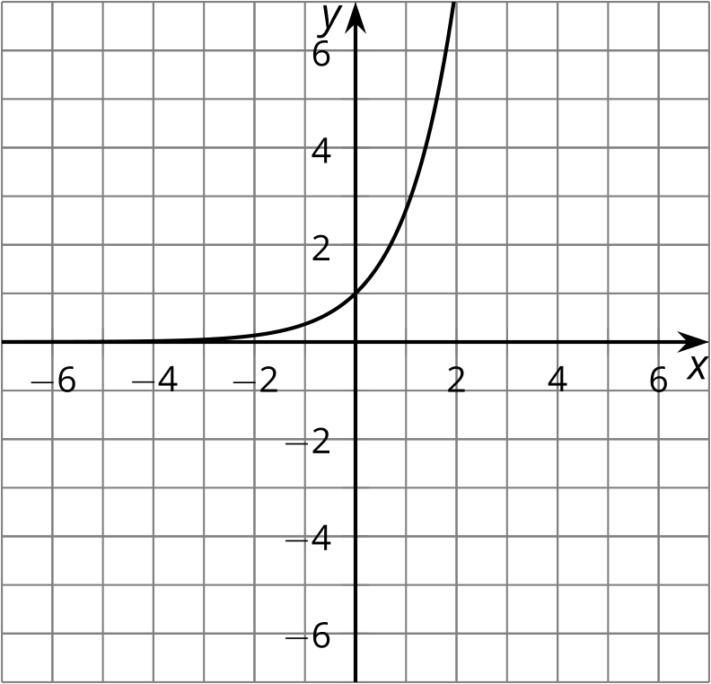

4. b.

5. a.
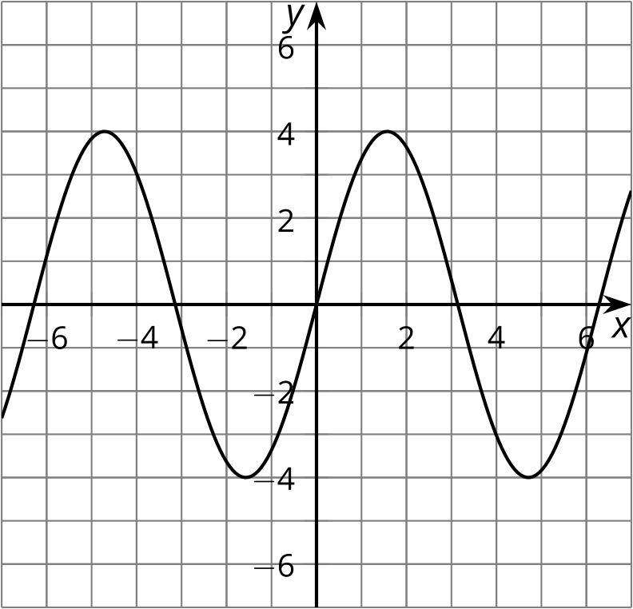

5. b.

6. a.

6. b.

Lesson 1 Summary
The data in the graph show the temperature $T$, in degrees Fahrenheit, of a can of soda $h$ hours after it was put into the refrigerator.
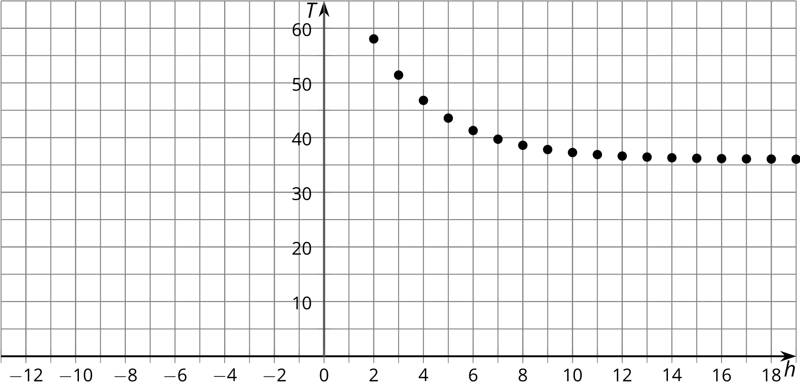
What if we want to build a function that fits this data set? One way to find a function that fits the data well is to start with a simpler function that has the same general shape as the data when graphed and transform it. What shape does this data form?
Let’s try an exponential decay function. We can get the right shape using a simpler equation like $T={\left(0.7\right)}^{h}$, but the graph doesn't fit where the data is. The graph of the function given by $T=36+45{\left(0.7\right)}^{h}$ isn't represented by a simple equation, but it does fit the data. (What did multiplying by 45 and adding 36 do to the graph?) In this unit we will learn how to translate, reflect, and stretch graphs to fit data.
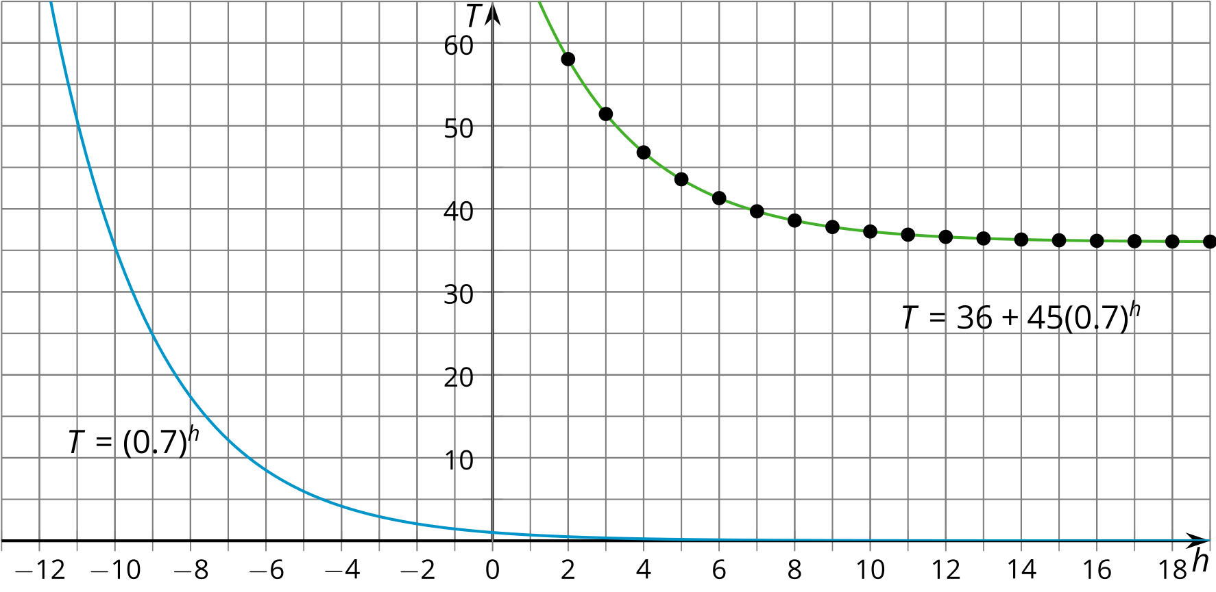
© CC BY 2019 by Illustrative Mathematics®

