Unit 6 Lesson 1: Moving in Circles

1 Which One Doesn't Belong: Reading Clocks (Warm up)

Student Task Statement
Which one doesn’t belong?

A
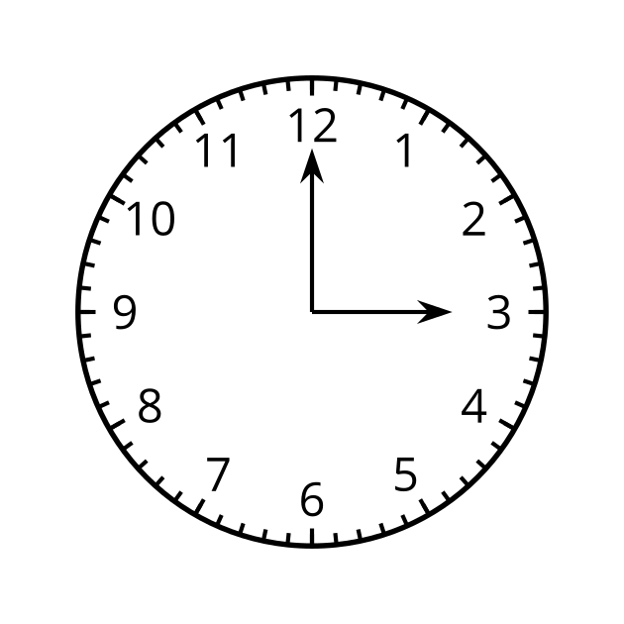

B
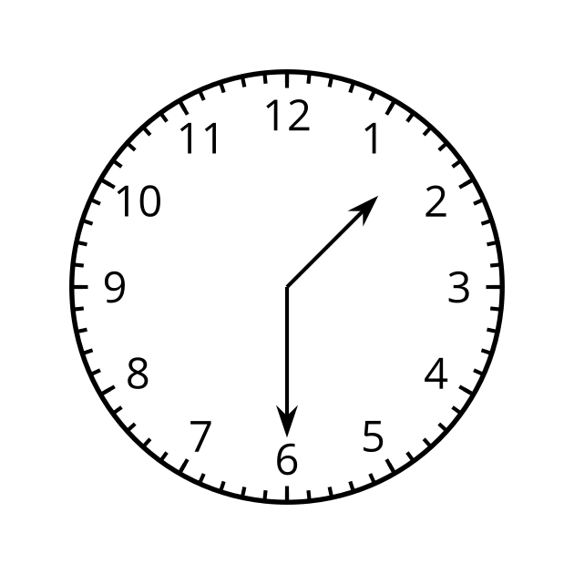

C
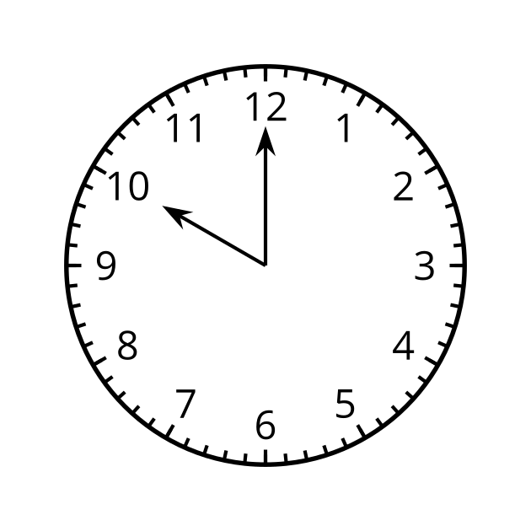

D
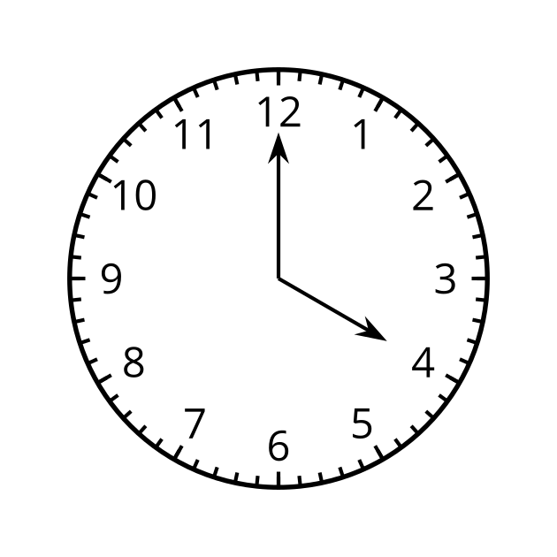

2 Around and Around

Images for Launch
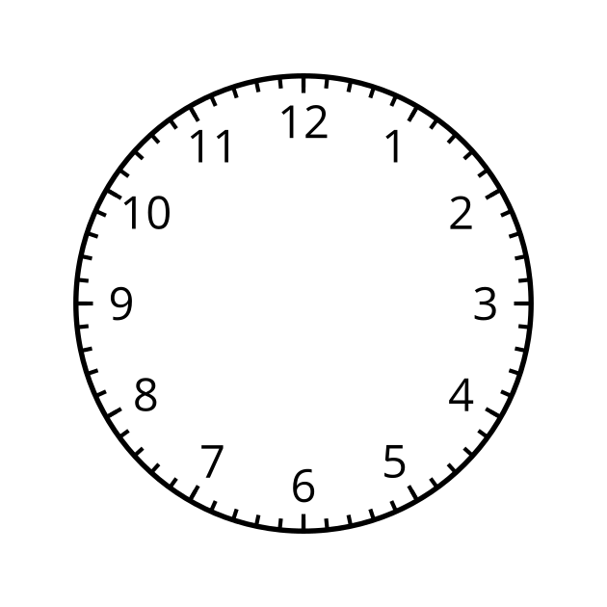

Student Task Statement
A ladybug lands on the end of a clock’s second hand when the hand is pointing straight up. The second hand is 1 foot long and when it rotates and points directly to the right, the ladybug is 10 feet above the ground.
- How far above the ground is the ladybug after 0, 30, 45, and 60 seconds have passed?
Pause here for a class discussion.
- Estimate how far above the ground the ladybug is after 10, 20, and 40 seconds. Be prepared to explain your reasoning.
- If the ladybug stays on the second hand, describe how its distance from the ground will change over the next minute. What about the minute after that?
- At exactly 3:15, the ladybug flies from the second hand to the minute hand, which is 9 inches long.
  - How far off the ground is the ladybug now?
  - At what time will the ladybug be at that height again if it stays on the minute hand? Be prepared to explain your reasoning.

3 Where is the Point?

Images for Launch
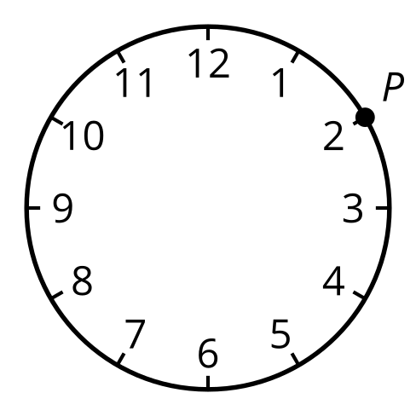
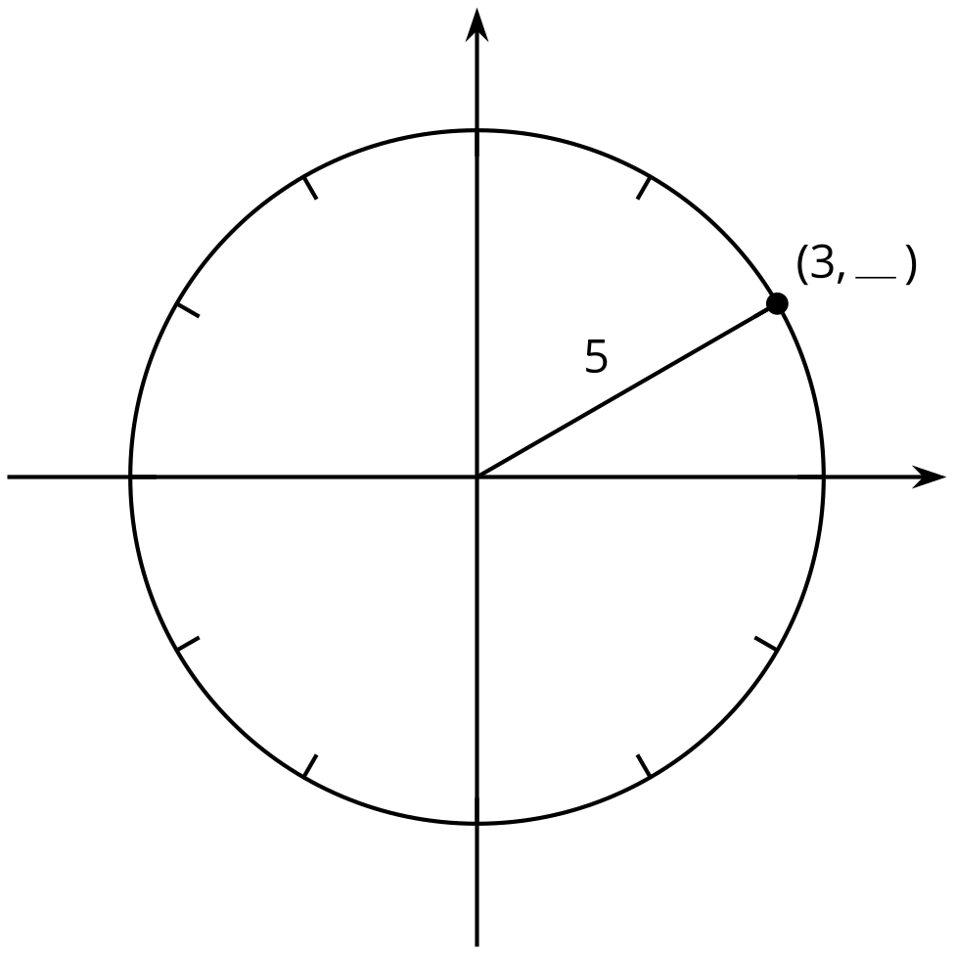

Student Task Statement
- What is the radius of the circle?
- 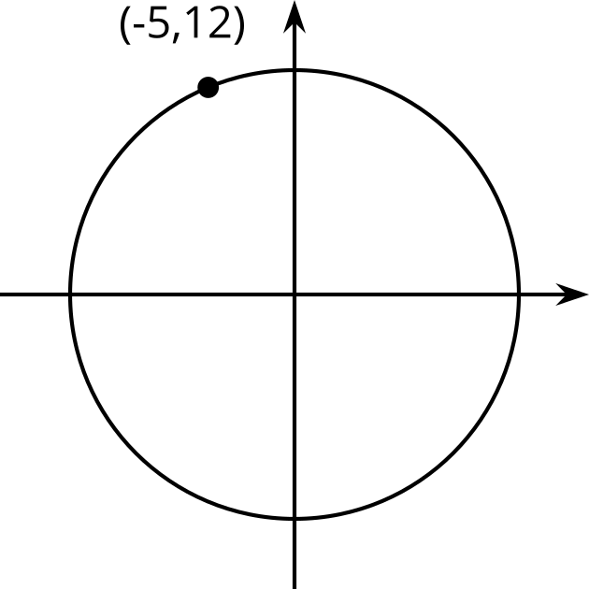
- If $Q$ has a $y$-coordinate of -4, what is the $x$-coordinate?
- 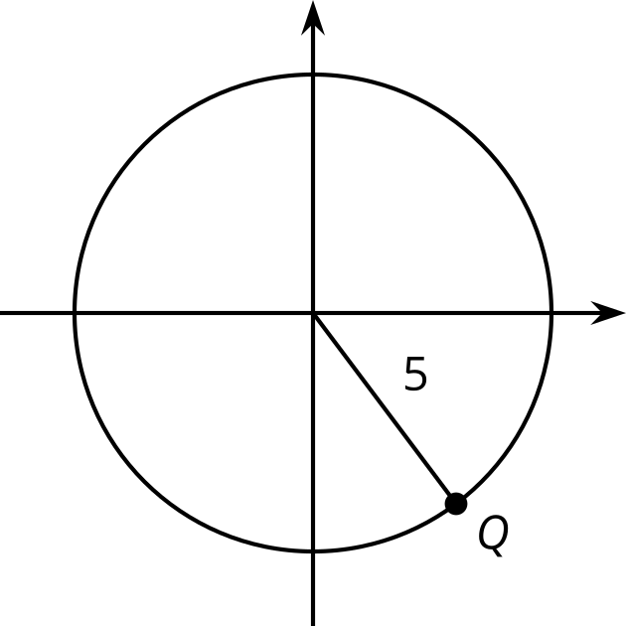
- If $B$ has a $y$-coordinate of 4, what is the $x$-coordinate?
- 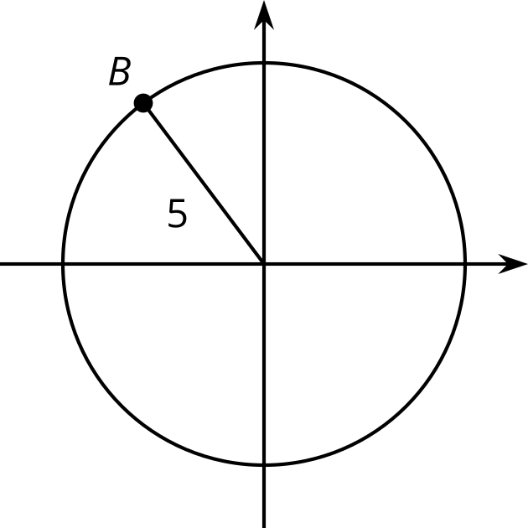
- A circle centered at $\left(0,0\right)$ has a radius of 10. Point $S$ on the circle has an $x$-coordinate of 6. What is the $y$-coordinate of point $S$? Explain or show your reasoning.
© CC BY 2019 by Illustrative Mathematics®

