Lesson 10: Practicing Proofs
- Let’s practice what we’ve learned about proofs and congruence.

10.1: Brace Yourself!
What can you do with the braces and fasteners your teacher will give you?
What different ways can you arrange them?
What different quadrilaterals can you make by changing the braces?
Keep track of your findings.

10.2: Card Sort: More Practice Seeing Shortcuts
- Your teacher will give you a set of cards that show different structures. Sort the cards into 2 categories of your choosing. Be prepared to explain the meaning of your categories. Then, sort the cards into 2 categories in a different way. Be prepared to explain the meaning of your new categories.
- Sort the cards by rigid vs. flexible structures.
- State at least one set of triangles that can be proved congruent using:
  - Side-Angle-Side Triangle Congruence Theorem
  - Angle-Side-Angle Triangle Congruence Theorem
  - Side-Side-Side Triangle Congruence Theorem

Are you ready for more?
This is the John Hancock Building. What shape do you think surrounds the diagonal braces? List several ways to test your conjecture.
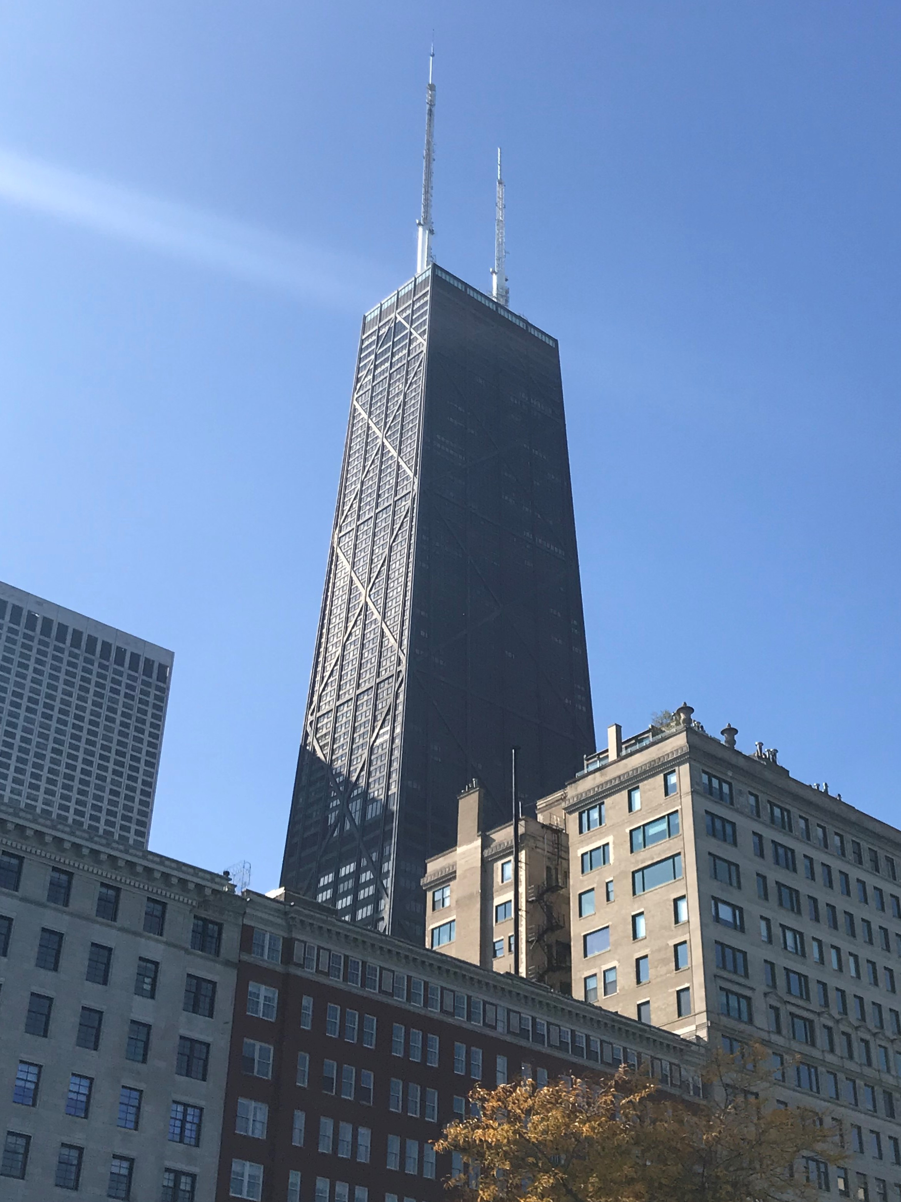

10.3: Matching Pictures to Proofs
Take turns with your partner to match a statement with a diagram that could go with that proof. For each match you find, explain to your partner how you know it’s a match. For each match your partner finds, listen carefully to their explanation. If you disagree, discuss your thinking and work to reach an agreement.
- A quadrilateral with perpendicular diagonals that bisect each other is equilateral.
- If one diagonal of a quadrilateral is the perpendicular bisector of the other, then 2 pairs of adjacent sides are congruent.
- Opposite angles in an equilateral quadrilateral are congruent.
- In a parallelogram, opposite sides are congruent.

Lesson 10 Summary
To prove that segments or angles are congruent, we can look for triangles that those segments or angles are part of. Can the triangles be proven congruent? Are the segments or angles corresponding parts of congruent triangles? Does that help prove the conjecture?
To prove that the triangles are congruent, we can look at the diagram and given information. Think about whether it will be easier to find pairs of corresponding angles that are congruent or pairs of corresponding sides that are congruent. Then check if there’s enough information to use the Side-Side-Side, Angle-Side-Angle, or Side-Angle-Side Triangle Congruence Theorems.
Here is an example: Prove that in a quadrilateral with 4 congruent sides, the opposite sides are parallel.
First, sketch a diagram to see what is given and look for congruent triangles. Since this is about a quadrilateral, adding a diagonal to make triangles will be helpful.
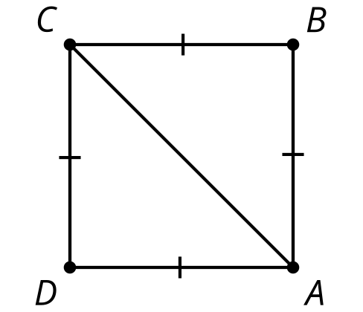
Because all the sides of the quadrilateral are congruent, and the triangles formed by the diagonals share a third side, we can use the Side-Side-Side Triangle Congruence Theorem to prove that triangles $ABC$ and $CDA$ are congruent.
© CC BY 2019 by Illustrative Mathematics®

