Lesson 15: Estimate and Subtract
- Let’s use place value to subtract decimals.

Warm-up: Number Talk: One and Five Tenths
Find the value of each expression mentally.
- $1.50−0.51$
- $1.50−0.52$
- $1.50−0.60$
- $1.50−0.62$

15.1: Revisit the Algorithm
- Find the value of $8.53−2.7$. Show your reasoning.
- Han used the standard algorithm to subtract decimals. This is Han’s work. Describe what Han did in each step.
- 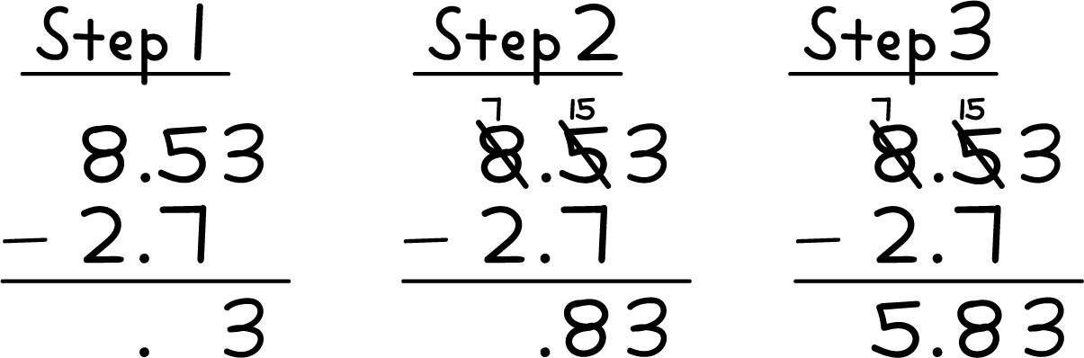
- Use the standard algorithm to find the value of $6.62−3.71$.

15.2: Estimate and Subtract
- Which whole number is the difference $15.27−4.3$ closest to? Explain or show your reasoning.
- What is the value of $15.27−4.3$? Explain or show your reasoning.
- Which whole number is the difference $16.14−9.8$ closest to? Explain or show your reasoning.
- What is the value of $16.14−9.8$? Explain or show your reasoning.

15.3: Compare Calculations to Evaluate a Difference
- Find the value of $622.35−71.4$. Explain or show your reasoning.
- Elena and Andre found the value of $622.35−71.4$. Who do you agree with? Explain or show your reasoning.
- 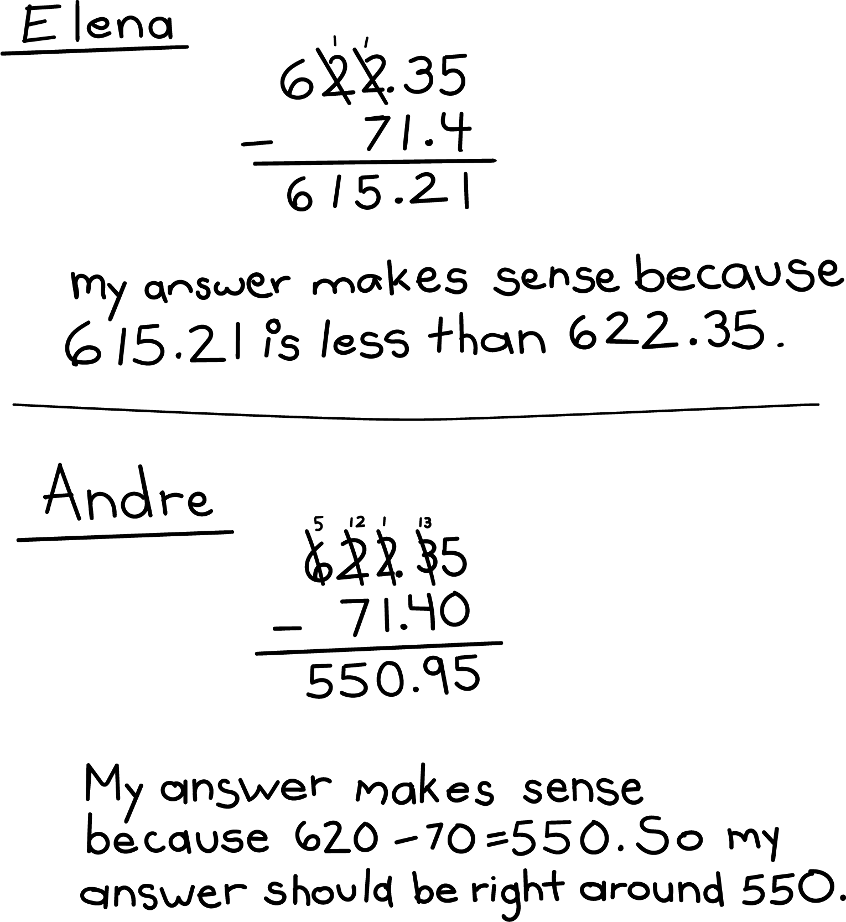
© CC BY 2021 Illustrative Mathematics®

