Unit 7 Lesson 3: Plot More Points

WU Notice and Wonder: Points with Zero (Warm up)

Student Task Statement
What do you notice? What do you wonder?
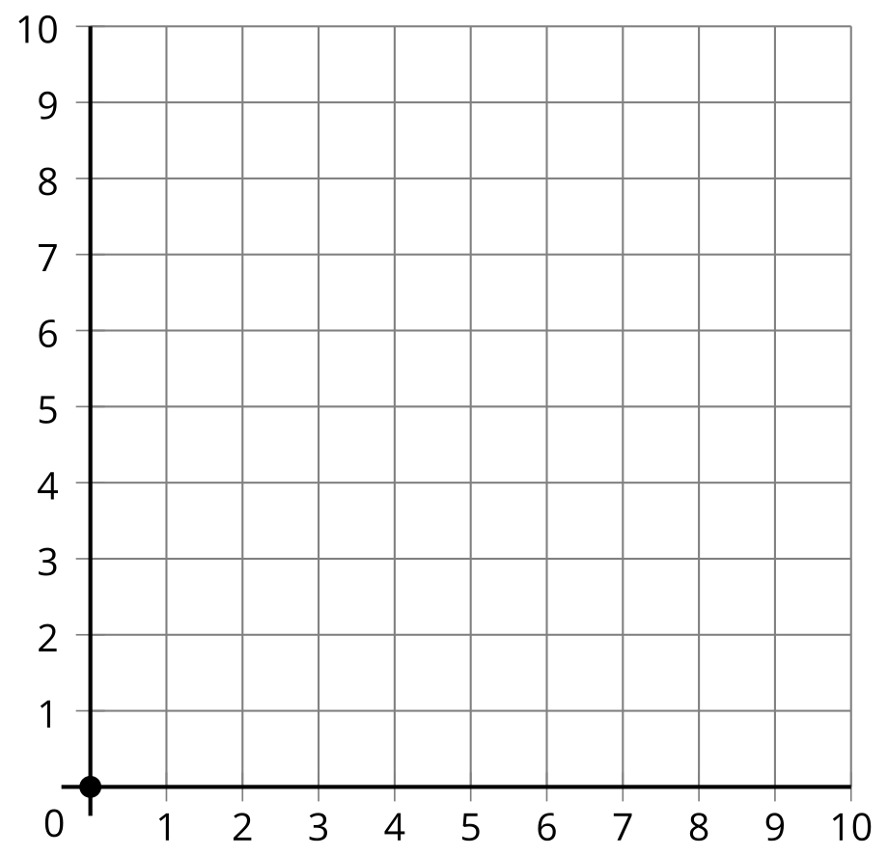

1 What’s the Point?

Student Task Statement
Partner A
- Estimate the location of each point.
- Point | - Coordinates
- $A$ | - $\left(5,1\right)$
- $B$ | - $\left(5,2\right)$
- $C$ | - $\left(5,3\right)$
- $D$ | - $\left(5,4\right)$
- Plot and label the points on the coordinate grid.
- 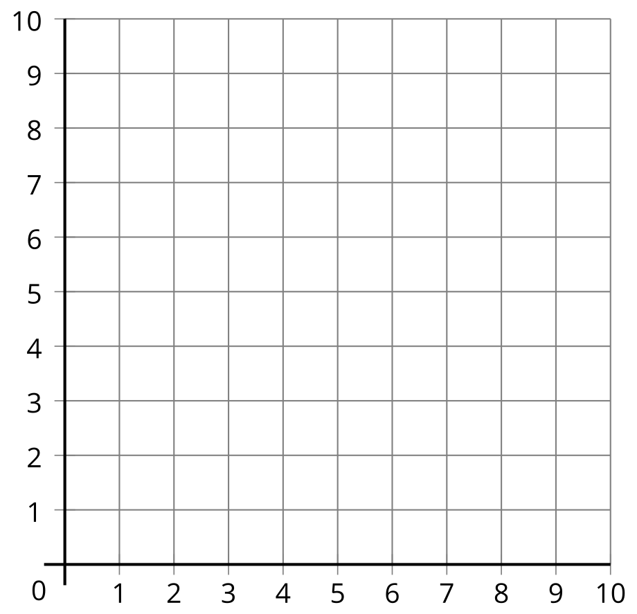
- What do the points have in common?
- Plot the point with coordinates $\left(5,0\right)$ on the coordinate grid.
Partner B
- Estimate the location of each point.
- Point | - Coordinates
- $A$ | - $\left(4,3\right)$
- $B$ | - $\left(5,3\right)$
- $C$ | - $\left(6,3\right)$
- $D$ | - $\left(7,3\right)$
- Plot and label the points on the coordinate grid.
- What do the points have in common?
- Plot the point with coordinates $\left(0,3\right)$ on the coordinate grid.

2 Plotting Points Without a Grid

Student Task Statement
- A point is labeled in the coordinate plane. Plot and label some other points. Explain or show your reasoning.
- 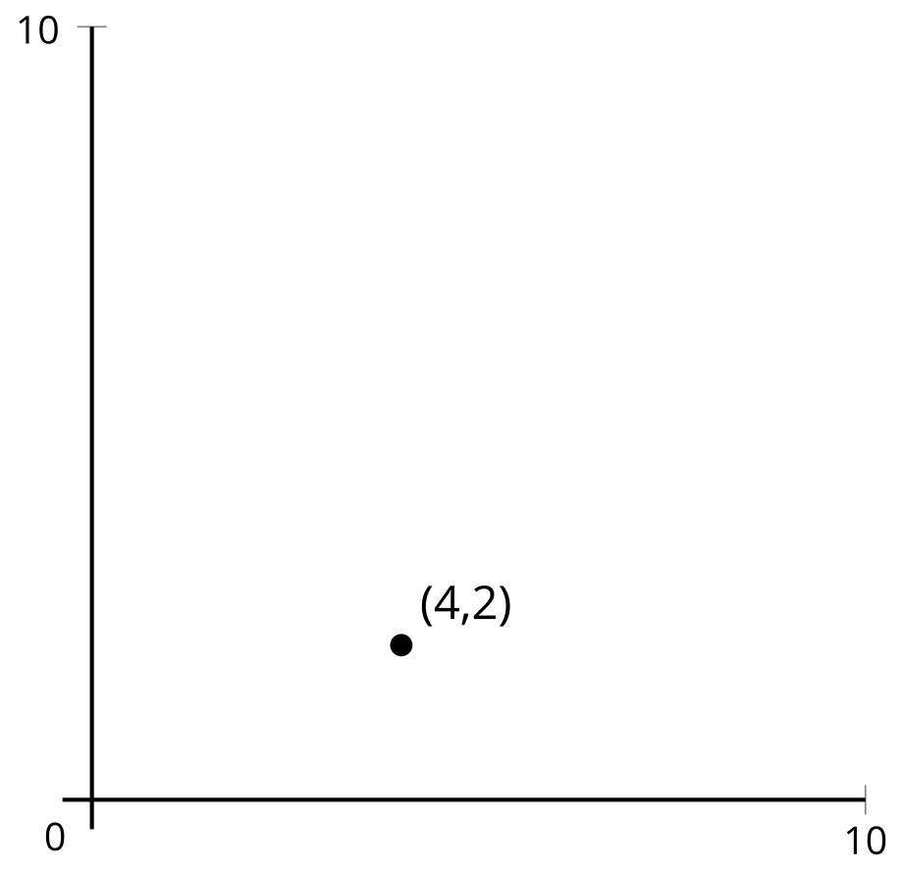
- Can you plot $\left(1,0\right)$ and $\left(0,1\right)$ accurately? Explain or show your reasoning.
© CC BY 2021 Illustrative Mathematics®

