Lesson 10: Compare Drawings
- Let’s figure out how drawings can show what is happening in a story problem.

10.1: Apple Slices for a Picnic

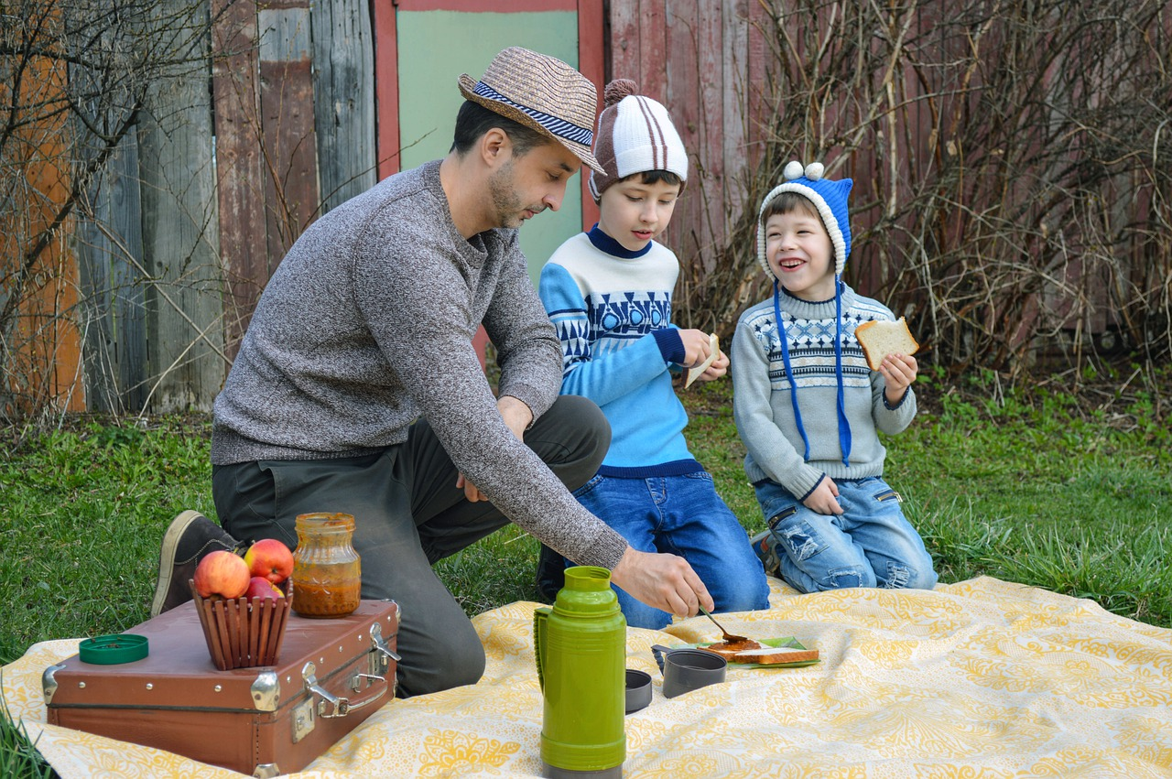
There were 3 apple slices at the picnic.
Tyler's dad brought 5 more apple slices to the picnic.
How many apples slices are there now?

10.2: Compare Drawings
Andre and Noah both drew pictures to show what happened in the story problem.
Andre
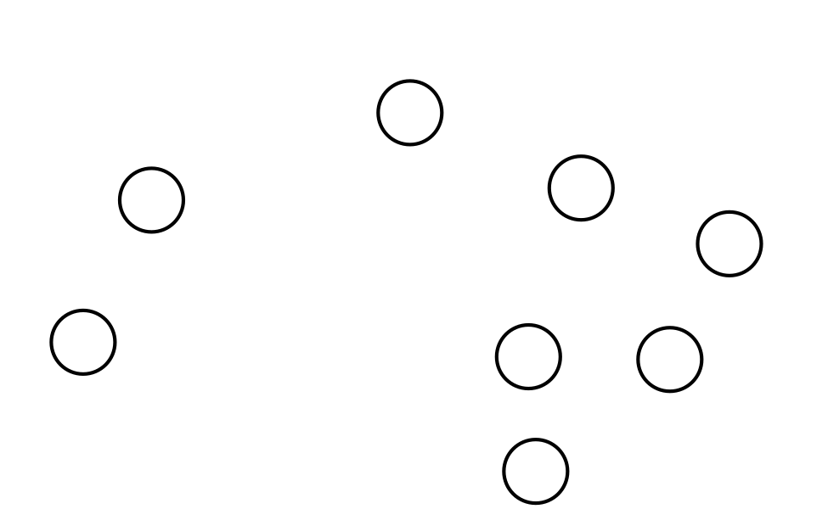
Noah

10.3: Introduce Bingo, Add and Cover
Choose a center.
Bingo
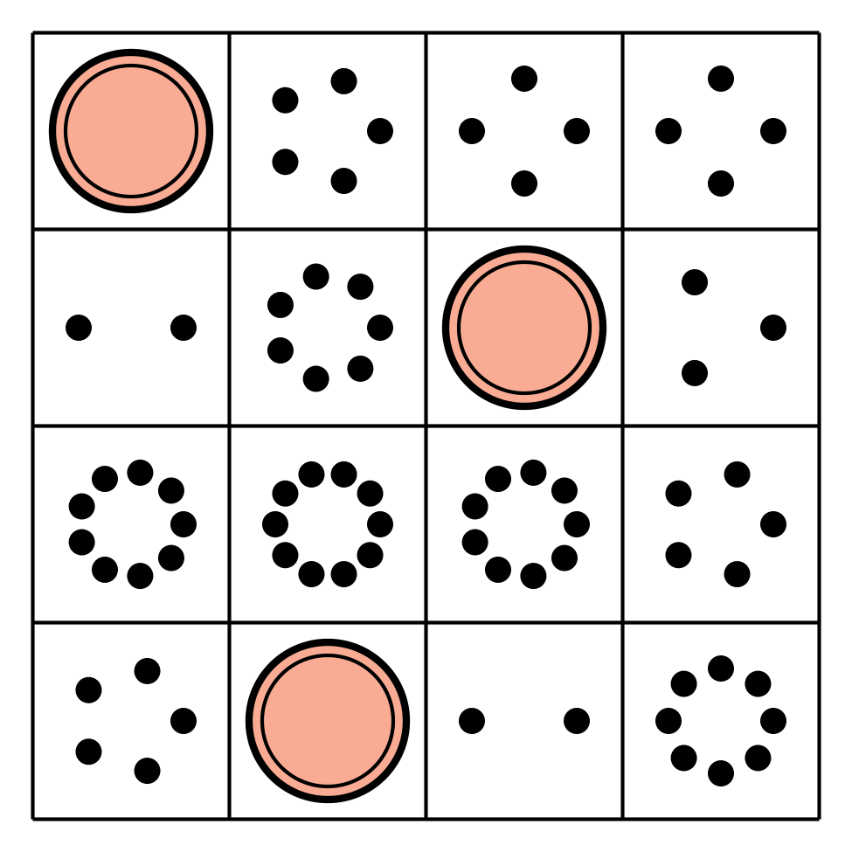
Math Fingers
Subtraction Towers
5-frames
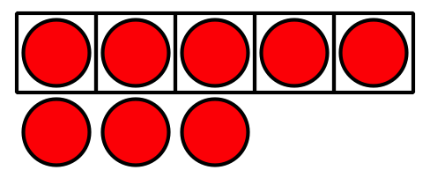
Math Stories
Counting Collections
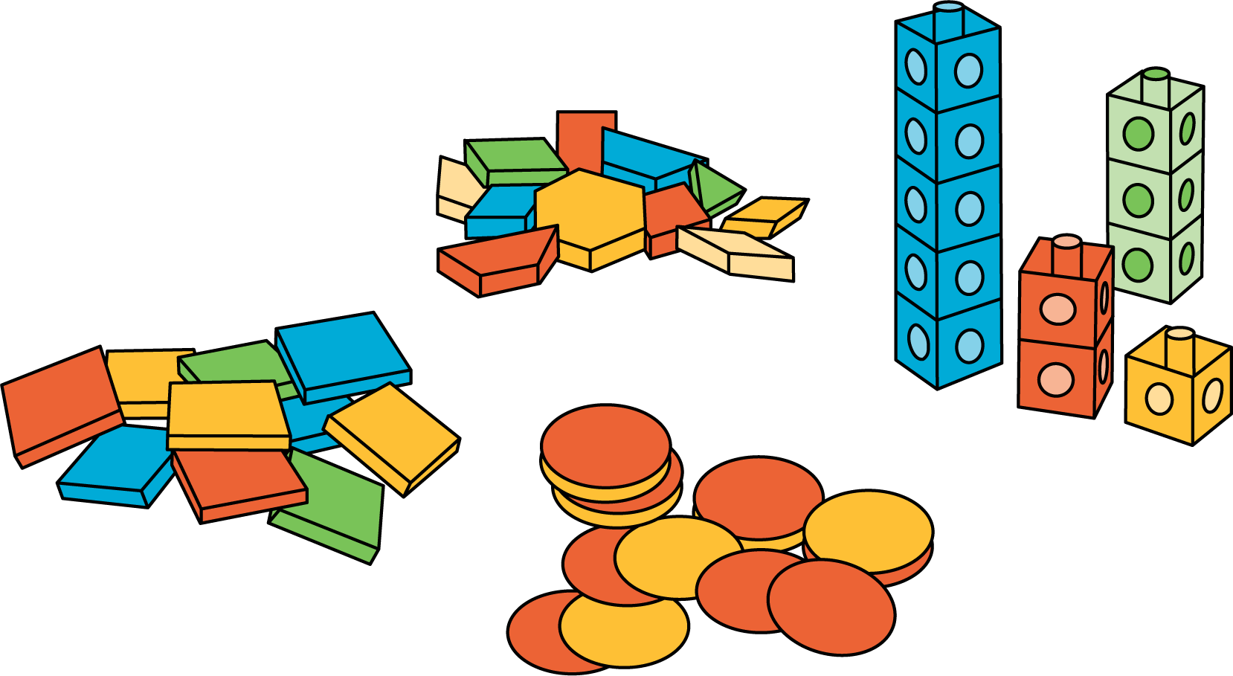
© CC BY 2021 Illustrative Mathematics®

