Unit 4 Lesson 10: Write Two-digit Numbers

WU Notice and Wonder: Same Digit, Different Place (Warm up)

Student Task Statement
What do you notice?
What do you wonder?
A
7
B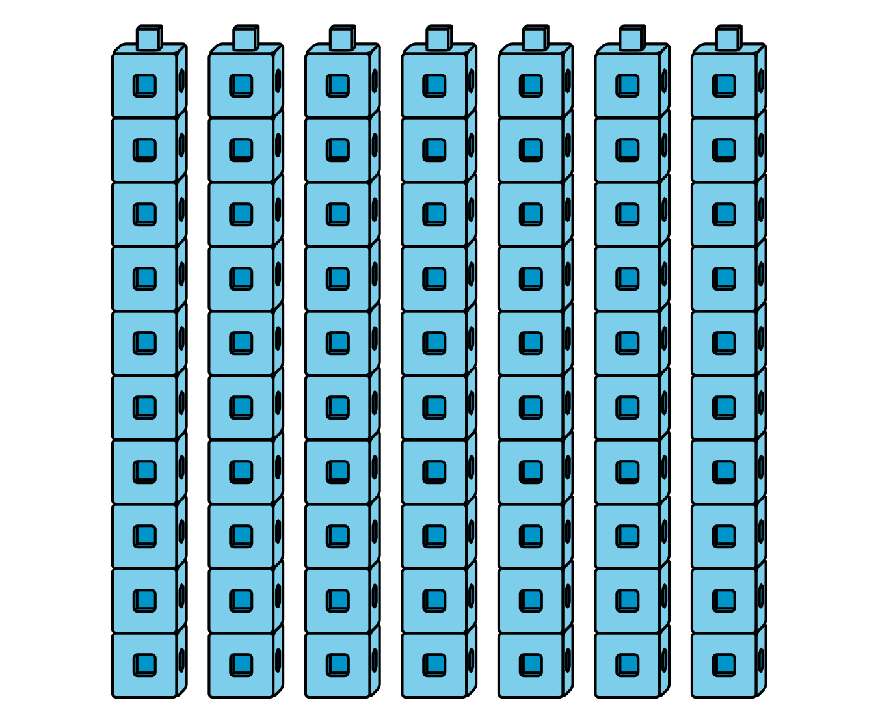
70
C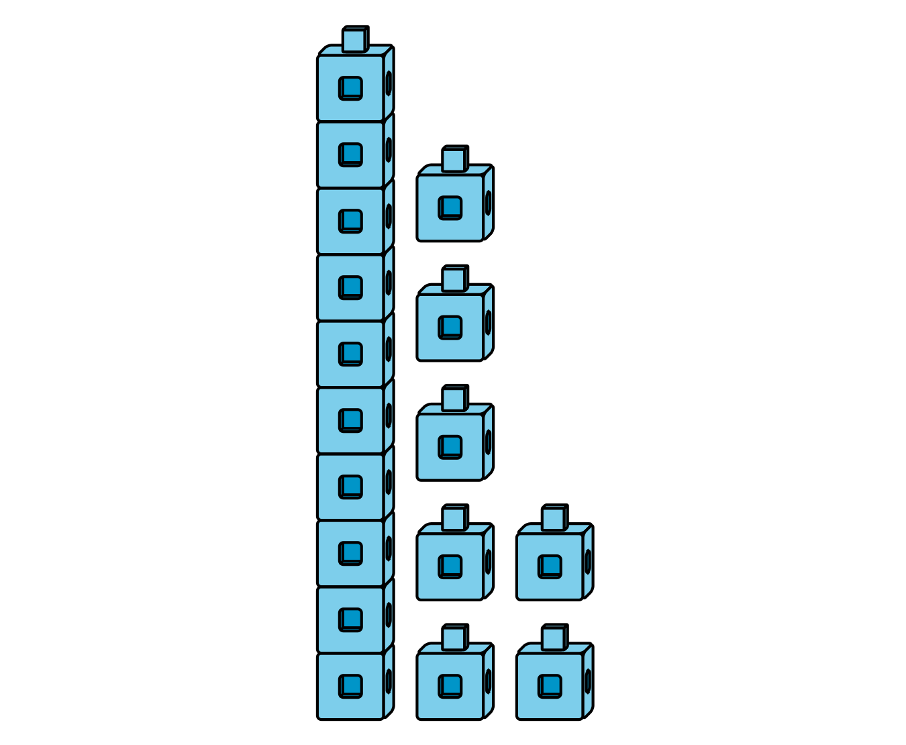
17
D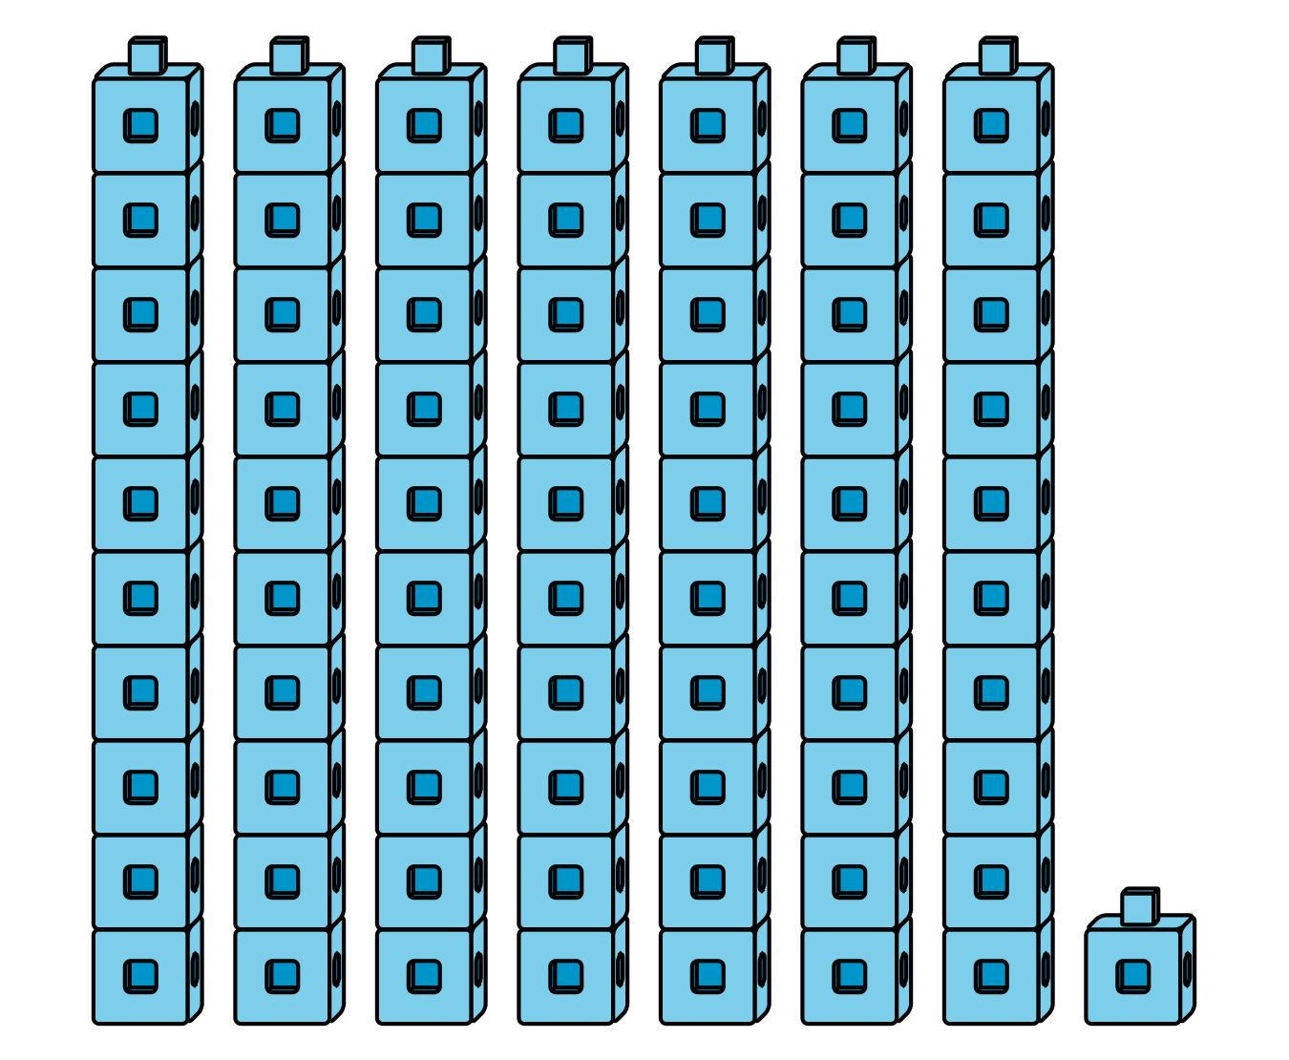
71

1 Write Numbers to Match Base-Ten Representations

Student Task Statement
Write the number that matches each representation.
- 1 ten 4 ones
- Number: ____________

- 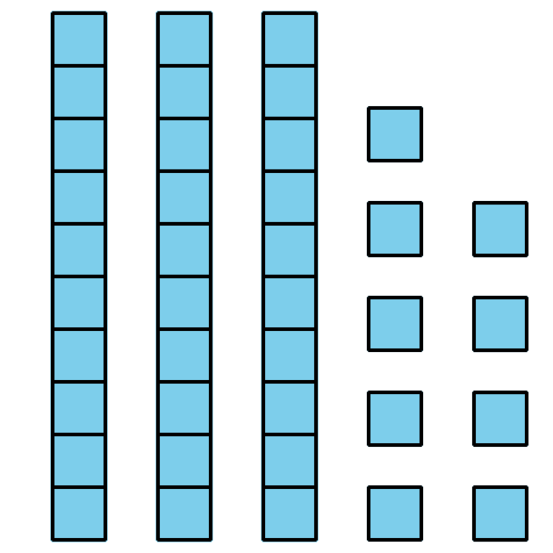
- Number: ____________
- 9 tens
- Number: ____________
- $20+5$
- Number: ____________

- 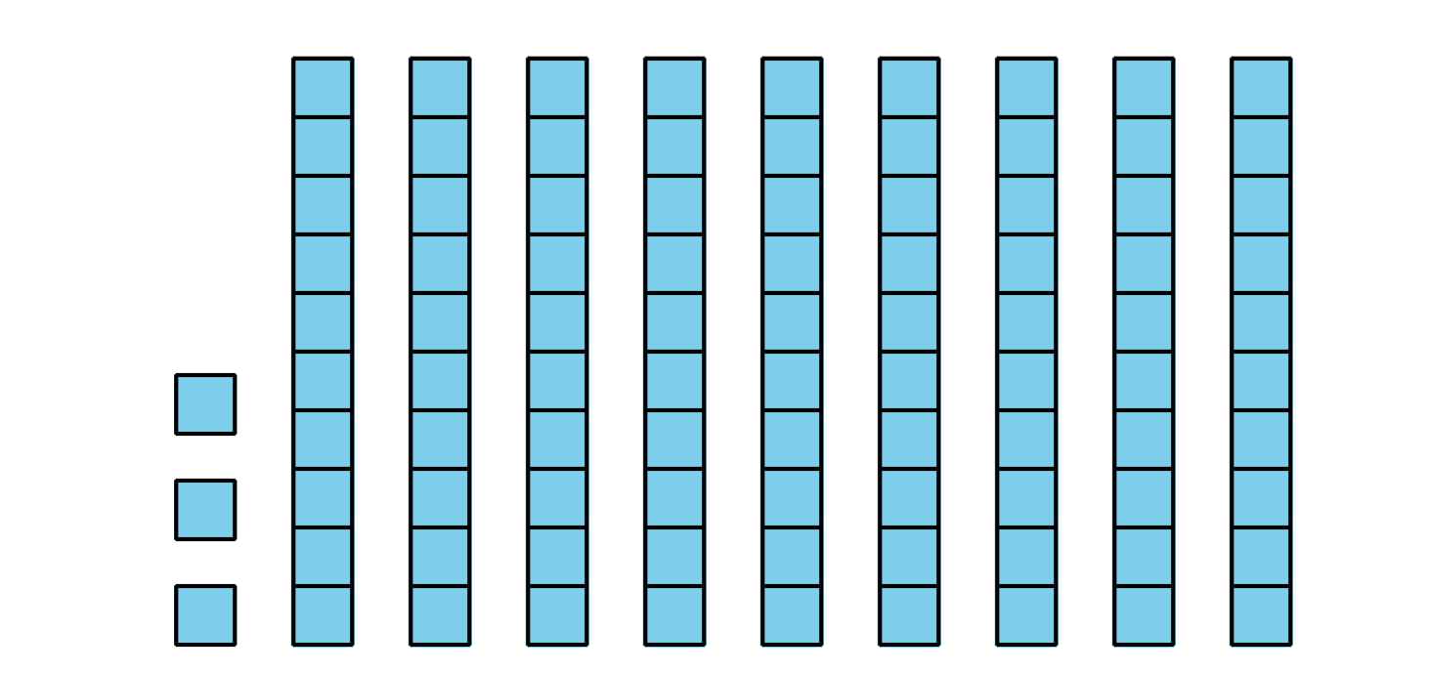
- Number: ____________
- $7+40$
- Number: ____________
- 2 ones 8 tens
- Number: ____________

- 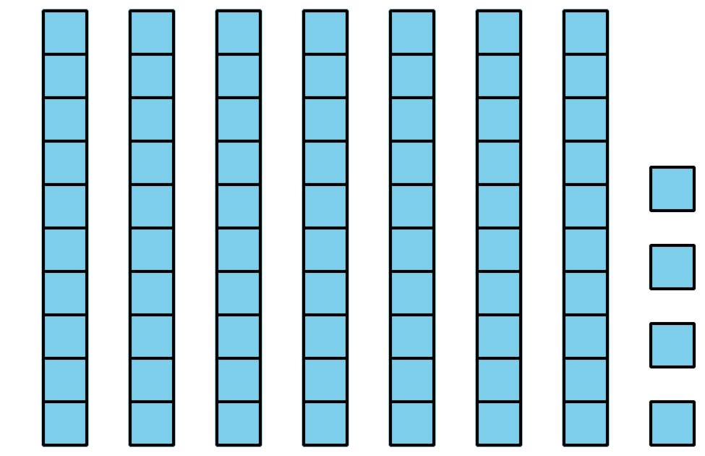
- Number: ____________
- $1+40$
- Number: ____________

- Number: ____________

2 Introduce Write Numbers, Numbers to 99 by 1

Student Task Statement
© CC BY 2021 Illustrative Mathematics®

