Lesson 10 Practice Problems
- Which graphs could represent a proportional relationship?
- 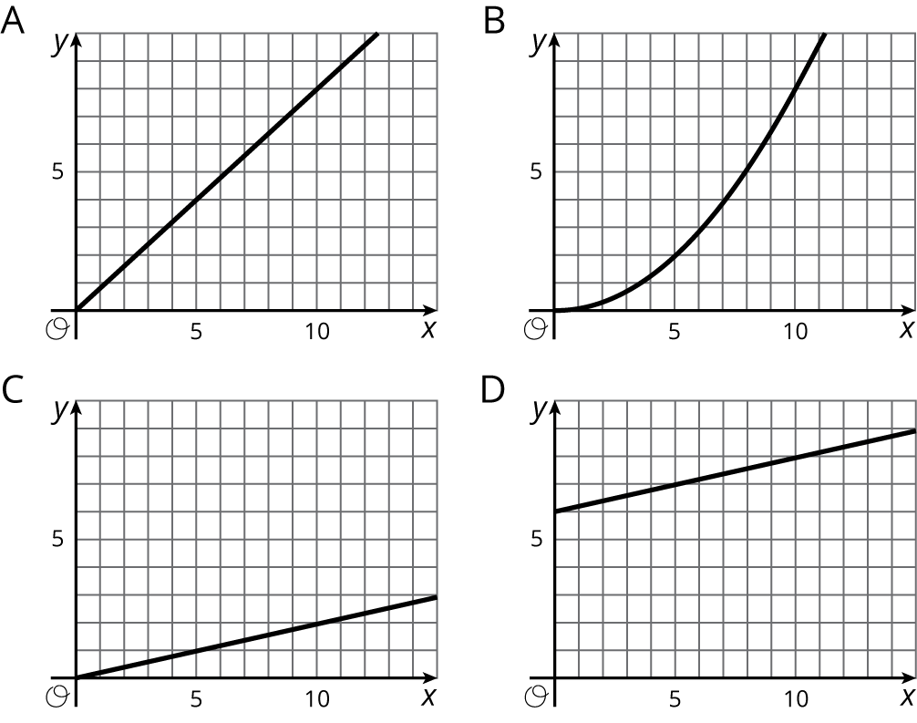
  - A
  - B
  - C
  - D
- A lemonade recipe calls for $\frac{1}{4}$ cup of lemon juice for every cup of water.
  - Use the table to answer these questions.
    - What does $x$ represent?
    - What does $y$ represent?
    - Is there a proportional relationship between $x$ and $y$?
  - Plot the pairs in the table in a coordinate plane.
- $x$ | - $y$
- 1 | - $\frac{1}{4}$
- 2 | - $\frac{1}{2}$
- 3 | - $\frac{3}{4}$
- 4 | - 1
- Select all the pieces of information that would tell you $x$ and $y$ have a proportional relationship. Let $y$ represent the distance in meters between a rock and a turtle's current position and $x$ represent the time in minutes the turtle has been moving.
  - $y=3x$
  - After 4 minutes, the turtle has walked 12 feet away from the rock.
  - The turtle walks for a bit, then stops for a minute before walking again.
  - The turtle walks away from the rock at a constant rate.
- (From Unit 2, Lesson 9.)
- Decide whether each table could represent a proportional relationship. If the relationship could be proportional, what would be the constant of proportionality?
  - The sizes you can print a photo.
- width of photo (inches) | - height of photo (inches)
- 2 | - 3
- 4 | - 6
- 5 | - 7
- 8 | - 10
  - The distance from which a lighthouse is visible.
- height of a lighthouse (feet) | - distance it can be seen (miles)
- 20 | - 6
- 45 | - 9
- 70 | - 11
- 95 | - 13
- (From Unit 2, Lesson 7.)
© CC BY Open Up Resources. Adaptations CC BY IM.

