Unit 8 Lesson 9 Cumulative Practice Problems
- A preschool teacher is rearranging four boxes of playing blocks so that each box contains an equal number of blocks. Currently Box 1 has 32 blocks, Box 2 has 18, Box 3 has 41, and Box 4 has 9.
- Select all the ways he could make each box have the same number of blocks.
  - Remove all the blocks and make four equal piles of 25, then put each pile in one of the boxes.
  - Remove 7 blocks from Box 1 and place them in Box 2.
  - Remove 21 blocks from Box 3 and place them in Box 4.
  - Remove 7 blocks from Box 1 and place them in Box 2, and remove 21 blocks from Box 3 and place them in Box 4.
  - Remove 7 blocks from Box 1 and place them in Box 2, and remove 16 blocks from Box 3 and place them in Box 4.
- In a round of mini-golf, Clare records the number of strokes it takes to hit the ball into the hole of each green.
- 2
- 3
- 1
- 4
- 5
- 2
- 3
- 4
- 3
- She said that, if she redistributed the strokes on different greens, she could tell that her average number of strokes per hole is 3. Explain how Clare is correct.
- Three sixth-grade classes raised $25.50, $49.75, and $37.25 for their classroom libraries. They agreed to share the money raised equally. What is each class’s equal share? Explain or show your reasoning.
- In her English class, Mai’s teacher gives 4 quizzes each worth 5 points. After 3 quizzes, she has the scores 4, 3, and 4. What does she need to get on the last quiz to have a mean score of 4? Explain or show your reasoning.
- An earthworm farmer examined two containers of a certain species of earthworms so that he could learn about their lengths. He measured 25 earthworms in each container and recorded their lengths in millimeters.
- Here are histograms of the lengths for each container.
- 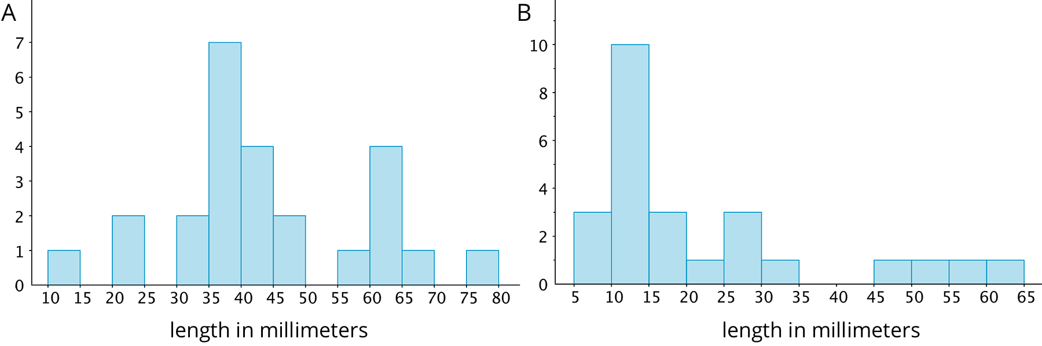
  - Which container tends to have longer worms than the other container?
  - For which container would 15 millimeters be a reasonable description of a typical length of the worms in the container?
  - If length is related to age, which container had the most young worms?
- (From Unit 8, Lesson 7.)
- Diego thinks that $x=3$ is a solution to the equation $x^{2}=16$. Do you agree? Explain or show your reasoning.
- (From Unit 6, Lesson 15.)
© CC BY Open Up Resources. Adaptations CC BY IM.

