Lesson 20: The Volume of a Sphere
Let’s explore spheres and their volumes.

20.1: Sketch a Sphere
Here is a method for quickly sketching a sphere:
- Draw a circle.
- Draw an oval in the middle whose edges touch the sphere.
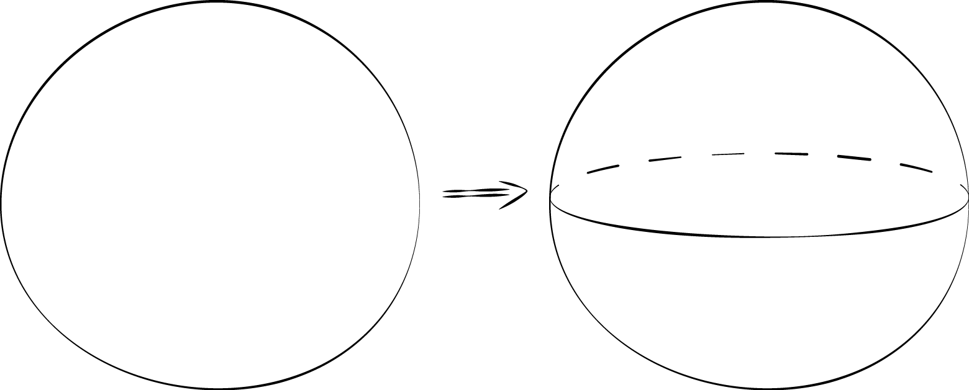
- Practice sketching some spheres. Sketch a few different sizes.
- For each sketch, draw a radius and label it $r$.

20.2: A Sphere in a Cylinder
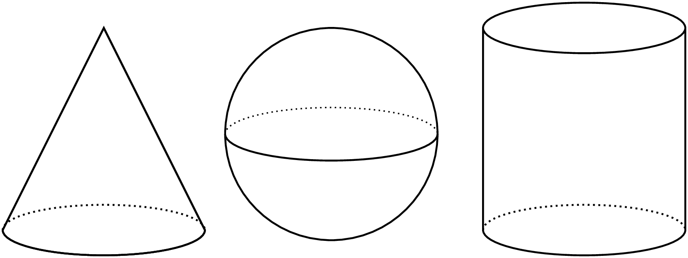
Here are a cone, a sphere, and a cylinder that all have the same radii and heights. The radius of the cylinder is 5 units. When necessary, express all answers in terms of $π$.
- What is the height of the cylinder?
- What is the volume of the cylinder?
- What is the volume of the cone?
- What is the volume of the sphere? Explain your reasoning.

20.3: Spheres in Cylinders
Here are a cone, a sphere, and a cylinder that all have the same radii and heights. Let the radius of the cylinder be $r$ units. When necessary, express answers in terms of $π$.
- What is the height of the cylinder in terms of $r$?
- What is the volume of the cylinder in terms of $r$?
- What is the volume of the cone in terms of $r$?
- What is the volume of the sphere in terms of $r$?
- A volume of the cone is $\frac{1}{3}$ the volume of a cylinder. The volume of the sphere is what fraction of the volume of the cylinder?

Lesson 20 Summary
Think about a sphere with radius $r$ units that fits snugly inside a cylinder. The cylinder must then also have a radius of $r$ units and a height of $2r$ units. Using what we have learned about volume, the cylinder has a volume of $πr^{2}h=πr^{2}⋅\left(2r\right)$, which is equal to $2πr^{3}$ cubic units.
We know from an earlier lesson that the volume of a cone with the same base and height as a cylinder has $\frac{1}{3}$ of the volume. In this example, such a cone has a volume of $\frac{1}{3}⋅πr^{2}⋅2r$ or just $\frac{2}{3}πr^{3}$ cubic units.
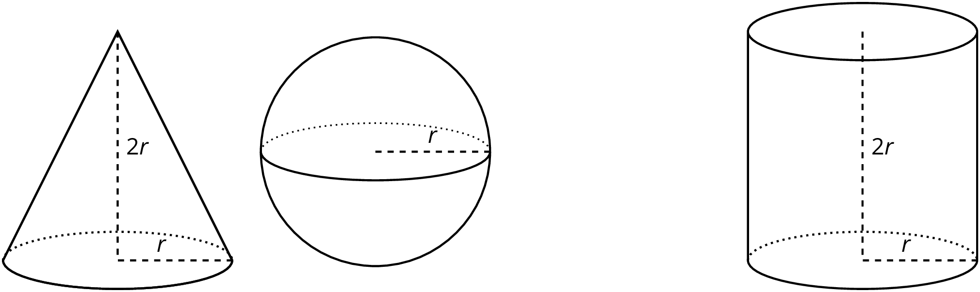
If we filled the cone and sphere with water, and then poured that water into the cylinder, the cylinder would be completely filled. That means the volume of the sphere and the volume of the cone add up to the volume of the cylinder. In other words, if $V$ is the volume of the sphere, then
$V+\frac{2}{3}πr^{3}=2πr^{3}$
This leads to the formula for the volume of the sphere,
$V=\frac{4}{3}πr^{3}$
© CC BY Open Up Resources. Adaptations CC BY IM.

