Lesson 12 Practice Problems
- Which is larger: the number of meters across the Milky Way, or the number of cells in all humans? Explain or show your reasoning.
- Some useful information:
  - The Milky Way is about 100,000 light years across.
  - There are about 37 trillion cells in a human body.
  - One light year is about ${10}^{16}$ meters.
  - The world population is about 7 billion.

- Ecologists measure the body length and wingspan of 127 butterfly specimens caught in a single field.
  - Draw a line that you think is a good fit for the data.
  - Write an equation for the line.
  - What does the slope of the line tell you about the wingspans and lengths of these butterflies?
- 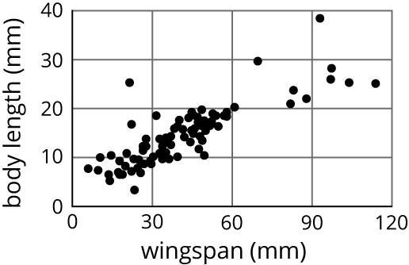
- (From Unit 6, Lesson 5.)
- Diego was solving an equation, but when he checked his answer, he saw his solution was incorrect. He knows he made a mistake, but he can’t find it. Where is Diego’s mistake and what is the solution to the equation?
- $\begin{matrix}\text{-}4\left(7−2x\right)=3\left(x+4\right) \\ \text{-}28−8x=3x+12 \\ \text{-}28=11x+12 \\ \text{-}40=11x \\ \text{-}\frac{40}{11}=x \end{matrix}$
- (From Unit 4, Lesson 5.)
- The two triangles are similar. Find $x$.
- 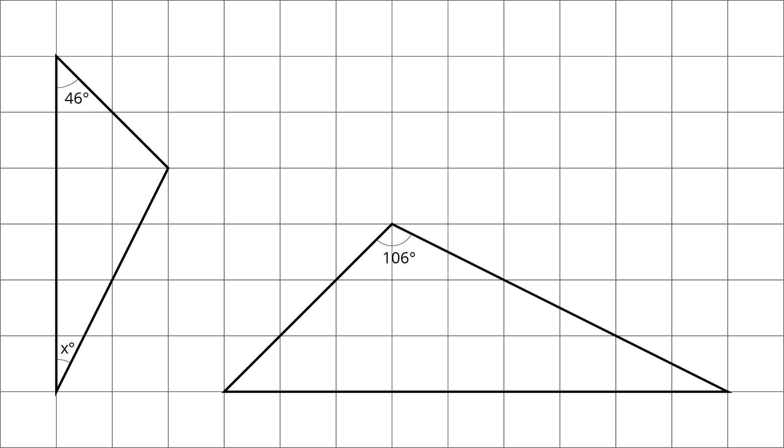
- (From Unit 2, Lesson 7.)
© CC BY Open Up Resources. Adaptations CC BY IM.

