Unit 4 Lesson 1 Cumulative Practice Problems
- At the book sale, all books cost less than $5.
  - What is the most expensive a book could be?
  - Write an inequality to represent costs of books at the sale.
  - Draw a number line to represent the inequality.
- Kiran started his homework before 7:00 p.m. and finished his homework after 8:00 p.m. Let $h$ represent the number of hours Kiran worked on his homework.
- Decide if each statement it is definitely true, definitely not true, or possibly true. Explain your reasoning.
  - $h>1$
  - $h>2$
  - $h<1$
  - $h<2$
  - Show that the two triangles are congruent.
  - Find the side lengths of $DEF$ and the angle measures of $ABC$.
- 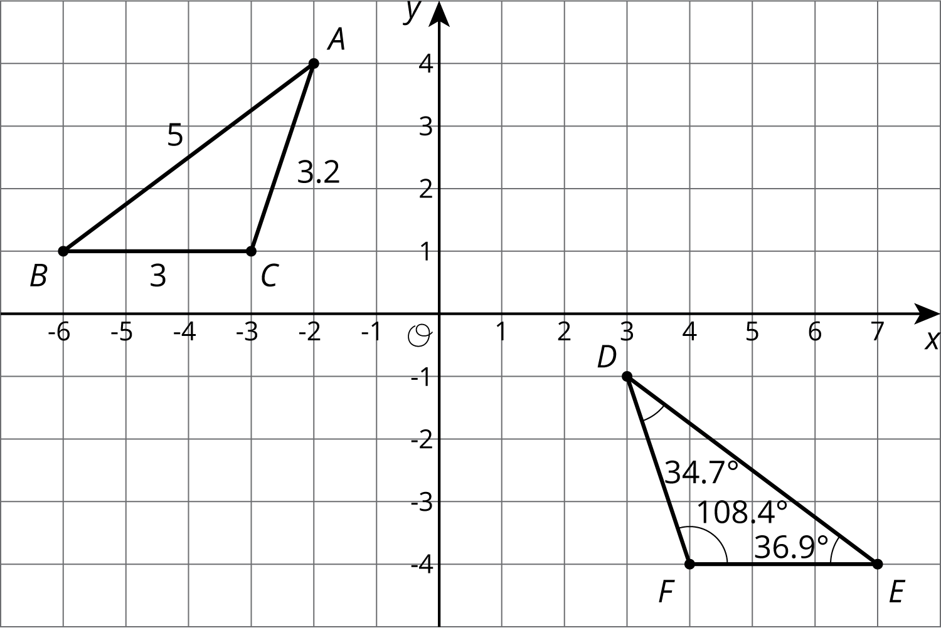
- (From Unit 1, Lesson 11.)
- Here is a polygon on a grid.
- Draw a scaled copy of this polygon that has a perimeter of 30 units. What is the scale factor? Explain how you know.
- (From Unit 2, Lesson 2.)
© CC BY Open Up Resources. Adaptations CC BY IM.

