Lesson 3: Recubramos rectángulos

Standards Alignments
Addressing | 3.MD.C.5.b, 3.MD.C.6

Teacher-facing Learning Goals
- Explain that rectangles that can be covered by the same number of unit squares without gaps or overlaps have the same area.
- Find the area of rectangles (within 24 square units) by counting unit squares.

Student-facing Learning Goals
- Contemos fichas cuadradas.

Lesson Purpose
The purpose of this lesson is for students to measure area by counting square tiles and create rectangles with a given area.
In previous lessons, students learned that counting square tiles that cover a figure gives the area of the figure in square units. In this lesson, students further explore tiling and learn that, when measuring area, squares that are used to tile a figure can't overlap. They learn that the area is the number of square units that cover a flat figure with no gaps or overlaps. Students also create rectangles of a specific area on grids to demonstrate they understand that rectangles covered by the same number of square units without gaps or overlaps have the same area.
Students should have access to square tiles throughout the lesson and also be encouraged to draw the partitioned rectangles they create with the tiles.

Access for:

Students with Disabilities
- Representation (Activity 2)

English Learners
- MLR8 (Activity 2)

Instructional Routines
Card Sort (Activity 2), MLR1 Stronger and Clearer Each Time (Activity 1), Which One Doesn’t Belong? (Warm-up)

Materials to Gather
- Inch tiles: Activity 1, Activity 2

Materials to Copy
- Time to Tile (groups of 1): Activity 1
- Card Sort: Rectangles (groups of 2): Activity 2

Required Preparation

Lesson Timeline
Warm-up | 10 min
Activity 1 | 15 min
Activity 2 | 20 min
Lesson Synthesis | 10 min
Cool-down | 5 min

Teacher Reflection Question
Reflect on students’ counting strategies. What strategies are they comfortable using as they find area? What strategies could use more practice?

Cool-down
(to be completed at the end of the lesson) 5min
Recubre un rectángulo

Standards Alignments
Addressing | 3.MD.C.5.b

Student-facing Task Statement
Andre dice que este rectángulo tiene un área de 23 unidades cuadradas porque él lo cubrió con 23 fichas cuadradas.
¿Estás de acuerdo con Andre? Explica tu razonamiento.
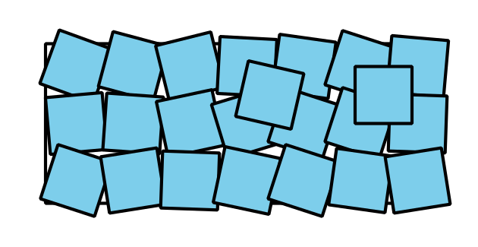

Student Responses
Sample responses:
- No, even though it is 23 tiles, we don’t know that completely fills the rectangle because you can see some of the rectangle and some of the squares are overlapping.
- No, even though it is 23 tiles, you can see that some of the space in the rectangle isn’t covered.

