Unit 6 Lesson 2: Revisiting Right Triangles

1 Notice and Wonder: A Right Triangle (Warm up)

Student Task Statement
What do you notice? What do you wonder?
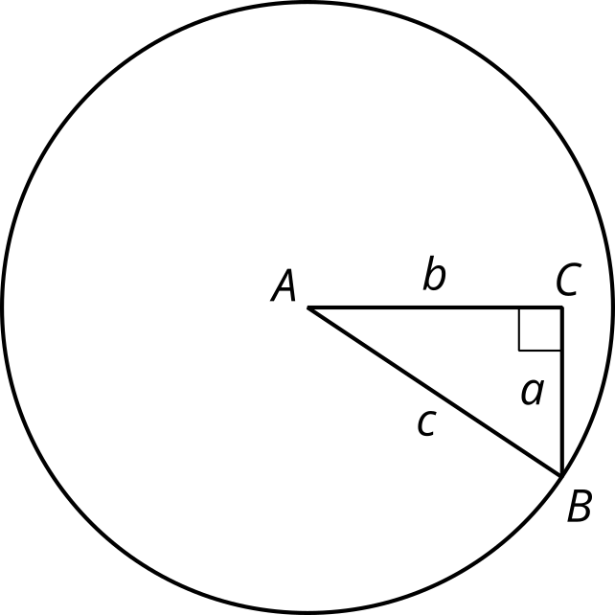

2 Recalling Right Triangle Trigonometry

Images for Launch
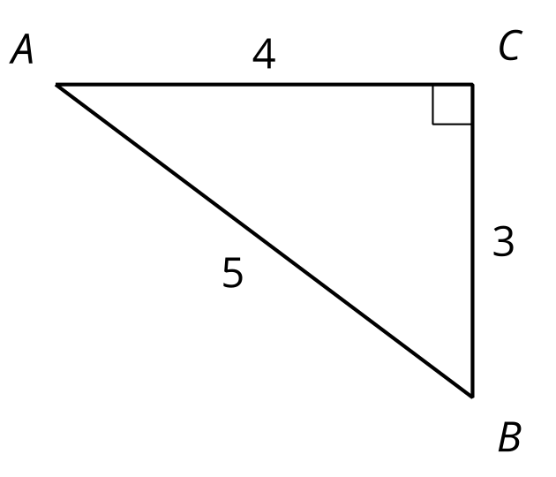

Student Task Statement
- Find $cos\left(A\right)$, $sin\left(A\right)$, and $tan\left(A\right)$ for triangle $ABC$.
- 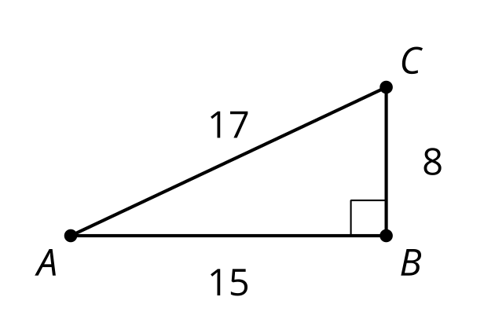
- Sketch a triangle $DEF$ where $sin\left(D\right)=cos\left(D\right)$ and $E$ is a right angle. What is the value of $tan\left(D\right)$ for this triangle? Explain how you know.
- If the coordinates of point $I$ are $\left(9,12\right)$, what is the value of $cos\left(G\right)$, $sin\left(G\right)$, and $tan\left(G\right)$ for triangle $GHI$? Explain or show your reasoning.
- 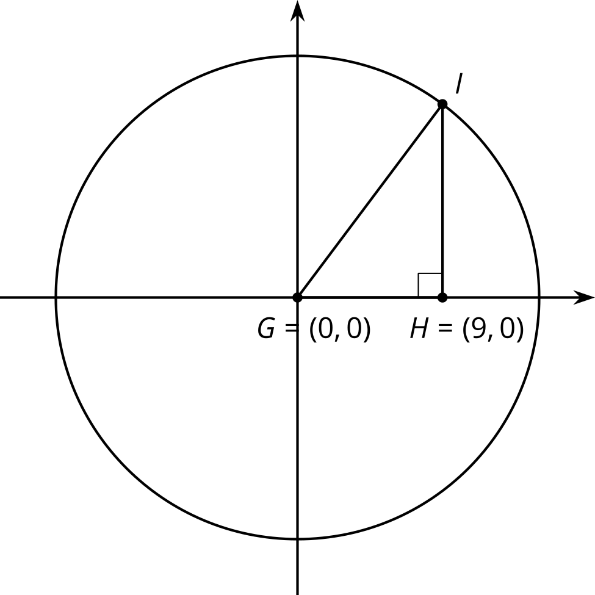

3 Shrinking Triangles

Student Task Statement
- What are $cos\left(D\right)$, $sin\left(D\right)$, and $tan\left(D\right)$? Explain how you know.
- 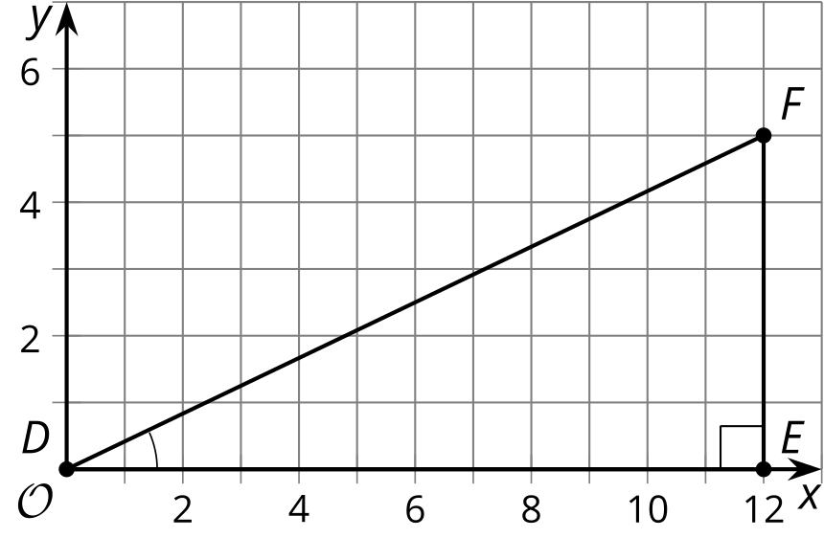
- Here is a triangle similar to triangle $DEF$.
- 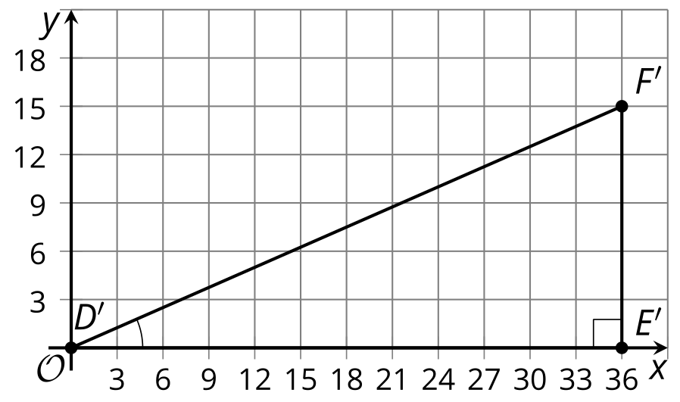
  - What is the scale factor from $△DEF$ to $△D^{′}E^{′}F^{′}$? Explain how you know.
  - What are $cos\left(D^{′}\right)$, $sin\left(D^{′}\right)$, and $tan\left(D^{′}\right)$?
- Here is another triangle similar to triangle $DEF$.
- 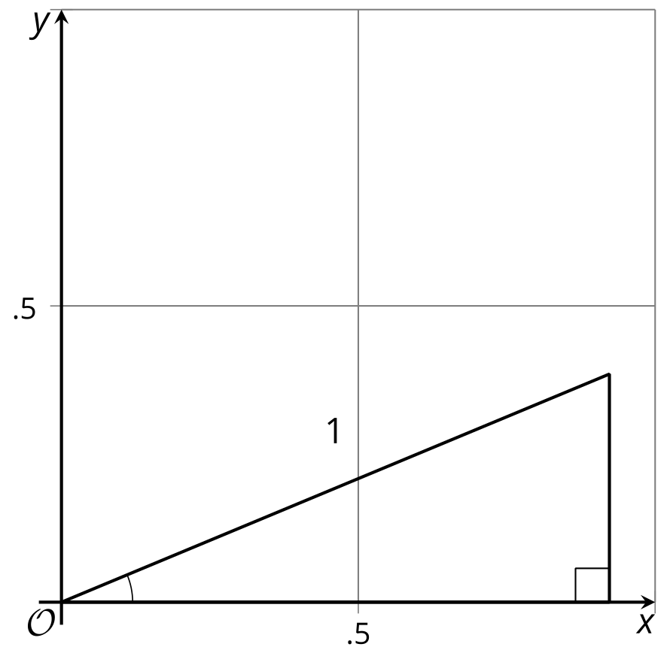
  - Label the triangle $D^{″}E^{″}F^{″}$.
  - What is the scale factor from triangle $DEF$ to triangle $D^{″}E^{″}F^{″}$?
  - What are the coordinates of $F^{″}$? Explain how you know.
  - What are $cos\left(D^{″}\right)$, $sin\left(D^{″}\right)$, and $tan\left(D^{″}\right)$?

Images for Activity Synthesis
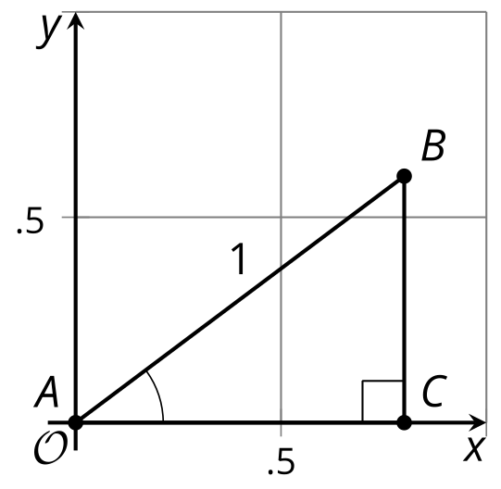
© CC BY 2019 by Illustrative Mathematics®

