Lesson 22: Rewriting Quadratic Expressions in Vertex Form
- Let’s see what else completing the square can help us do.

22.1: Three Expressions, One Function
These expressions each define the same function.
$x^{2}+6x+8 \left(x+2\right)\left(x+4\right) {\left(x+3\right)}^{2}−1$
Without graphing or doing any calculations, determine where the following features would be on a graph that represents the function.
- the vertex
- the $x$-intercepts
- the $y$-intercept

22.2: Back and Forth
- Here are two expressions in vertex form. Rewrite each expression in standard form. Show your reasoning.
  - ${\left(x+5\right)}^{2}+1$
  - ${\left(x−3\right)}^{2}−7$
- Think about the steps you took, and about reversing them. Try converting one or both of the expressions in standard form back into vertex form. Explain how you go about converting the expressions.
- Test your strategy by rewriting $x^{2}+10x+9$ in vertex form.
- Let’s check the expression you rewrote in vertex form.
  - Use graphing technology to graph both $x^{2}+10x+9$ and your new expression. Does it appear that they define the same function?
  - If you convert your expression in vertex form back into standard form, do you get $x^{2}+10x+9$?

22.3: Inconvenient Coefficients

  - Here is one way to rewrite $3x^{2}+12x+9$ in vertex form. Study the steps and write a brief explanation of what is happening at each step.
  - $\begin{matrix}3x^{2}+12x+9 & & \text{Original expression} \\ & & \\ 3\left(x^{2}+4x+3\right) & & \\ & & \\ 3\left(x^{2}+4x+3+1−1\right) & & \\ & & \\ 3\left(x^{2}+4x+4−1\right) & & \\ & & \\ 3\left({\left(x+2\right)}^{2}−1\right) & & \\ & & \\ 3{\left(x+2\right)}^{2}−3 & & \end{matrix}$
  - What is the vertex of the graph that represents this expression?
  - Does the graph open upward or downward? Explain how you know.
- Rewrite each expression in vertex form. Show your reasoning.
  - $\text{-}2x^{2}−4x+6$
  - $4x^{2}+24x+20$
  - $\text{-}x^{2}+20x$

Are you ready for more?
- Write $f\left(x\right)=2\left(x−3\right)\left(x−9\right)$ in vertex form without completing the square. (Hint: Think about finding the zeros of the function.) Explain your reasoning.
- Write $g\left(x\right)=2\left(x−3\right)\left(x−9\right)+21$ in vertex form without completing the square. Explain your reasoning.

22.4: Info Gap: Features of Functions
Your teacher will give you either a problem card or a data card. Do not show or read your card to your partner.
If your teacher gives you the data card:
- Silently read the information on your card.
- Ask your partner “What specific information do you need?” and wait for your partner to ask for information. Only give information that is on your card. (Do not figure out anything for your partner!)
- Before telling your partner the information, ask “Why do you need to know (that piece of information)?”
- Read the problem card, and solve the problem independently.
- Share the data card, and discuss your reasoning.
If your teacher gives you the problem card:
- Silently read your card and think about what information you need to answer the question.
- Ask your partner for the specific information that you need.
- Explain to your partner how you are using the information to solve the problem.
- When you have enough information, share the problem card with your partner, and solve the problem independently.
- Read the data card, and discuss your reasoning.
Pause here so your teacher can review your work. Ask your teacher for a new set of cards and repeat the activity, trading roles with your partner.

Lesson 22 Summary
Remember that a quadratic function can be defined by equivalent expressions in different forms, which enable us to see different features of its graph. For example, these expressions define the same function:
$\begin{matrix}\left(x−3\right)\left(x−7\right) & \text{factored form} \\ x^{2}−10x+21 & \text{standard form} \\ {\left(x−5\right)}^{2}−4 & \text{vertex form}\end{matrix}$
- From factored form, we can tell that the $x$-intercepts are $\left(3,0\right)$ and $\left(7,0\right)$.
- From standard form, we can tell that the $y$-intercept is $\left(0,21\right)$.
- From vertex form, we can tell that the vertex is $\left(5,\text{-}4\right)$.
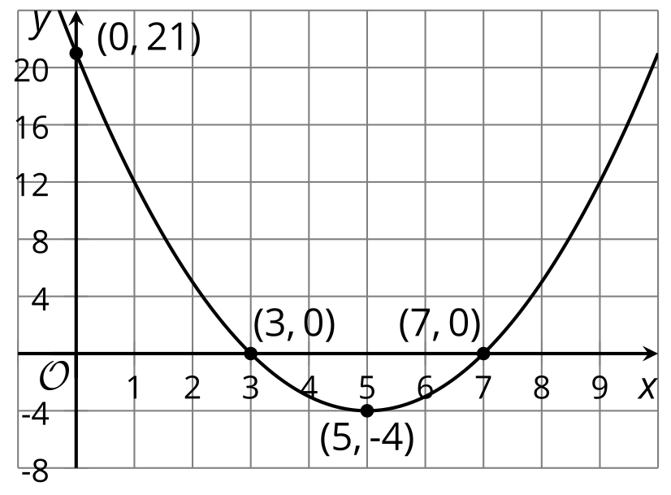
Recall that a function expressed in vertex form is written as: $a{\left(x−h\right)}^{2}+k$. The values of $h$ and $k$ reveal the vertex of the graph: $\left(h,k\right)$ are the coordinates of the vertex. In this example, $a$ is 1, $h$ is 5, and $k$ is -4.
- If we have an expression in vertex form, we can rewrite it in standard form by using the distributive property and combining like terms.
- Let’s say we want to rewrite ${\left(x−1\right)}^{2}−4$ in standard form.
- $\begin{matrix} & {\left(x−1\right)}^{2}−4 \\ & \left(x−1\right)\left(x−1\right)−4 \\ & x^{2}−2x+1−4 \\ & x^{2}−2x−3\end{matrix}$
- If we have an expression in standard form, we can rewrite it in vertex form by completing the square.
- Let’s rewrite $x^{2}+10x+24$ in vertex form.
- A perfect square would be $x^{2}+10x+25$, so we need to add 1. Adding 1, however, would change the expression. To keep the new expression equivalent to the original one, we will need to both add 1 and subtract 1.
- $\begin{matrix} & x^{2}+10x+24 \\ & x^{2}+10x+24+1−1 \\ & x^{2}+10x+25−1 \\ & {\left(x+5\right)}^{2}−1\end{matrix}$
- Let’s rewrite another expression in vertex form: $\text{-}2x^{2}+12x−30$.
- To make it easier to complete the square, we can use the distributive property to rewrite the expression with -2 as a factor, which gives $\text{-}2\left(x^{2}−6x+15\right)$.
- For the expression in the parentheses to be a perfect square, we need $x^{2}−6x+9$. We have 15 in the expression, so we can subtract 6 from it to get 9, and then add 6 again to keep the value of the expression unchanged. Then, we can rewrite $x^{2}−6x+9$ in factored form.
- $\begin{matrix} & \text{-}2x^{2}+12x−30 \\ & \text{-}2\left(x^{2}−6x+15\right) \\ & \text{-}2\left(x^{2}−6x+15−6+6\right) \\ & \text{-}2\left(x^{2}−6x+9+6\right) \\ & \text{-}2\left({\left(x−3\right)}^{2}+6\right)\end{matrix}$
- This expression is not yet in vertex form, however. To finish up, we need to apply the distributive property again so that the expression is of the form $a{\left(x−h\right)}^{2}+k$:
- $\begin{matrix} & \text{-}2\left({\left(x−3\right)}^{2}+6\right) \\ & \text{-}2{\left(x−3\right)}^{2}−12\end{matrix}$
- When written in this form, we can see that the vertex of the graph representing $\text{-}2{\left(x−3\right)}^{2}−12$ is $\left(3,\text{-}12\right)$.
© CC BY 2019 by Illustrative Mathematics®

