Lesson 16: Addition and Subtraction
- Let’s use place value strategies to add and subtract decimals.

Warm-up: Number Talk: Subtracting Decimals
Find the value of each expression mentally.
- $2.57−2.55$
- $2.57−2.49$
- $2.57−0.99$
- $2.57−0.59$

16.1: What's the Difference?
Find the value of each expression. Explain or show your reasoning.
- $7.35−2.6$
- $100.8−6.03$
- $26.5−13.62$
- $465−463.14$

16.2: Sums and Differences
Find the value of each expression. Explain or show your reasoning.
- $36.51−4.3$
- $100+31.05$
- $100−31.05$
- $266.43+75.9$

16.3: Subtraction with Larger Numbers
Find the value of each expression.
- $43.14−18.6$
- $73.3−52.99$
- $128.44−62.57$
- $261.25−260.7$

Section Summary
Section Summary
In this section, we learned that we can use the same strategies and algorithms we used to add and subtract whole numbers to add and subtract decimals.
We learned that it is helpful to estimate a sum before we solve. For example, the sum below is going to be close to $620+70$ or 690.
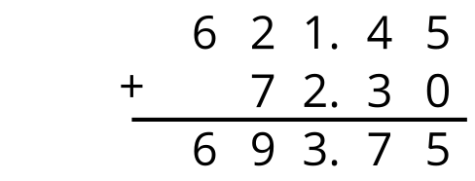
We also learned that it is important to make sure the places are aligned when we add and subtract.
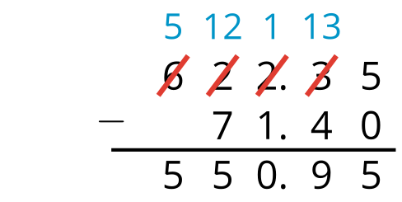
We can also estimate that the value of the difference will be about $620−70$ or 550.
© CC BY 2021 Illustrative Mathematics®

