Unit 7 Lesson 4: Sort Quadrilaterals

WU What Do You Know About Quadrilaterals? (Warm up)

Student Task Statement
What do you know about quadrilaterals?

1 Guess Which One?

Student Task Statement
- Play a round of Guess Which One.
- Partner A: Select one of the quadrilaterals. Do not reveal your choice to your partner.
- Partner B: Ask “yes” or “no” questions to guess which shape your partner picked. After each question, cross out or remove quadrilaterals based on your partner’s answer.
- 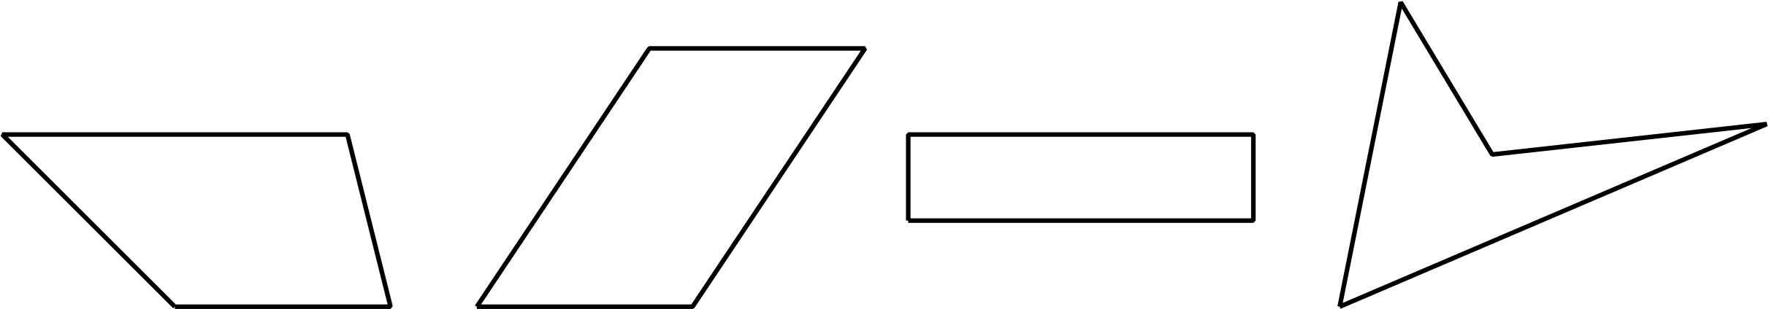
- 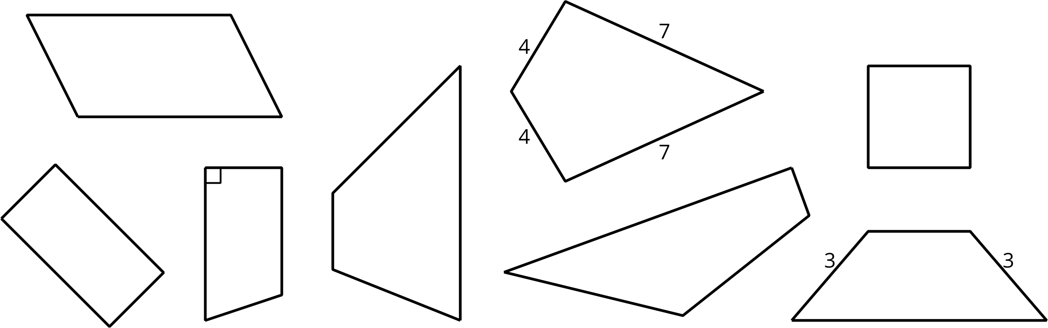
- 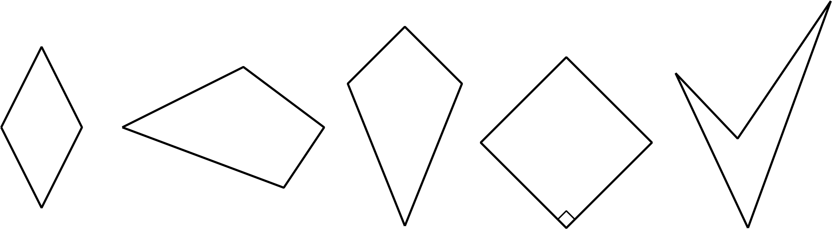
- Use the space to record your questions for this round.
- Han and Mai were playing Guess Which One. These are the last two shapes. What question can Mai ask to determine which shape is the one that Han picked?
- 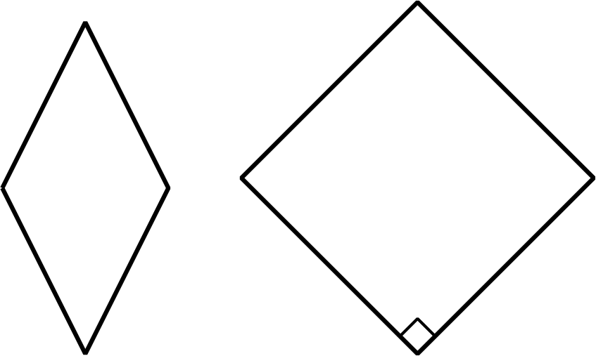
If there is time: Switch roles and play Guess Which One again.

2 Card Sort: Quadrilaterals

Student Task Statement
Your teacher will give you a set of cards.
- Sort all of the quadrilateral cards in a way that makes sense to you. Name the categories in your sort.
- Sort the quadrilateral cards in a different way and name each of the categories in your new sort.
© CC BY 2021 Illustrative Mathematics®

