Lesson 11: Drawings to Represent Story Problems
- Let’s draw a picture to show what happens in a story problem.

Warm-up: Which One Doesn’t Belong: Butterflies
Which one doesn’t belong?
A
B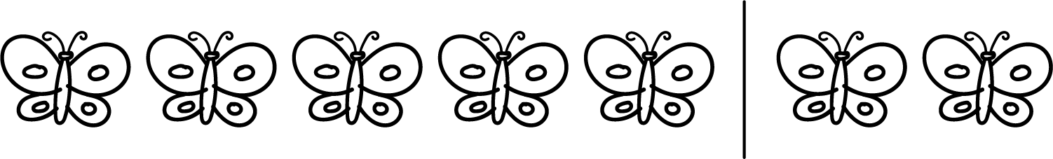
C
D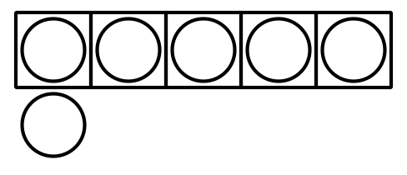

11.1: Draw a Picture
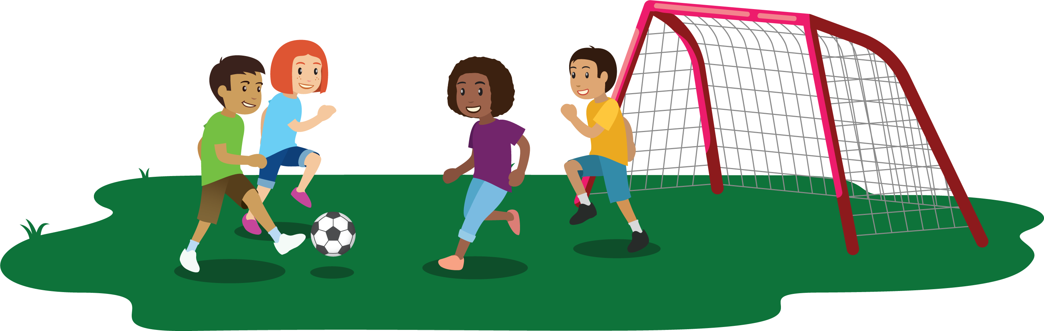
There were 7 kids playing soccer in the park.
3 of the kids left to go play on the swings.
How many kids are playing soccer in the park now?

11.3: Centers: Choice Time
Choose a center.
Bingo
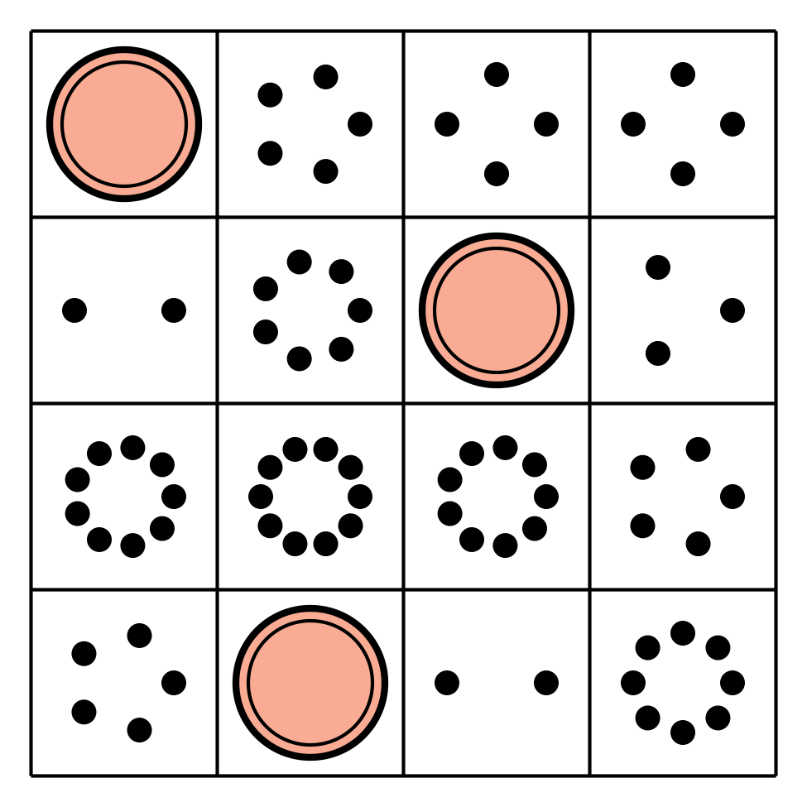
Math Fingers
Subtraction Towers
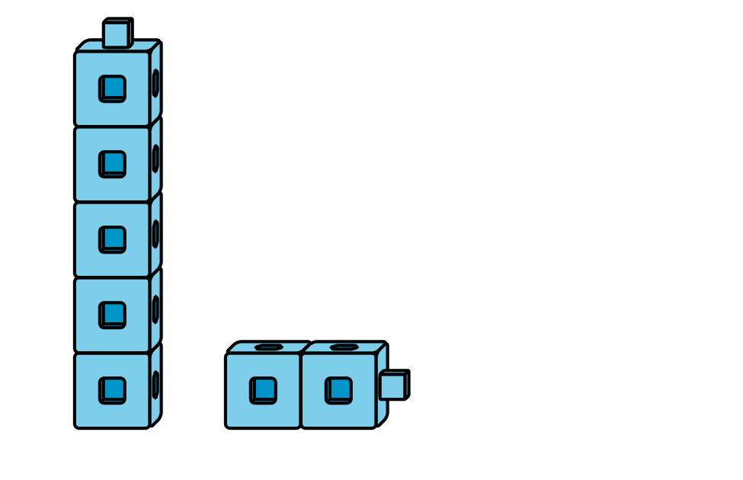
5-frames
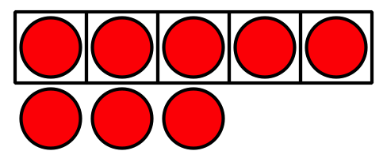
Math Stories
Counting Collections
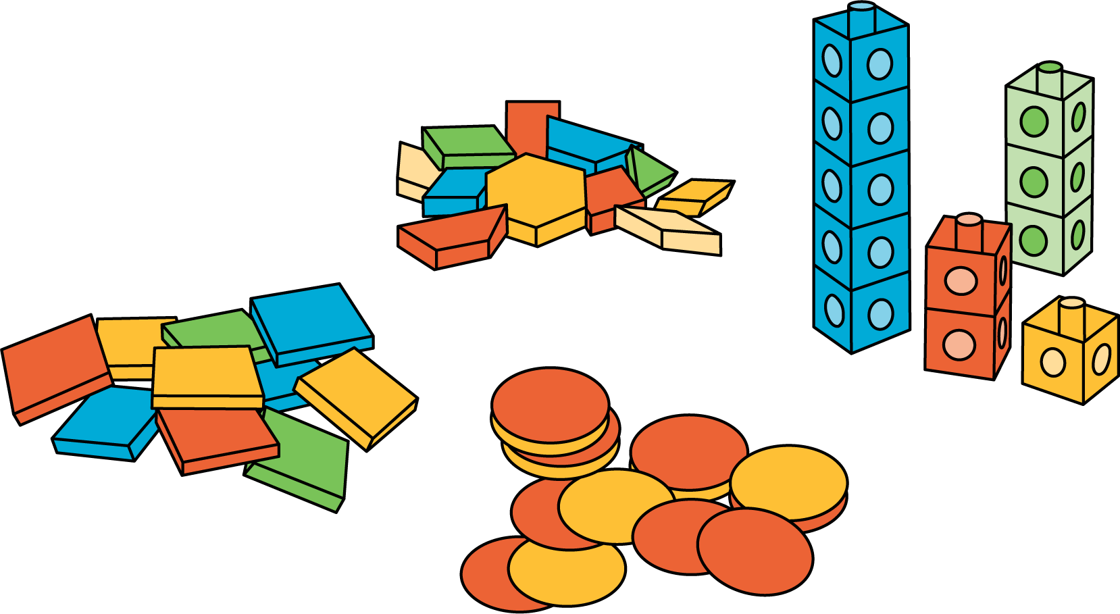
© CC BY 2021 Illustrative Mathematics®

