Unit 4 Lesson 11: Add Tens to Two-digit Numbers

WU True or False: Tens and Ones (Warm up)

Student Task Statement
Decide if each statement is true or false.
Be prepared to explain your reasoning.
- $80+5=5+80$
- $70+1=80+1$
- $20+6=6+30$

1 Add Two-digit Numbers and Tens

Student Task Statement
Find the number that makes each equation true.
Show your thinking using drawings, numbers, or words.
- 37+20=aaaiaaai
- 60+23=aaaiaaai
- 48+50=aaaiaaai
- aaaiaaai=54+20
- 30+65=aaaiaaai
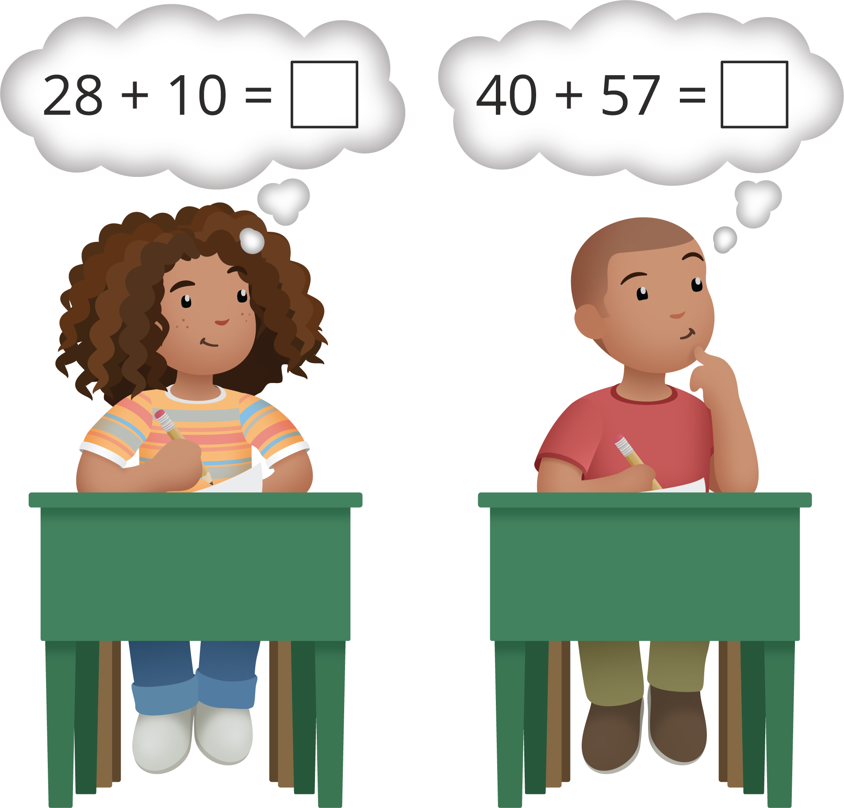

2 The Missing Digit

Student Task Statement
- This equation is true.
- 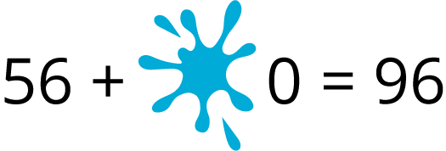
- What digit is under the smudge?
Show your thinking using drawings, numbers, or words.
- This equation is not true.
- Show why it is not true using drawings, numbers, or words.
© CC BY 2021 Illustrative Mathematics®

