Lesson 14: Write and Solve Equations with Unknowns
- Let’s work with equations with unknown numbers.

Warm-up: Number Talk: Fives
Find the value of each expression mentally.
- $1×5$
- $2×5$
- $3×5$
- $4×5$

14.1: Card Sort: Unknown Numbers
Your teacher will give you a set of cards. Match each equation with a situation or diagram.
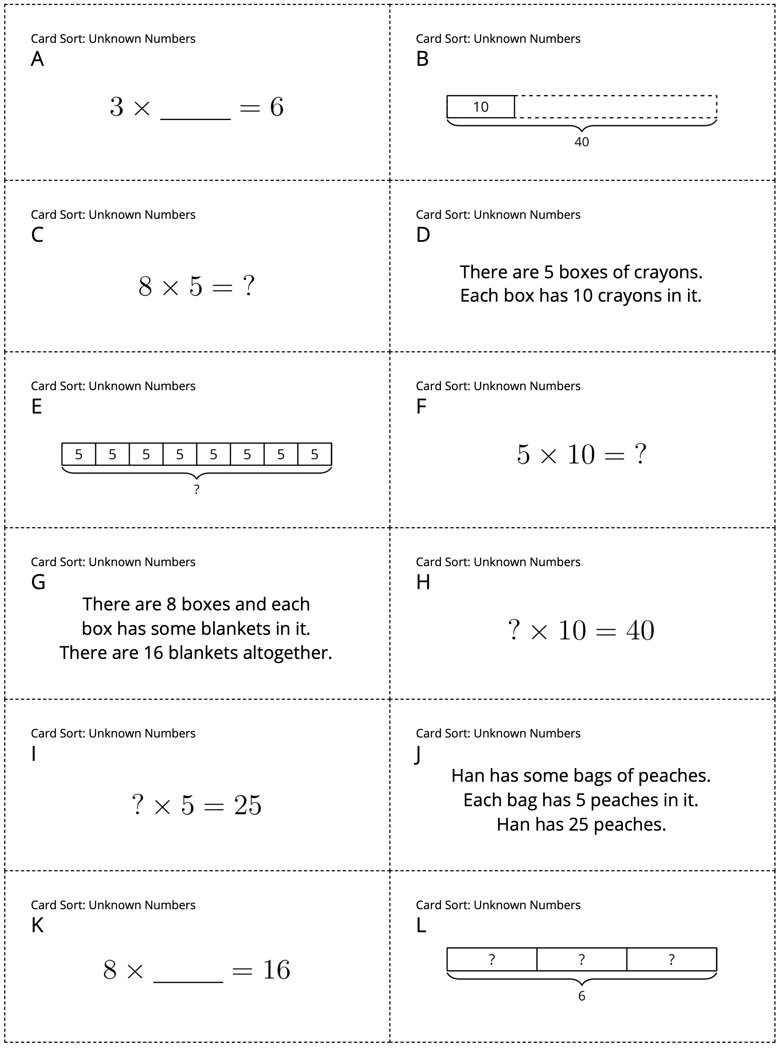

14.2: Write Equations with an Unknown Number
- Write an equation to represent each diagram or situation. Use a symbol for the unknown. Be prepared to share your reasoning.
- Find the number that makes each equation true. Rewrite the equation with the solution.
diagram or situation | equation with symbol | equation with solution
Jada has some packs of sports cards. Each pack has 5 cards. If Jada has 45 cards, how many packs of cards does she have?
The school has 6 bags. Each bag has 10 basketballs in it. How many basketballs does the school have?
© CC BY 2021 Illustrative Mathematics®

