Unit 6 Lesson 4: Numerical Patterns

WU Which One Doesn’t Belong: Stacked Squares (Warm up)

Student Task Statement
Which one doesn’t belong?
A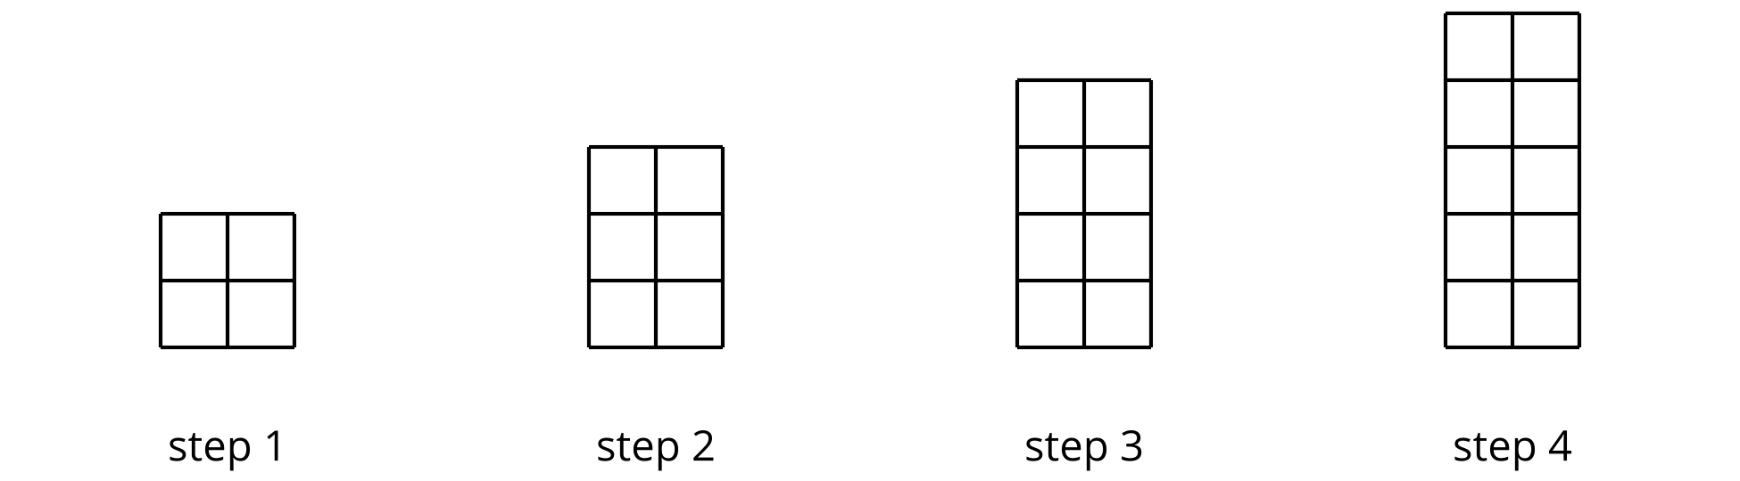
B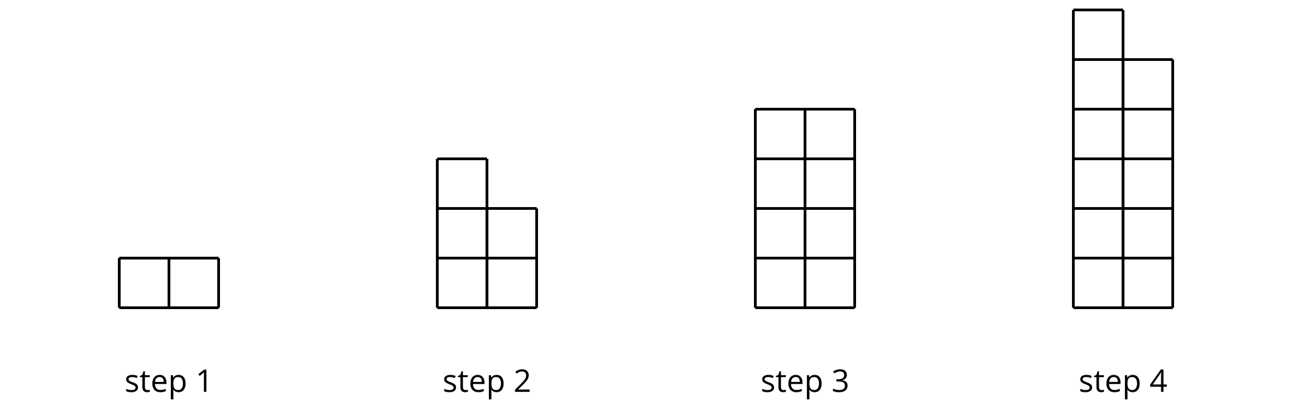
C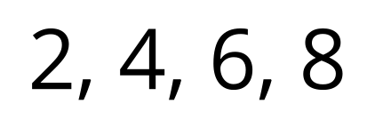
D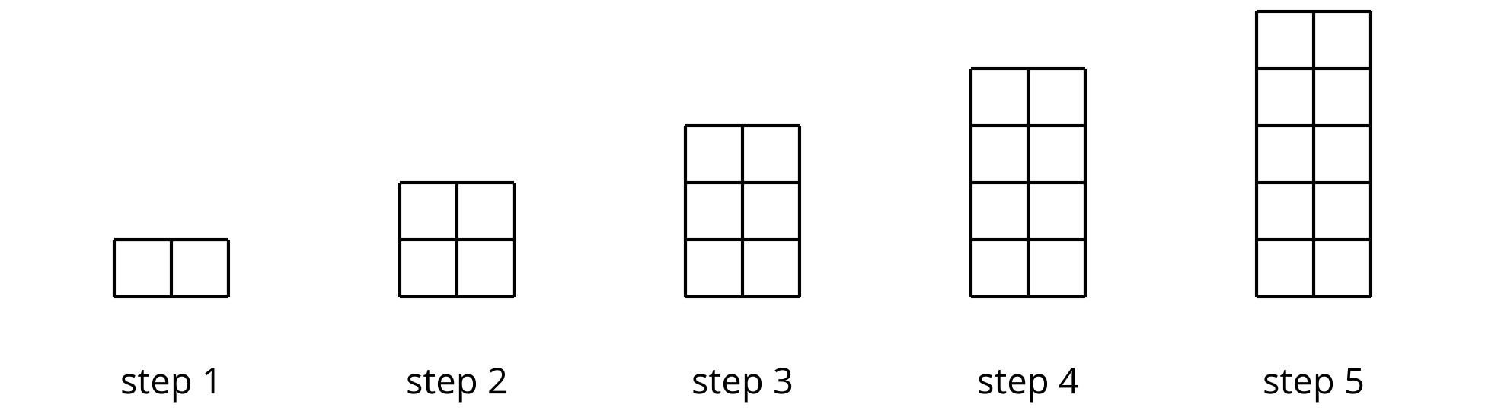

1 Count by 10 and by 9

Student Task Statement
Andre’s class is choral counting by 10 and then by 9. The left column shows the numbers they say when counting by 10.
- Complete the right column with the first ten numbers the class will say when counting by 9.
- What patterns do you notice about the features of the numerical patterns? Make at least two observations about each list of numbers.
- counting by 10 | - counting by 9
- 10
- 20
- 30
- 40
- 50
- 60
- 70
- 80
- 90
- 100
- For the numbers in the “counting by 10” column, why do you think:
  - the digits in the tens place change the way they do?
  - the digits in the ones place are the way they are?
- For the numbers in the “counting by 9” column, why do you think the digits in the ones place change the way they do? Explain your reasoning.

2 Count by 99

Student Task Statement
Andre’s class did a choral count by 99. Here are the first six numbers they said.
- Study the list of numbers. Make at least 3 observations about features of the pattern.
- counting by 99
- 99
- 198
- 297
- 396
- 495
- 594
- Extend the list with the next four multiples of 99. Be prepared to discuss how you know what numbers to write.
- Why do you think the digits in the numbers change the way they do?
- 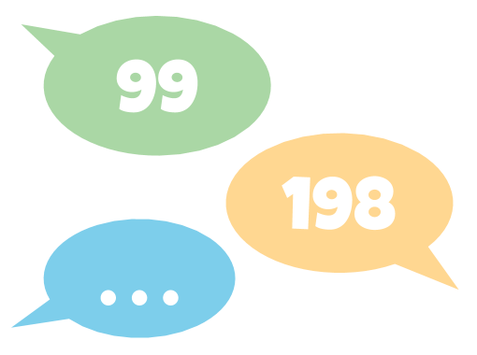

3 Count by 15 (Optional)

Student Task Statement
Elena counted by 15 and recorded the numbers she counted:
15 | 30 | 45 | 60 | 75 | 90

- Write the next four numbers she’d record if she kept going.
- What patterns do you see? Describe as many as you can.
- Choose one pattern that you noticed and explain why you think it happens.
- Could 250 be a number that Elena calls out if she continued to count by 15? Explain or show your reasoning.
© CC BY 2021 Illustrative Mathematics®

