## Unit 5 Lesson 27: Gone In 30 Seconds

### 1 Measuring 30 Seconds (Optional)

#### Student Task Statement

In this activity, you’ll get two chances to guess at how long 30 seconds is, then look for an association between the two guesses of all students.

1. Work with a partner. Follow the instructions listed here to gather your data.
   * One of you will hold a stopwatch where the other person cannot see it.
   * The person holding the stopwatch says “go” and starts the timer.
   * The other person says “stop” when they think 30 seconds have passed.
   * The person holding the stopwatch will stop the timer, then report and record the time to the nearest second.
   * The person holding the stopwatch will give a second chance, repeating the experiment.
   * After *both* times are recorded, switch roles.
2. Record the group data in this table. When you finish, a group member should give the data to the teacher.

|  |  |  |
| --- | --- | --- |
| * name | * time 1 | * time 2 |
|  |  |  |
|  |  |  |
|  |  |  |
|  |  |  |

1. Look at your data. Comparing Time 1 to Time 2, do you think there is a positive association, a negative association, or no association? Discuss your thinking with your group.
2. What are some ways you could organize and represent the entire class's data?
3. Make a scatter plot of the entire class’s data and look for patterns. Identify any outliers and the type of any association you observe.

* 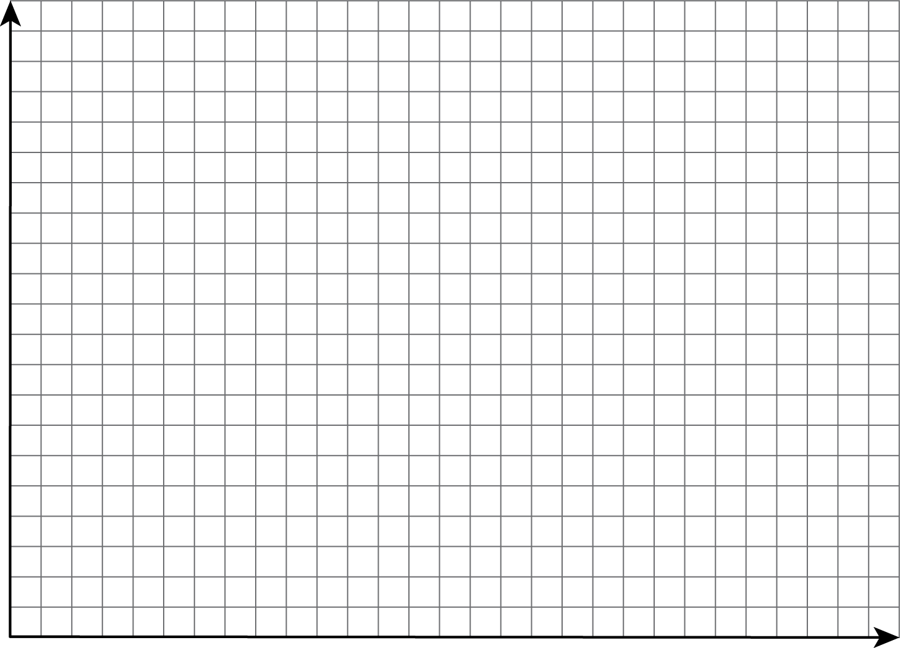

1. Draw two lines on your scatter plot: a vertical line and a horizontal line, each representing 30 seconds for one trial. Use the table for the class’s data to complete this two-way table.

|  |  |  |  |  |
| --- | --- | --- | --- | --- |
|  | * time 2 < 30 sec | * time 2 = 30 sec | * time 2 > 30 sec | * total |
| * time 1 < 30 sec |  |  |  |  |
| * time 1 = 30 sec |  |  |  |  |
| * time 1 > 30 sec |  |  |  |  |
| * total |  |  |  |  |

1. Use the two-way table to decide whether there is an association between Time 1 and Time 2. Explain how you know.



© CC BY Open Up Resources. Adaptations CC BY IM.