Unit 8 Lesson 1 Cumulative Practice Problems
- Find the area of each square. Each grid square represents 1 square unit.
- 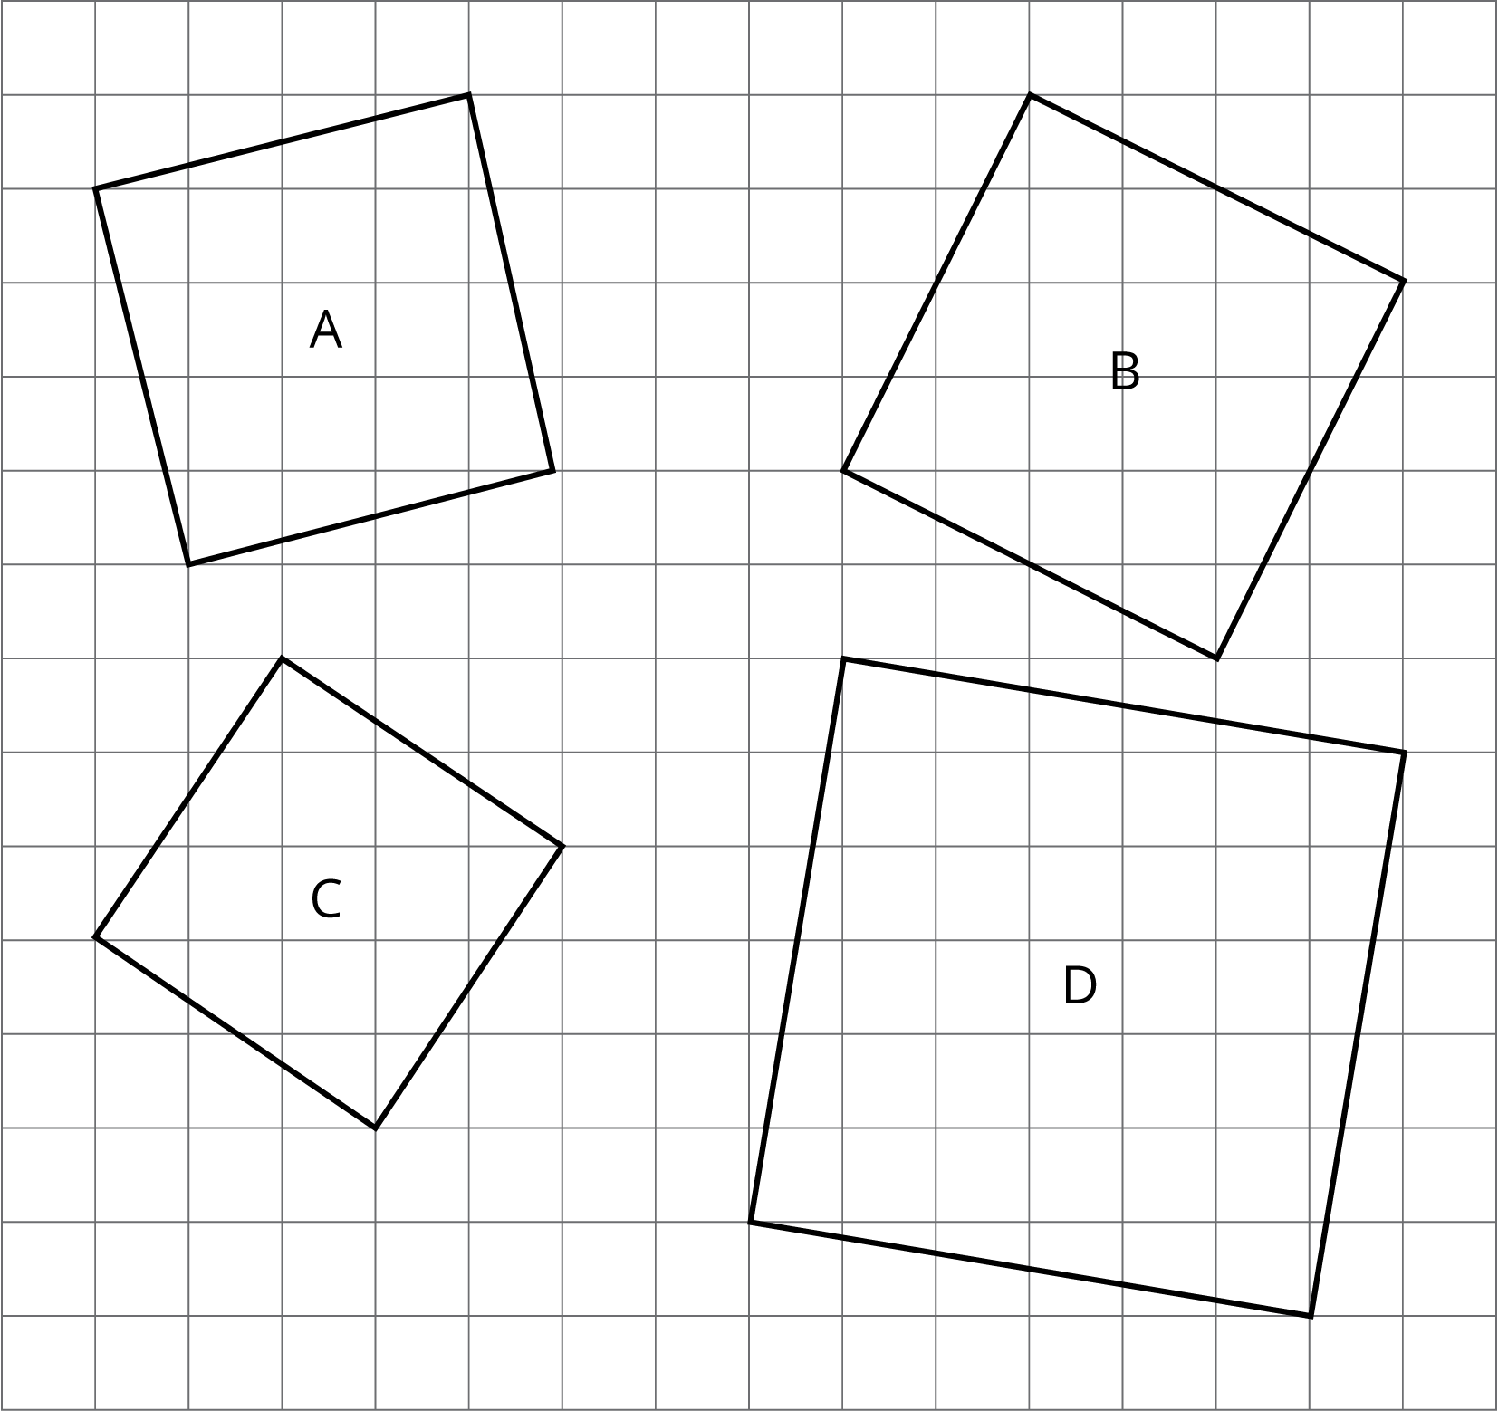

- Find the length of a side of a square if its area is:
  - 81 square inches
  - $\frac{4}{25}$ cm²
  - 0.49 square units
  - $m^{2}$ square units
- Find the area of a square if its side length is:
  - 3 inches
  - 7 units
  - 100 cm
  - 40 inches
  - $x$ units
- Evaluate $(3.1×{10}^{4})⋅(2×{10}^{6})$. Choose the correct answer:
  - $5.1×{10}^{10}$
  - $5.1×{10}^{24}$
  - $6.2×{10}^{10}$
  - $6.2×{10}^{24}$
- (From Unit 7, Lesson 14.)
- Noah reads the problem, “Evaluate each expression, giving the answer in scientific notation.” The first problem part is: $5.4×{10}^{5}+2.3×{10}^{4}$.
- Noah says, “I can rewrite $5.4×{10}^{5}$ as $54×{10}^{4}$. Now I can add the numbers: $54×{10}^{4}+2.3×{10}^{4}=57.3×{10}^{4}$.”
- Do you agree with Noah’s solution to the problem? Explain your reasoning.
- (From Unit 7, Lesson 15.)
- Select all the expressions that are equivalent to $3^{8}$.
  - $(3^{2})^{4}$
  - $8^{3}$
  - $3⋅3⋅3⋅3⋅3⋅3⋅3⋅3$
  - $(3^{4})^{2}$
  - $\frac{3^{6}}{3^{\text{-}2}}$
  - $3^{6}⋅{10}^{2}$
- (From Unit 7, Lesson 6.)
© CC BY Open Up Resources. Adaptations CC BY IM.

