Lesson 17 Practice Problems
- One thousand baseball fans were asked how far they would be willing to travel to watch a professional baseball game. From this population, 100 different samples of size 40 were selected. Here is a dot plot showing the mean of each sample.
- 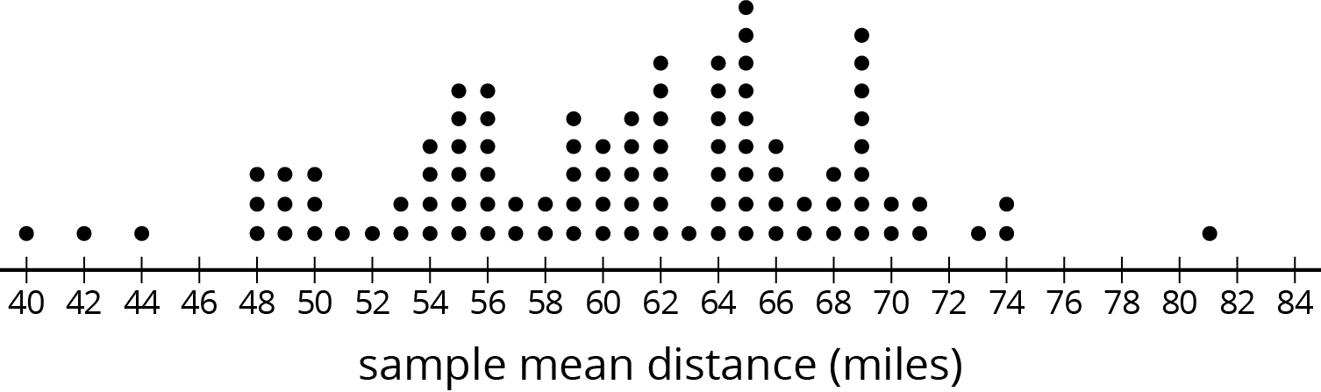
- Based on the distribution of sample means, what do you think is a reasonable estimate for the mean of the population?
- Last night, everyone at the school music concert wrote their age on a slip of paper and placed it in a box. Today, each of the students in a math class selected a random sample of size 10 from the box of papers. Here is a dot plot showing their sample means, rounded to the nearest year.
- 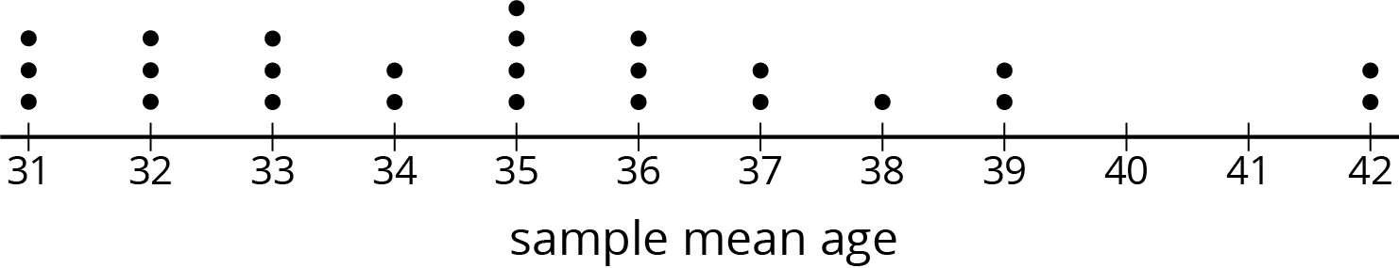
  - Does the number of dots on the dot plot tell you how many people were at the concert or how many students are in the math class?
  - The mean age for the population was 35 years. If Elena picks a new sample of size 10 from this population, should she expect her sample mean to be within 1 year of the population mean? Explain your reasoning.
  - What could Elena do to select a random sample that is more likely to have a sample mean within 1 year of the population mean?
- A random sample of people were asked which hand they prefer to write with. “l” means they prefer to use their left hand, and “r” means they prefer to use their right hand. Here are the results:
- l | - r | - r | - r | - r | - r | - r | - r
- r | - r | - l | - r | - r | - r | - r

- Based on this sample, estimate the proportion of the population that prefers to write with their left hand.
- (From Unit 8, Lesson 16.)
- Andre would like to estimate the mean number of books the students at his school read over the summer break. He has a list of the names of all the students at the school, but he doesn’t have time to ask every student how many books they read.
- What should Andre do to estimate the mean number of books?
- (From Unit 8, Lesson 15.)
- A hockey team has a 75% chance of winning against the opposing team in each game of a playoff series. To win the series, the team must be the first to win 4 games.
  - Design a simulation for this event.
  - What counts as a successful outcome in your simulation?
  - Estimate the probability using your simulation.
- (From Unit 8, Lesson 10.)
© CC BY Open Up Resources. Adaptations CC BY IM.

