Unit 8 Lesson 10 Cumulative Practice Problems
- On school days, Kiran walks to school. Here are the lengths of time, in minutes, for Kiran’s walks on 5 school days:
- 16 | - 11 | - 18 | - 12 | - 13

  - Create a dot plot for Kiran’s data.
  - Without calculating, decide if 15 minutes would be a good estimate of the mean. If you think it is a good estimate, explain your reasoning. If not, give a better estimate and explain your reasoning.
  - Calculate the mean for Kiran’s data.
  - In the table, record the distance of each data point from the mean and its location relative to the mean.
- time in minutes | - distance from the mean | - left or right of the mean?
  - 16
  - 11
  - 18
  - 12
  - 13
  - Calculate the sum of all distances to the left of the mean, then calculate the sum of distances to the right of the mean. Explain how these sums show that the mean is a balance point for the values in the data set.
- Noah scored 20 points in a game. Mai's score was 30 points. The mean score for Noah, Mai, and Clare was 40 points. What was Clare's score? Explain or show your reasoning.
- Compare the numbers using >, <, or =.
  - $\text{-}2$ _____ $3$
  - $|\text{-}12|$ _____ $|15|$
  - $3$ _____ $\text{-}4$
  - $|15|$ _____ $|\text{-}12|$
  - $7$ _____ $\text{-}11$
  - $\text{-}4$ _____ $|5|$
- (From Unit 7, Lesson 7.)
  - Plot $\frac{2}{3}$ and $\frac{3}{4}$ on a number line.
  - Is $\frac{2}{3}<\frac{3}{4}$, or is $\frac{3}{4}<\frac{2}{3}$? Explain how you know.
- (From Unit 7, Lesson 3.)
- Select all the expressions that represent the total area of the large rectangle.
- 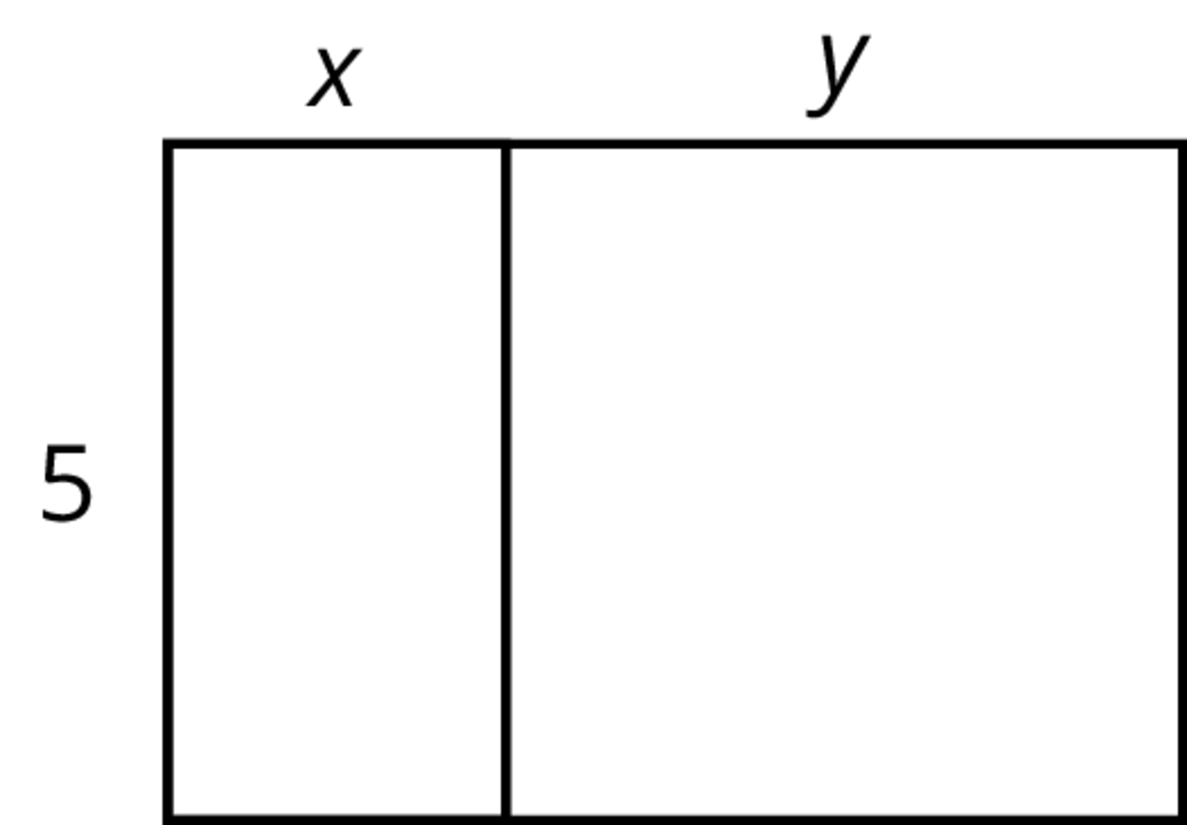
  - $5(x+y)$
  - $5+xy$
  - $5x+5y$
  - $2(5+x+y)$
  - $5xy$
- (From Unit 6, Lesson 10.)
© CC BY Open Up Resources. Adaptations CC BY IM.

