Lesson 8: ¿Todas las partes son creadas iguales?

Standards Alignments
Addressing | 2.G.A.3, 2.NBT.A.2

Teacher-facing Learning Goals
- Partition circles and rectangles into halves, thirds, and fourths in different ways.
- Recognize halves, thirds, and fourths of rectangles and circles.

Student-facing Learning Goals
- Hagamos medios, tercios y cuartos de distintas formas.

Lesson Purpose
The purpose of this lesson is for students to understand that equal pieces of an identical whole do not need to be the same shape.
In previous lessons, students learned that when they partition circles and rectangles into halves, thirds, or fourths, each piece must be equal. To this point, they have determined whether the pieces are equal by cutting out pieces and physically matching them and by visually inspecting whether the pieces appear to be the same equal-size shape.
In this lesson, students learn that halves, thirds, and fourths of the same whole can be different shapes or have different attributes. For example, they recognize that a square is partitioned into fourths, whether it is partitioned into equal-size triangles or equal-size squares.
A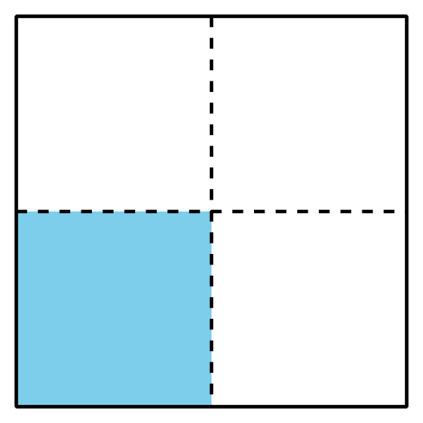
B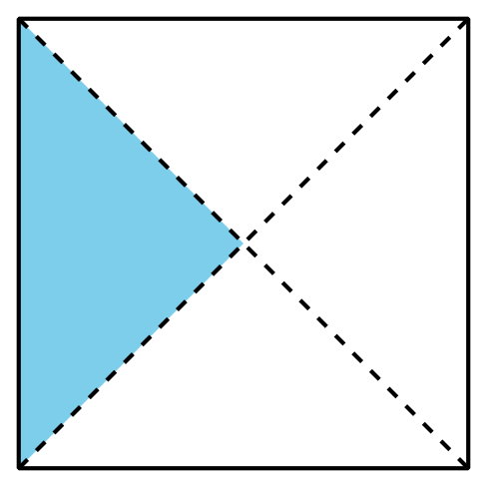
By the end of the lesson, students realize that as long as the shapes are partitioned into the same number of equal pieces, the pieces will have the same name and have the same size.

Access for:

Students with Disabilities
- Representation (Activity 2)

English Learners
- MLR2 (Activity 1)

Instructional Routines
Number Talk (Warm-up)

Lesson Timeline
Warm-up | 10 min
Activity 1 | 20 min
Activity 2 | 15 min
Lesson Synthesis | 10 min
Cool-down | 5 min

Teacher Reflection Question
What did you say, do, or ask during the lesson synthesis that helped students be clear on the learning of the day? How did previewing the cool-down of the lesson before you started teaching today allow you to help students synthesize their learning?

Cool-down
(to be completed at the end of the lesson) 5min
Pinta una imagen

Standards Alignments
Addressing | 2.G.A.3

Student-facing Task Statement
Andre y Noah tenían cada uno una hoja de papel del mismo tamaño.
Cada uno pintó una parte de su papel.
Andre:
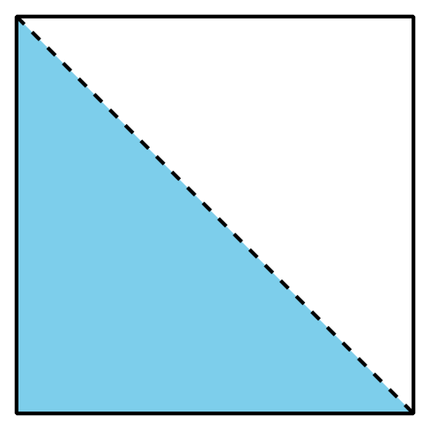
​​​​​​
Noah:
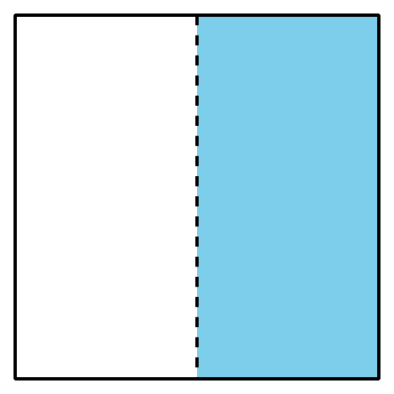
Andre dice que él pintó más que Noah. ¿Estás de acuerdo? Explica.

Student Responses
Sample response: No. Andre and Noah painted the same amount. They both painted a half of the page because each page is split into 2 equal parts and the pages are the same size.

