Lesson 20: Products in the Hundredths Place
- Let’s multiply tenths by tenths.

Warm-up: What do you know about $1×0.1$ and $0.1×0.1$?
What do you know about these expressions?
- $1×0.1$
- $0.1×0.1$

20.1: Products of Tenths
- Find the value of each expression. Explain or show your reasoning. Use the grids if they are helpful.
  - $2×0.3$
  - 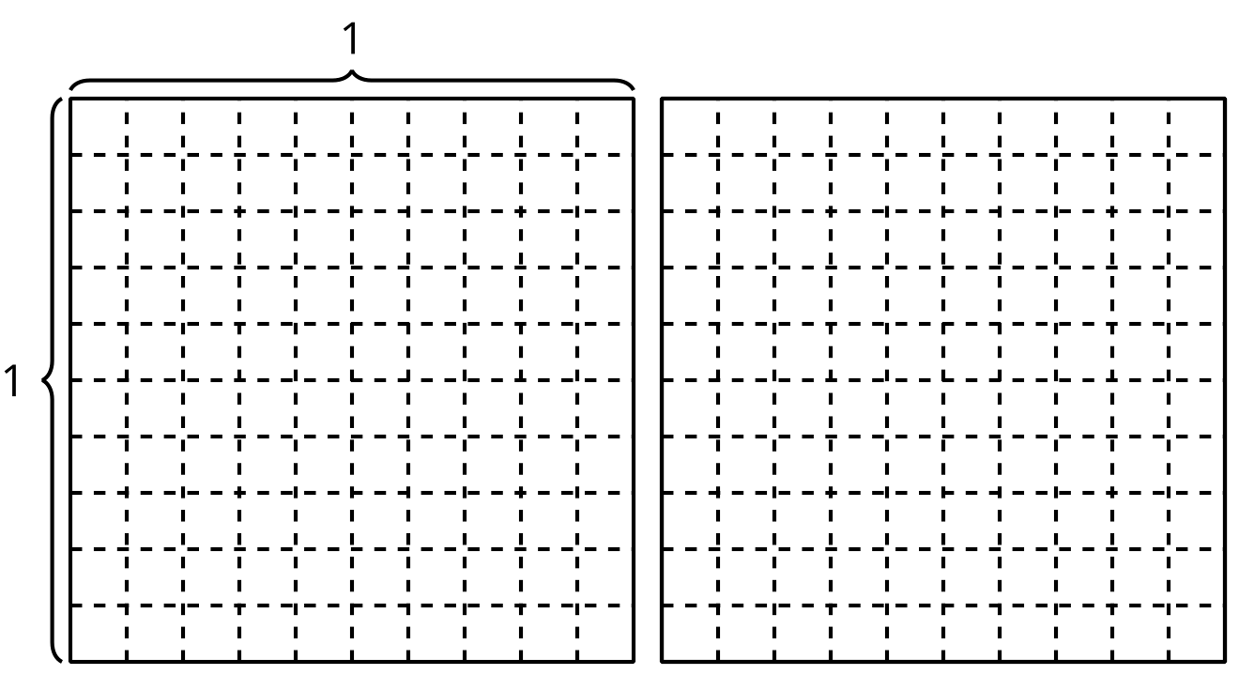
  - $0.2×0.3$
- Kiran says $0.2×0.4=0.8$. Do you agree with Kiran? Explain or show your reasoning.

20.2: Multiply Tenths
- Find the value of each expression. Explain or show your reasoning.
  - $1.8×0.4$
  - $2.5×0.6$
  - $3.8×0.7$
- How are these products the same? How are they different?
  - $74×6$
  - $7.4×6$
  - $7.4×0.6$
© CC BY 2021 Illustrative Mathematics®

