Lesson 18: Represent Arrays with Expressions
- Let’s represent situations with arrays and expressions.

Warm-up: How Many Do You See: An Array of Shapes
How many do you see? How do you see them?
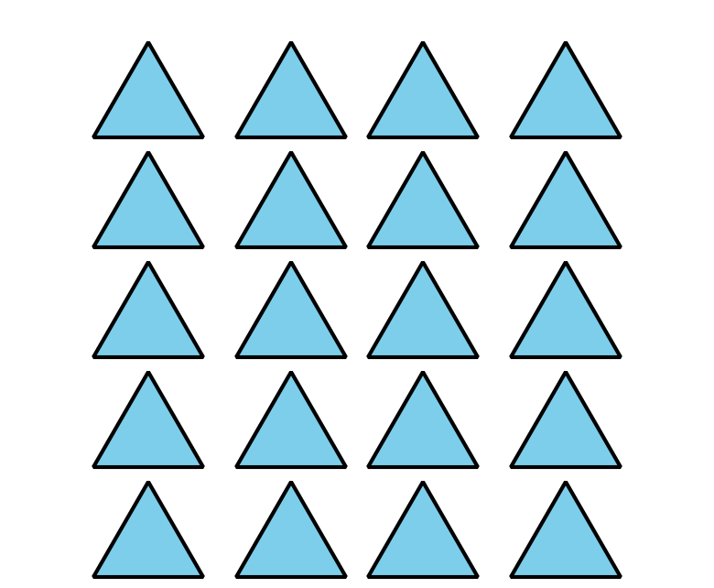

18.1: Represent Array Situations
Use objects or drawings to represent each situation with an array.
- There are 3 rows of chairs. Each row has 5 chairs.
- There are 4 rows of cars. Each row has 5 cars in it.
- There are 2 rows of eggs. Each row has 6 eggs.
- There are 2 teams of students lined up. Each team has 10 students.
Write a multiplication expression to represent each situation.

18.2: Connect Arrays to Expressions
Draw an array for each multiplication expression. Be prepared to share your reasoning.
- $2×3$
- $5×2$
- $4×4$
© CC BY 2021 Illustrative Mathematics®

