Lesson 3: More Movement
- Let’s translate graphs vertically and horizontally to match situations.

3.1: Moving a Graph
How can we translate the graph of $A$ to match one of the other graphs?
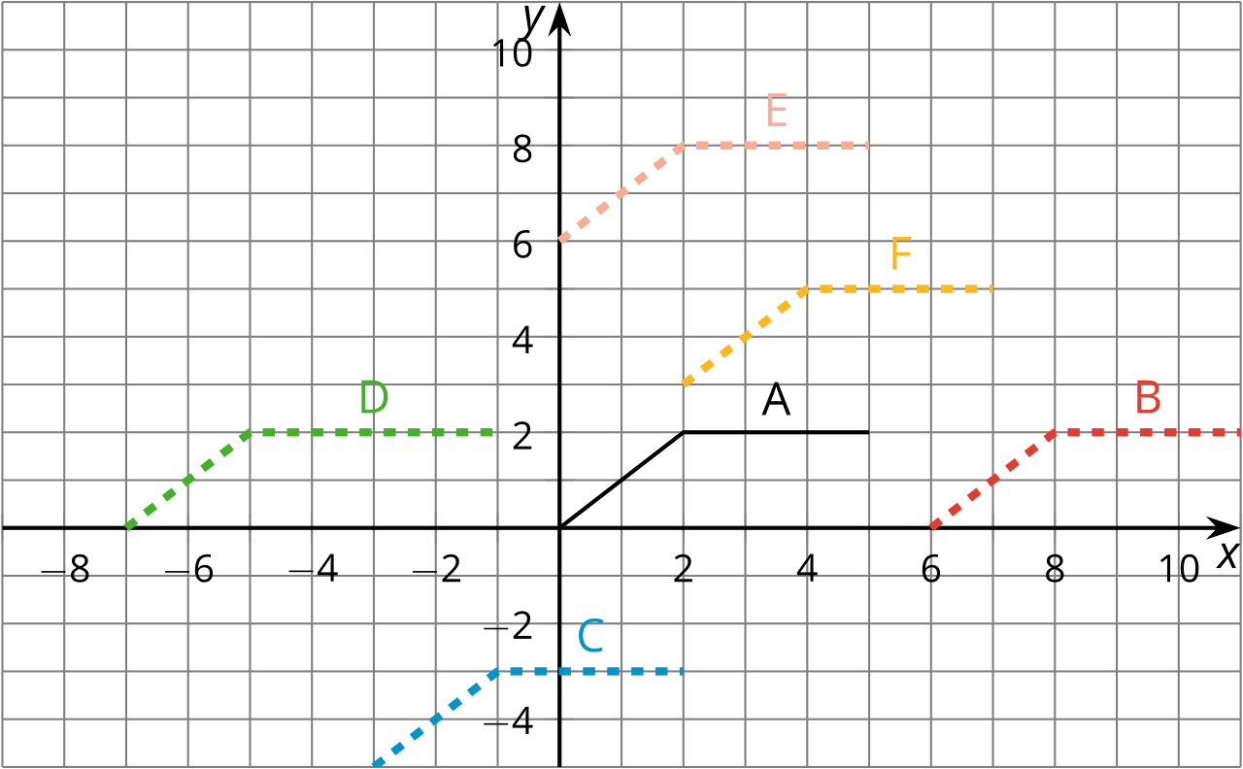

3.2: New Hours for the Kitchen
Remember the bakery with the thermostat set to ${65}^{∘}\text{F}$? At 5:00 a.m., the temperature in the kitchen rises to ${85}^{∘}\text{F}$ due to the ovens and other kitchen equipment being used until they are turned off at 10:00 a.m. When the owner decided to open 2 hours earlier, the baking schedule changed to match.
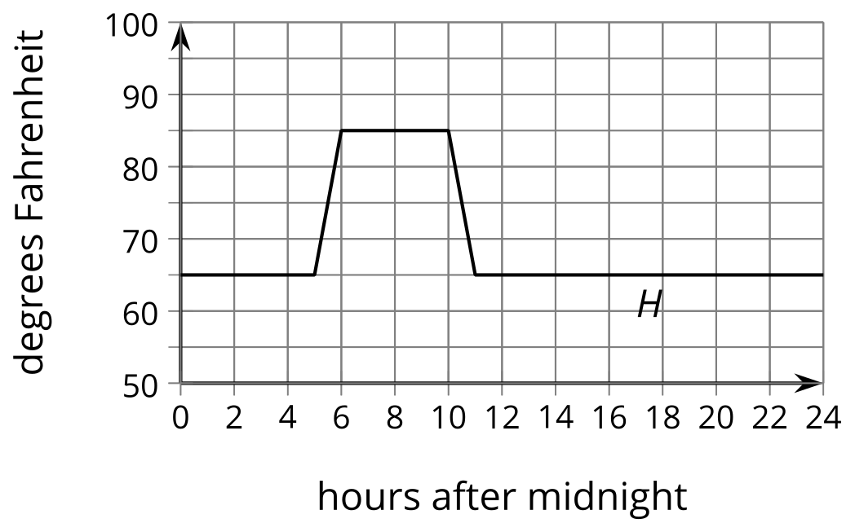
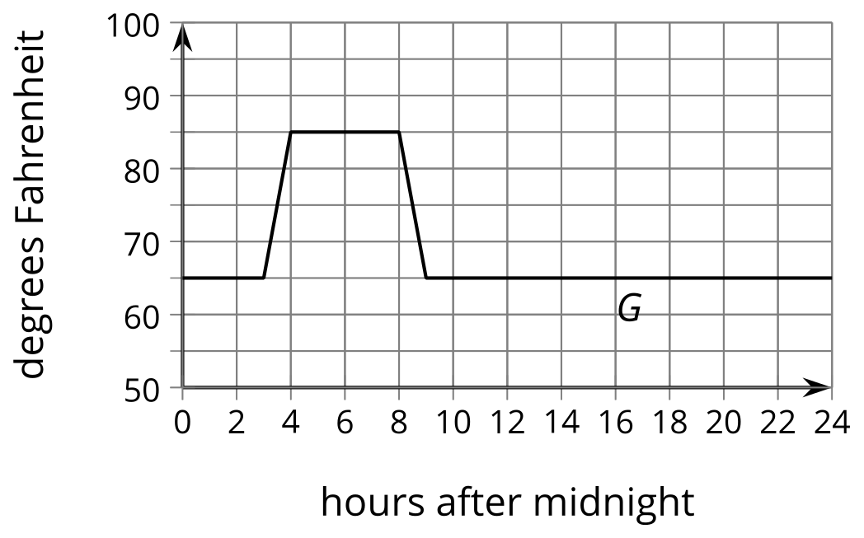
- Andre thinks, “When the bakery starts baking 2 hours earlier, that means I need to subtract 2 from $x$ and that $G\left(x\right)=H\left(x−2\right)$.” How could you help Andre understand the error in his thinking?
- The graph of $F$ shows the temperatures after a change to the thermostat settings. What did the owner do?
- 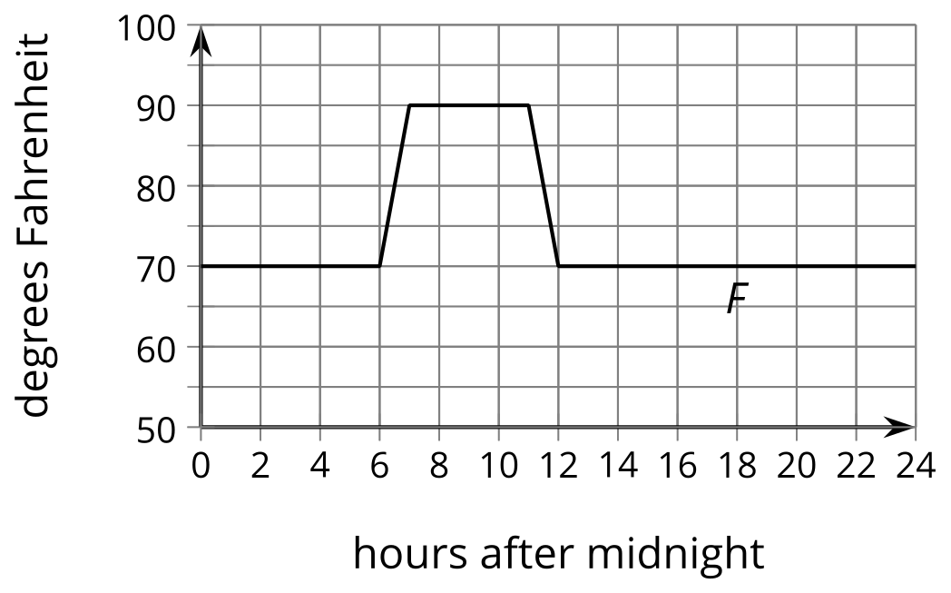
- Write an expression for $F$ in terms of the original baking schedule, $H$.

3.3: Thawing Meat
A piece of meat is taken out of the freezer to thaw. The data points show its temperature $M$, in degrees Fahrenheit, $t$ hours after it was taken out. The graph $M=G\left(t\right)$, where $G\left(t\right)=\text{-}62{\left(0.85\right)}^{t}$, models the shape of the data but is in the wrong position.
$t$ | $M$
0 | 13.1
0.41 | 22.9
1.84 | 29
2.37 | 36.1
2.95 | 36.8
3.53 | 38.8
3.74 | 40
4.17 | 42.2
4.92 | 45.8
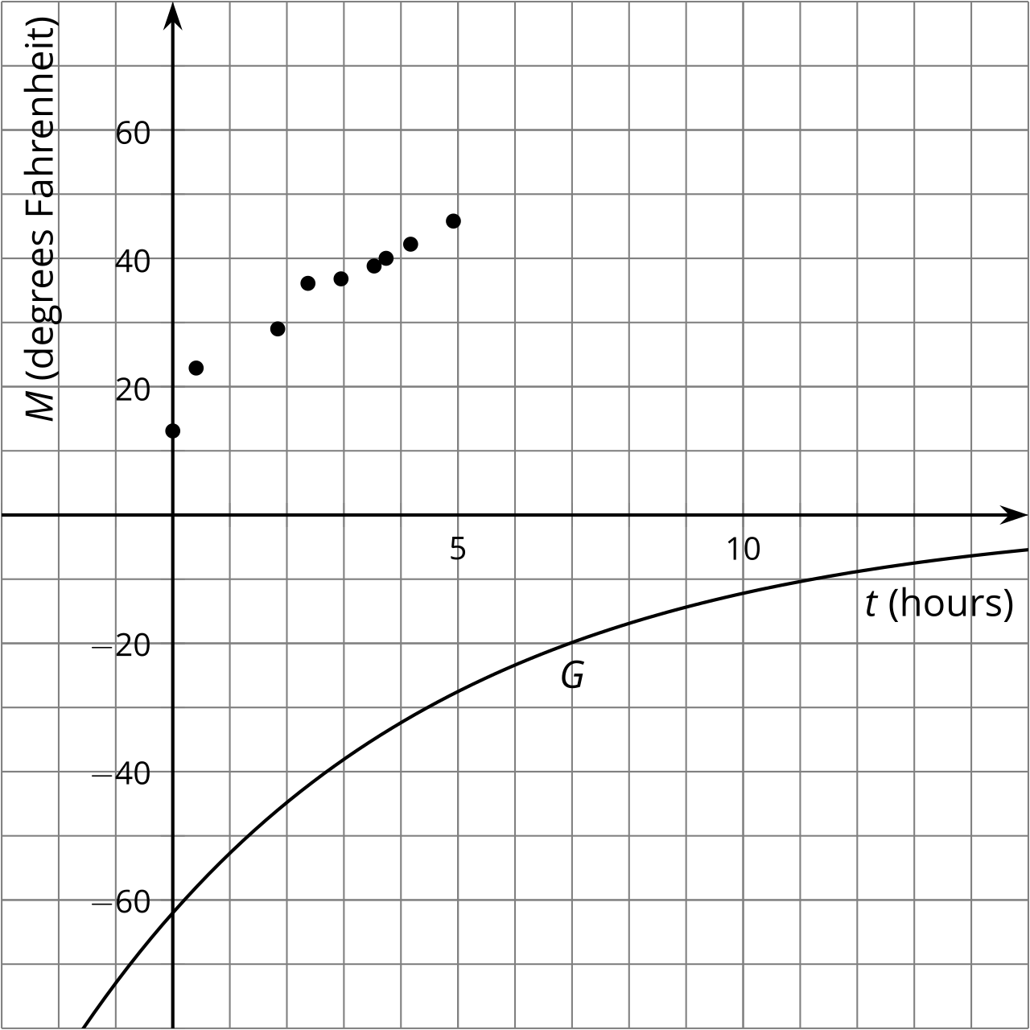
Jada thinks changing the equation to $J\left(t\right)=\text{-}62{\left(0.85\right)}^{t}+75.1$ makes a good model for the data. Noah thinks $N\left(t\right)=\text{-}62{\left(0.85\right)}^{\left(t+1\right)}+68$ is better.
- Without graphing, describe how Jada and Noah each transformed the graph of $G$ to make their new functions to fit the data.
- Use technology to graph the data, $J$ and $N$, on the same axes.
- Whose function do you think best fits the data? Be prepared to explain your reasoning.

Are you ready for more?
Elena excludes the first data point and chooses a linear model, $E\left(t\right)=21.32+5.06t$, to fit the remaining data.
- How well does Elena’s model fit the data?
- Is Elena’s idea to exclude the first data point a good one? Explain your reasoning.

Lesson 3 Summary
Remember the pumpkin catapult? The function $h$ gives the height $h\left(t\right)$, in feet, of the pumpkin above the ground $t$ seconds after launch. Now suppose $k$ represents the height $k\left(t\right)$, in feet, of the pumpkin if it were launched 5 seconds later. If we graph $k$ and $h$ on the same axes they looks identical, but the graph of $k$ is translated 5 units to the right of the graph of $g$.
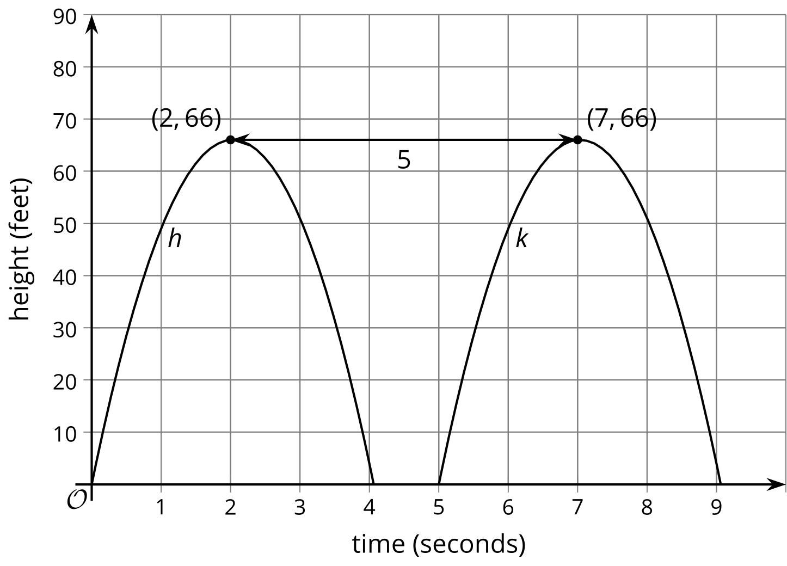
Since we know the pumpkin's height $k\left(t\right)$ at time $t$ is the same as the height $h\left(t\right)$ of the original pumpkin at time $t−5$, we can write $k$ in terms of $h$ as $k\left(t\right)=h\left(t−5\right)$.
Suppose there was a third function, $j$, where $j\left(t\right)=h\left(t+4\right)$. Even without graphing $j$, we know that the graph reaches a maximum height of 66 feet. To evaluate $j\left(t\right)$ we evaluate $h$ at the input $t+4$, which is zero when $t=\text{-}4$. So the graph of $j$ is translated 4 seconds to the left of the graph of $h$. This means that $j\left(t\right)$ is the height, in feet, of a pumpkin launched from the catapult 4 seconds earlier.
© CC BY 2019 by Illustrative Mathematics®

