Unit 1 Lesson 2: Data Representations

1 Notice and Wonder: Battery Life (Warm up)

Student Task Statement
The dot plot, histogram, and box plot summarize the hours of battery life for 26 cell phones constantly streaming video. What do you notice? What do you wonder?
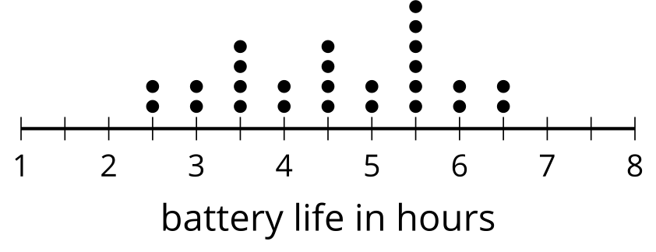
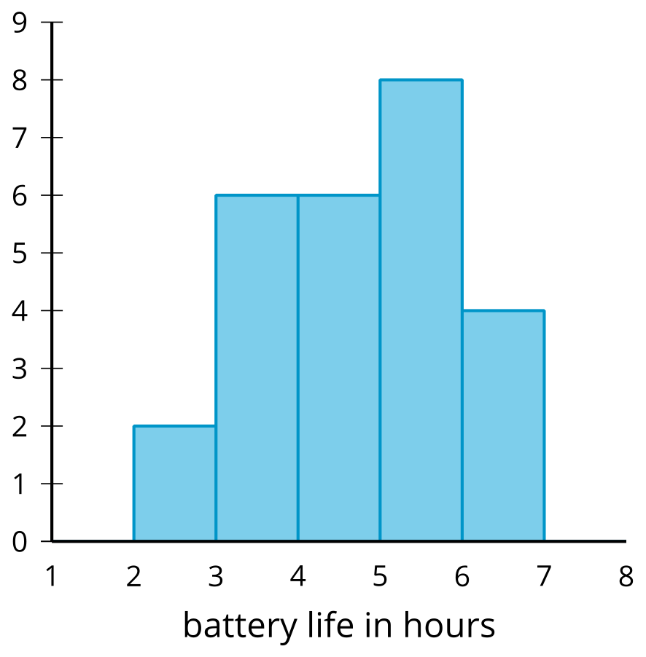
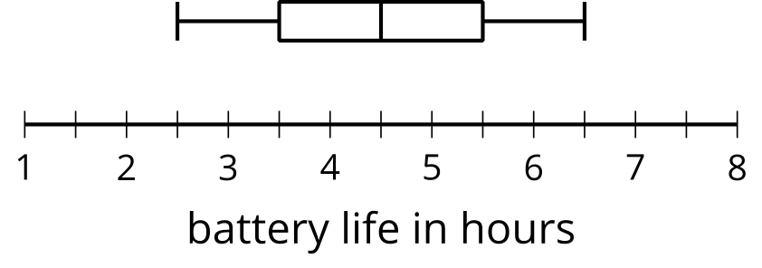

2 Tomato Plants: Histogram (Optional)

Student Task Statement
A histogram can be used to represent the distribution of numerical data.
- The data represent the number of days it takes for different tomato plants to produce tomatoes. Use the information to complete the frequency table.
- 47 | - 52 | - 53 | - 55 | - 57 | - 60 | - 61 | - 62
- 63 | - 65 | - 65 | - 65 | - 65 | - 68 | - 70 | - 72
- 72 | - 75 | - 75 | - 75 | - 76 | - 77 | - 78 | - 80
- 81 | - 82 | - 85 | - 88 | - 89 | - 90

- days to produce fruit | - frequency
- 40–50
- 50–60
- 60–70
- 70–80
- 80–90
- 90–100
- Use the set of axes and the information in your table to create a histogram.
- 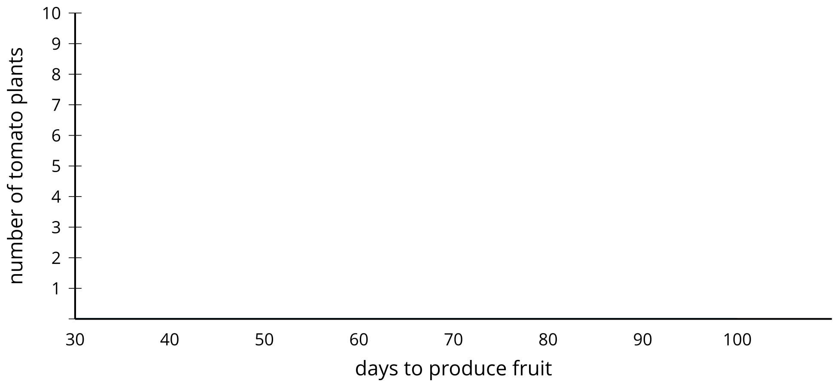
- The histogram you created has intervals of width 10 (like 40–50 and 50–60). Use the set of axes and data to create another histogram with an interval of width 5. How does this histogram differ from the other one?
- 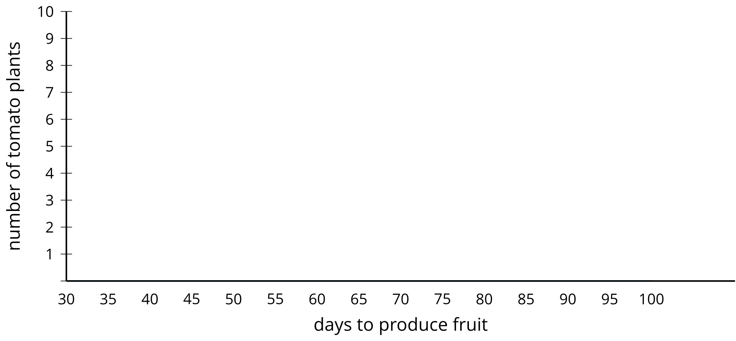

3 Tomato Plants: Box Plot (Optional)

Student Task Statement
A box plot can also be used to represent the distribution of numerical data.
minimum | Q1 | median | Q3 | maximum
- Using the same data as the previous activity for tomato plants, find the median and add it to the table. What does the median represent for these data?
- Find the median of the least 15 values to split the data into the first and second quarters. This value is called the first quartile. Add this value to the table under Q1. What does this value mean in this situation?
- Find the value (the third quartile) that splits the data into the third and fourth quarters and add it to the table under Q3. Add the minimum and maximum values to the table.
- Use the five-number summary to create a box plot that represents the number of days it takes for these tomato plants to produce tomatoes.
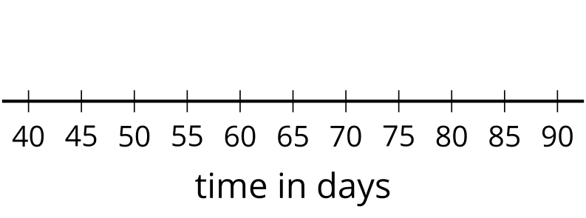
© CC BY 2019 by Illustrative Mathematics®

