Unit 2 Lesson 16: Solving Systems by Elimination (Part 3)

1 Multiplying Equations By a Number (Warm up)

Student Task Statement
Consider two equations in a system:
$\left\{\begin{matrix}\begin{matrix}4x+ y & = 1 & & \text{Equation A} \\ x+2y & = 9 & & \text{Equation B}\end{matrix}\end{matrix}\right.$
- Use graphing technology to graph the equations. Then, identify the coordinates of the solution.
- Write a few equations that are equivalent to equation A by multiplying both sides of it by the same number, for example, 2, -5, or $\frac{1}{2}$. Let’s call the resulting equations A1, A2, and A3. Record your equations here:
  - Equation A1:
  - Equation A2:
  - Equation A3:
- Graph the equations you generated. Make a couple of observations about the graphs.

2 Writing a New System to Solve a Given System

Student Task Statement
Here is a system you solved by graphing earlier.​​​​​​
$\left\{\begin{matrix}\begin{matrix}4x+ y & = 1 & & \text{Equation A} \\ x+2y & = 9 & & \text{Equation B}\end{matrix}\end{matrix}\right.$
To start solving the system, Elena wrote:
$\begin{matrix}4x+ y & = 1 \\ 4x+8y & =36\end{matrix}$
And then she wrote:
$\begin{matrix}4x+ y & = 1 \\ 4x+8y & = 36 − \\ \overset{¯}{ \text{-}7y} & \overset{¯}{ =\text{-}35 }\end{matrix}$
- What were Elena's first two moves? What might be possible reasons for those moves?
- Complete the solving process algebraically. Show that the solution is indeed $x=\text{-}1,y=5$.

Activity Synthesis
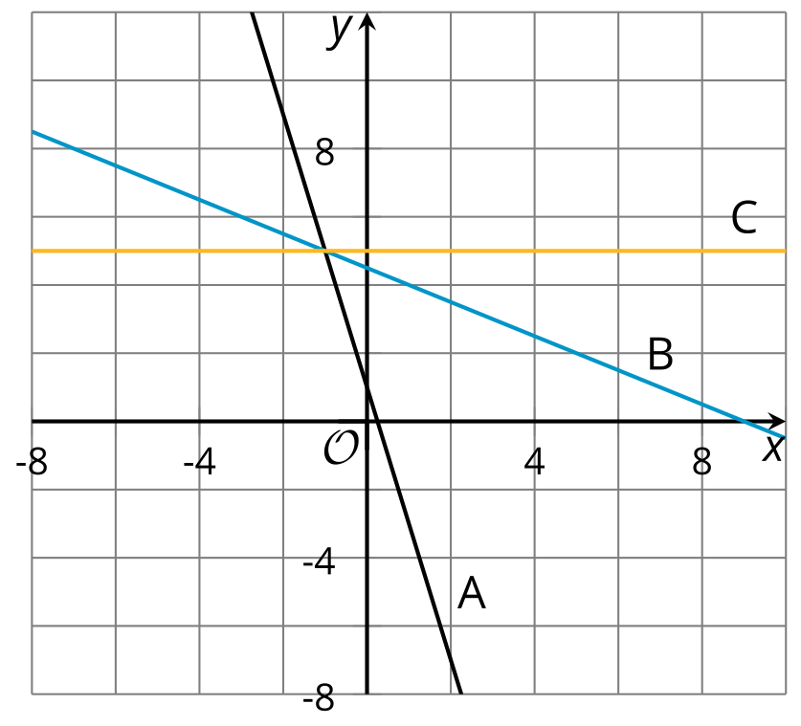

3 What Comes Next?

Student Task Statement
Your teacher will give you some slips of paper with systems of equations written on them. Each system represents a step in solving this system:
$\left\{\begin{matrix}\frac{4}{5}x+6y=15 \\ \text{-}x+18y=11\end{matrix}\right.$
Arrange the slips in the order that would lead to a solution. Be prepared to:
- Describe what move takes one system to the next system.
- Explain why each system is equivalent to the one before it.

4 Build Some Equivalent Systems (Optional)

Student Task Statement
Here is a system of equations:
$\left\{\begin{matrix}\begin{matrix}12a+5b & =\text{-}15 \\ 8a+ b & = 11\end{matrix}\end{matrix}\right.$
- To solve this system, Diego wrote these equivalent systems for his first two steps.
- Step 1:
- $\left\{\begin{matrix}\begin{matrix}12a+ 5b & =\text{-}15 \\ \text{-}40a+\text{-}5b & =\text{-}55\end{matrix}\end{matrix}\right.$
- Step 2:
- $\left\{\begin{matrix}\begin{matrix}12a+5b & =\text{-}15 \\ \text{-}28a & =\text{-}70\end{matrix}\end{matrix}\right.$
- Describe the move that Diego made to get each equivalent system. Be prepared to explain how you know the systems in Step 1 and Step 2 have the same solution as the original system.
- Write another set of equivalent systems (different than Diego's first two steps) that will allow one variable to be eliminated and enable you to solve the original system. Be prepared to describe the moves you make to create each new system and to explain why each one has the same solution as the original system.
- Use your equivalent systems to solve the original system. Then, check your solution by substituting the pair of values into the original system.
© CC BY 2019 by Illustrative Mathematics®

