Lesson 12: Proofs about Quadrilaterals
- Let’s prove theorems about quadrilaterals and their diagonals.

12.1: Play with Parallelograms
- Make several parallelograms with your strips.
- Make several rectangles with your strips.

12.2: From Conjecture to Proof
Here are some conjectures:
- All rectangles are parallelograms.
- If a parallelogram has (at least) one right angle, then it is a rectangle.
- If a quadrilateral has 2 pairs of opposite sides that are congruent, then it is a parallelogram.
- If the diagonals of a quadrilateral both bisect each other, then the quadrilateral is a parallelogram.
- If the diagonals of a quadrilateral both bisect each other and they are perpendicular, then the quadrilateral is a rhombus.
- Pick one conjecture and use the strips to convince yourself it is true.
- Re-write the conjecture to identify the given information and the statement to prove.
- Draw a diagram of the situation. Mark the given information and any information you can figure out for sure.
- Write a rough draft of how you might prove your conjecture is true.

12.3: Checking a Proof
Exchange proofs with your partner. Read the rough draft of their proof. If it convinces you, write a detailed proof together following their plan. If it does not convince you, suggest changes that will make the proof convincing.

Are you ready for more?
Draw 2 circles (of different sizes) that intersect in 2 places. Label the centers $A$ and $B$ and the points of intersection $C$ and $D$. Prove that segment $AB$ must be perpendicular to segment $CD$.

Lesson 12 Summary
Why did we spend so much time learning about when triangles are congruent? Because we can decompose other shapes into triangles. By looking for triangles that must be congruent we can prove other shapes have many properties. For example we could learn more about these types of quadrilaterals:
- A parallelogram is a quadrilateral with both pairs of opposite sides parallel.
- A rectangle is a quadrilateral with 4 right angles.
- A rhombus is a quadrilateral with 4 congruent sides.
- A square is a quadrilateral with 4 right angles and 4 congruent sides.
- A kite is a quadrilateral which has 2 sides next to each other that are congruent and where the other 2 sides are also congruent.
Knowing how to decompose quadrilaterals into triangles using their diagonals lets us prove how the different quadrilaterals’ definitions lead to their diagonals having different properties. We can also look at whether arranging the diagonals to have certain properties gives us enough information to prove which type of quadrilateral must be formed. For example, we might conjecture that if one diagonal is the perpendicular bisector of the other, the figure is a kite. But how do we turn that into a statement that we can prove?
Here is a specific statement that shows what we mean by “one diagonal is the perpendicular bisector of the other” and “the figure is a kite.” In quadrilateral $ABCD$ with diagonals $AC$ and $BD$, the diagonals intersect at $P$. Segment $AP$ is congruent to segment $PC$, and $AC$ is perpendicular to $BD$. Prove that segment $AB$ is congruent to segment $BC$, and that segment $CD$ is congruent to segment $DA$. This specific statement lets us draw and label a diagram, which might give us some ideas about how to prove the statement is true.
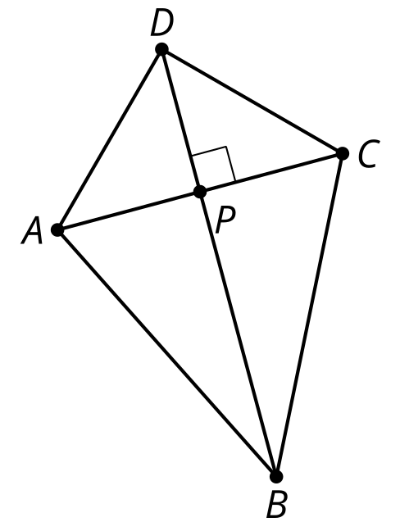
© CC BY 2019 by Illustrative Mathematics®

