Unit 7 Lesson 5: Trapezoids

WU What Do You Know About Trapezoids? (Warm up)

Student Task Statement
What do you know about trapezoids?

1 What’s a Trapezoid?

Student Task Statement
- Draw a trapezoid. Label the coordinates of the grid points you used.
- 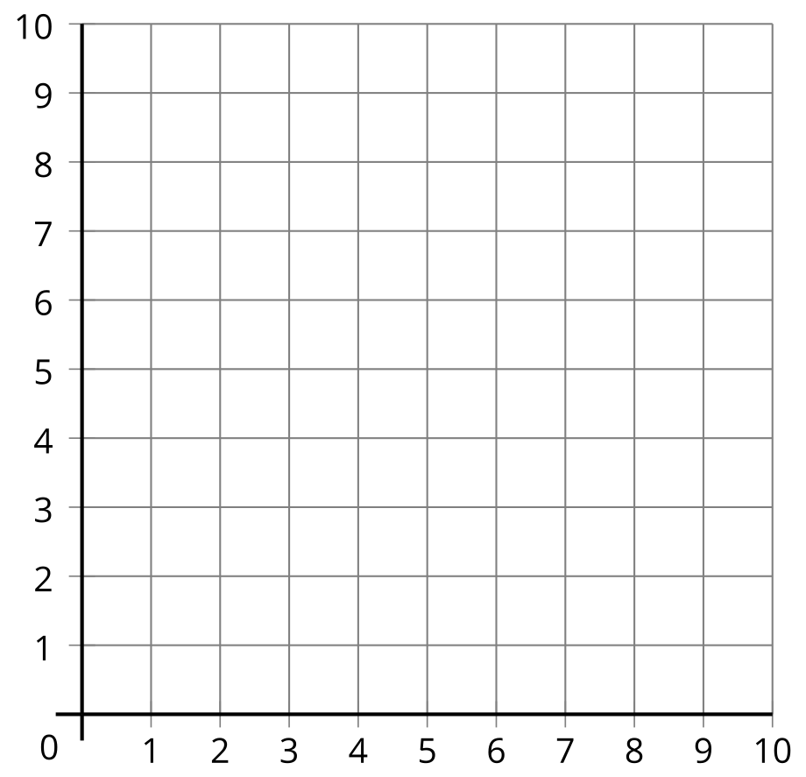
- Is it a square? Rectangle? Rhombus? Parallelogram? Explain your reasoning.
- Describe a trapezoid in your own words. Compare your definition with a partner.
- Is this shape a trapezoid according to your definition? Explain your reasoning.

2 Two Definitions of a Trapezoid

Student Task Statement
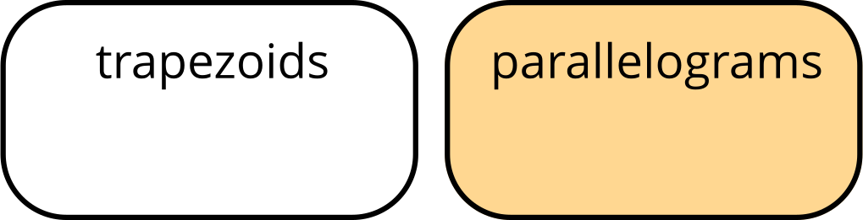
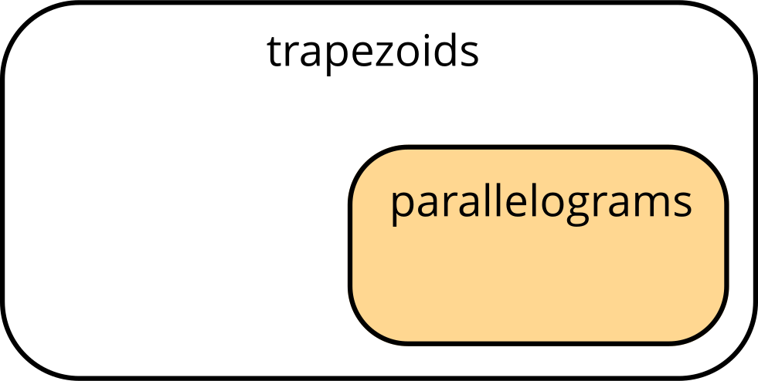
Definition 1
Definition 2
A trapezoid has exactly one pair of opposite sides that are parallel.
A trapezoid has at least one pair of opposite sides that are parallel.
Which statements go with the first definition? Which statements go with the second definition? Explain or show your reasoning.
- All parallelograms are trapezoids.
- No parallelograms are trapezoids.
- All trapezoids are parallelograms.
- Some trapezoids are parallelograms.
- No trapezoids are parallelograms.

Images for Activity Synthesis
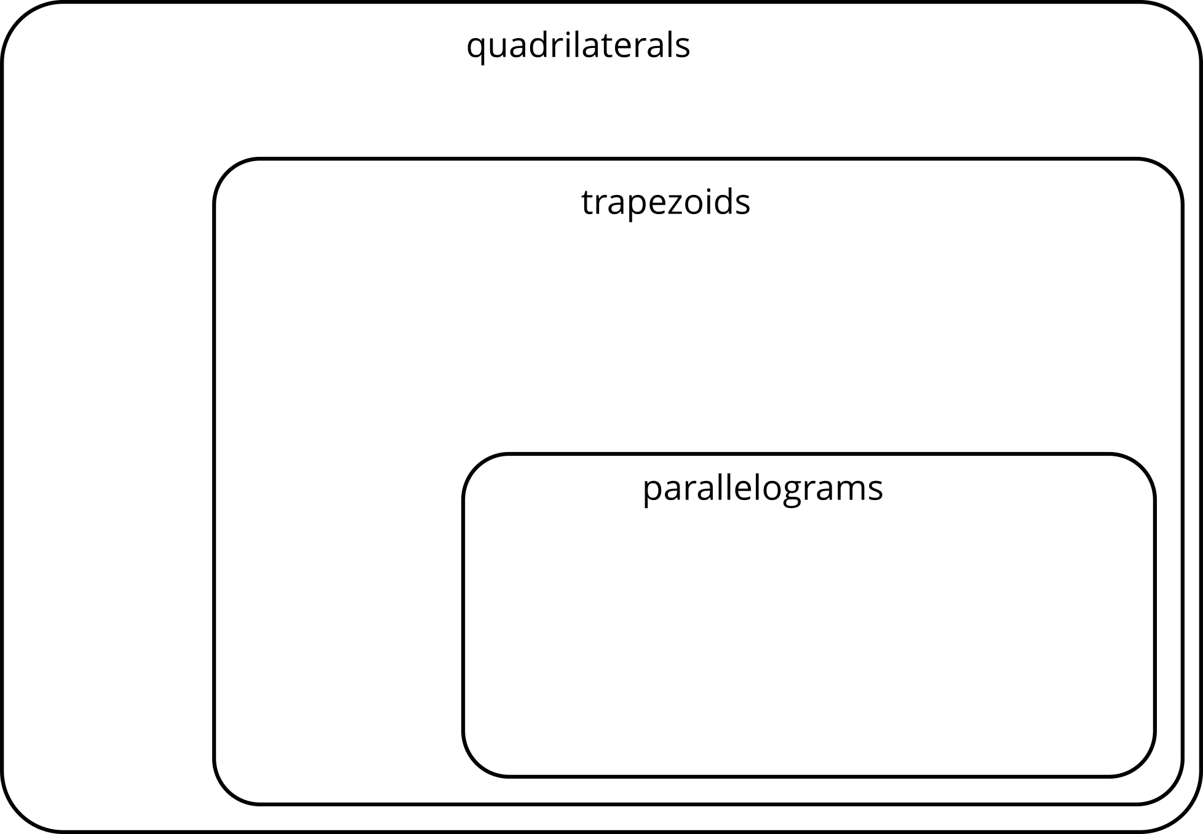
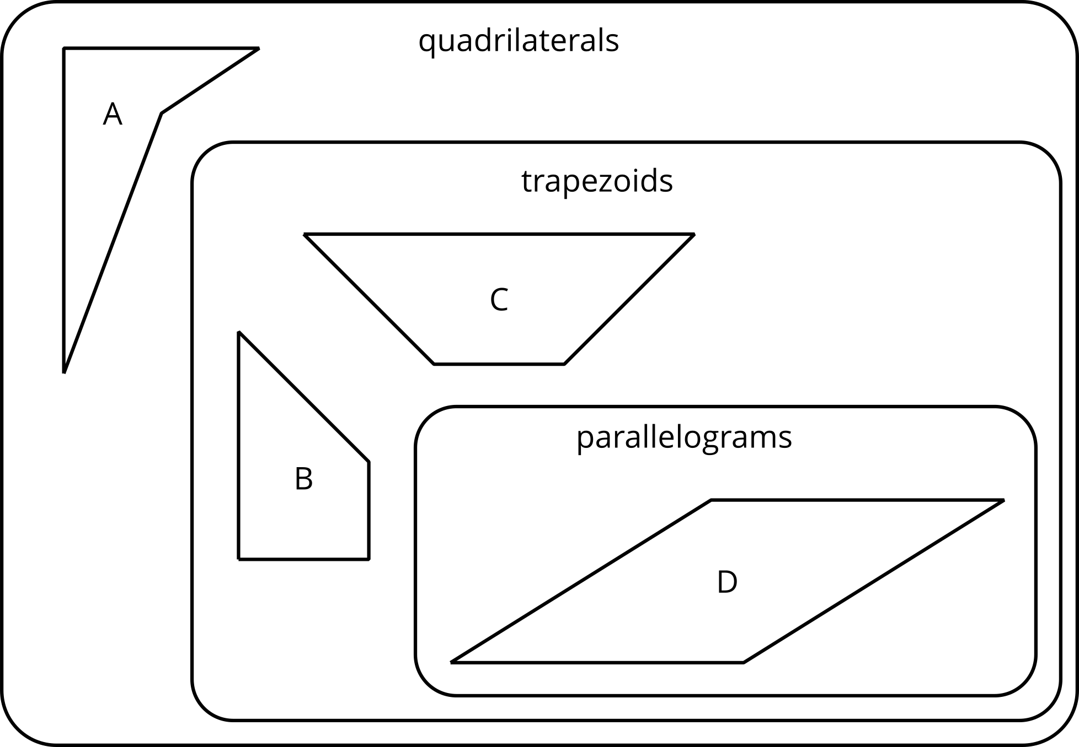
© CC BY 2021 Illustrative Mathematics®

