Lesson 2: Relate Addition and Subtraction within 10

Standards Alignments
Building On | 1.OA.A.1
Addressing | 2.OA.B.2
Building Towards | 2.OA.B.2

Teacher-facing Learning Goals
- Find the number that makes equations within 20 true.
- Write equations with unknown addends and sums of 10 and their related subtraction equations.

Student-facing Learning Goals
- Let’s think about the relationship between addition and subtraction.

Lesson Purpose
The purpose of this lesson is for students to find the number that makes equations true and write addition and related subtraction equations within 10.
In previous grades, students learned to find the number that makes 10 when added to a given number and to make a ten to add within 20 and 100. The ability to look for and use sums that have a value of 10 is a foundational skill for the grade 2 benchmark of fluency within 20 and for adding and subtracting within 1,000 using methods based on place value.
In this lesson, students revisit a center activity, What's Behind My Back, and use connecting cubes to elicit their understanding of sums that a value of 10 and the relationship between addition and subtraction. Students will continue practice recognizing and using these sums in lesson activities throughout the unit.
Math Community
Tell students they will have an opportunity to revise their math community ideas at the end of this lesson, so as they work today they should think about actions that may be missing from the current list.

Access for:

Students with Disabilities
- Action and Expression (Activity 2)

English Learners
- MLR8 (Activity 1)

Instructional Routines
What Do You Know About _____? (Warm-up)

Materials to Gather
- Connecting cubes: Activity 1

Materials to Copy
- What's Behind My Back Stage 2 Recording Sheet Grade 1 (groups of 1): Activity 1

Lesson Timeline
Warm-up | 10 min
Activity 1 | 20 min
Activity 2 | 15 min
Lesson Synthesis | 10 min
Cool-down | 5 min

Teacher Reflection Question
How are you facilitating the creation of a productive mathematical community? Where can you point to evidence of this for students to see?

Cool-down
(to be completed at the end of the lesson) 5min
Represent the Cubes

Standards Alignments
Addressing | 2.OA.B.2

Student-facing Task Statement
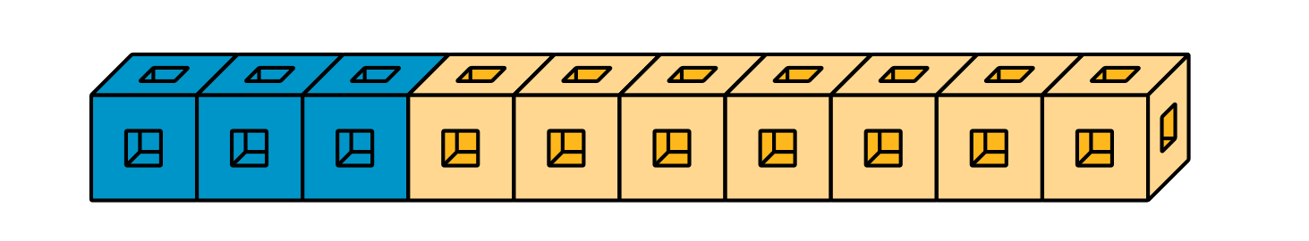
Circle the 2 equations that represent the cubes.
$7+\underset{_}{}=10$
$10+3=\underset{_}{}$
$3+\underset{_}{}=7$
$10−3=\underset{_}{}$

Student Responses
Students circle $7+\underset{_}{​}=10$ and $10−3=\underset{_}{​}$ .

