Lesson 12: Compare Addition and Subtraction Story Problems
- Let’s figure out what’s the same and what’s different about these story problems.

12.1: Ducks in the Pond
There were 5 ducks in the pond.
4 more ducks came to the pond to swim.
How many ducks are in the pond now?

12.2: Ducks Swim Ashore
There were 9 ducks swimming in the pond.
Then 4 of the ducks waddled onto the grass.
How many ducks are swimming in the pond now?

12.3: Centers: Choice Time
Choose a center.
Bingo
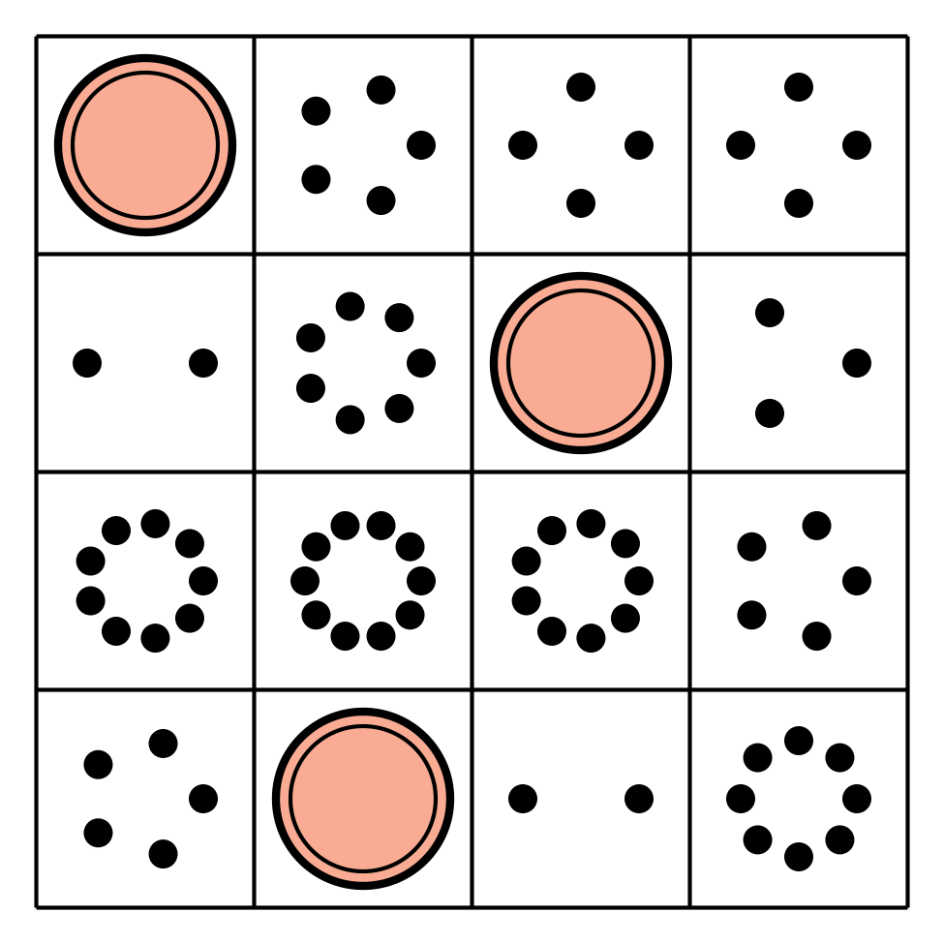
Math Fingers
Subtraction Towers
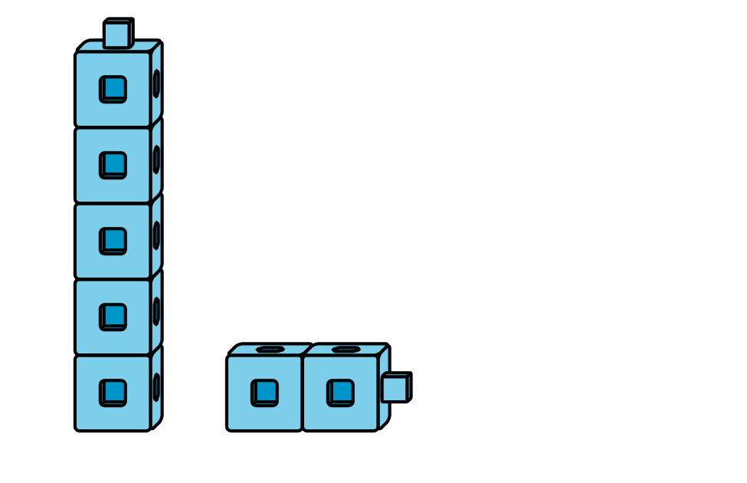
5-frames
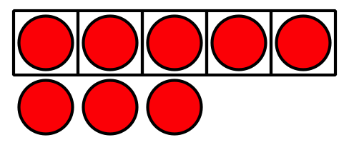
Math Stories
Counting Collections
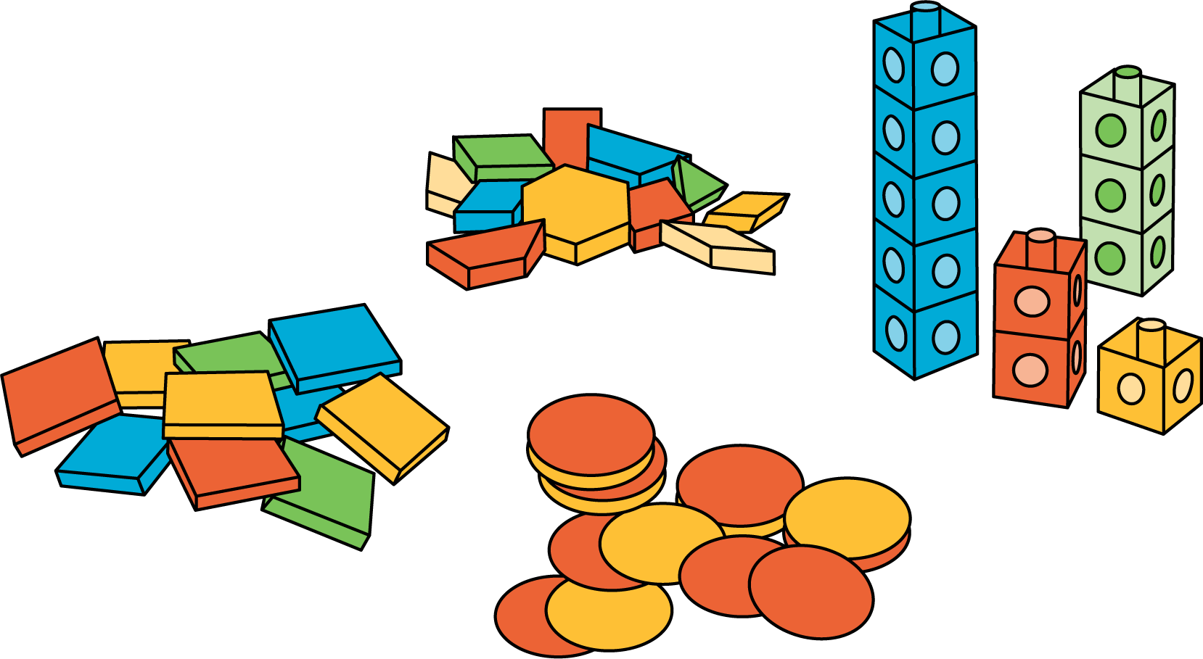

Section Summary
Section Summary
In this section, we learned about story problems.
We acted out story problems and used objects and drawings to show what is happening and help us solve story problems.
Sometimes things were added in the story problems.
There were 5 ducks in the pond.
4 more ducks came to the pond to swim.
How many ducks are in the pond now?
Sometimes things were subtracted, or taken away, in the story problems.
There were 5 balls on the playground.
Diego brought 5 of the balls inside.
How many balls are on the playground now?
© CC BY 2021 Illustrative Mathematics®

