Lesson 15: More Factors, More Problems
- Let’s solve more multiplication problems.

Warm-up: Number Talk: Tens
Find the value of each expression mentally.
- $1×10$
- $2×10$
- $3×10$
- $4×10$

15.1: Represent Situations with Equations
For each problem:
- Write an equation with a symbol for the unknown to represent the situation.
- Find the number that makes the equation true. Show your reasoning.
- There are 15 plates. Han placed 5 plates on each table. How many tables have plates on them?
  - equation:
  - solution:
- Lin made 6 sandwiches. She used 2 slices of bread for each sandwich. How many pieces of bread did she use?
  - equation:
  - solution:
- Han has 60 ice cubes. The ice cubes are in trays of 10. How many trays of ice cubes does Han have?
  - equation:
  - solution:

15.2: Multiplication Mashup
Solve each problem. Explain or show your reasoning.
- Clare has 16 socks. She puts them in piles of 2. How many piles can she make?
- Diego has 8 piles of socks. Each pile of socks has 2 socks. How many socks does Diego have?
- Andre has 16 socks. He puts them in 8 groups that are the same size. How many socks are in each group?
- The store has 9 boxes. Each box has 5 shirts. How many shirts are there?
- A store has 80 sweaters. There are 8 sweaters in each pile on a shelf. How many piles of sweaters are on the shelf?

Section Summary
Section Summary
In this section, we learned about equal groups. We created drawings and diagrams to represent situations that involve equal groups.
situation
Diego has 8 piles of socks. Each pile of socks has 2 socks.
drawing
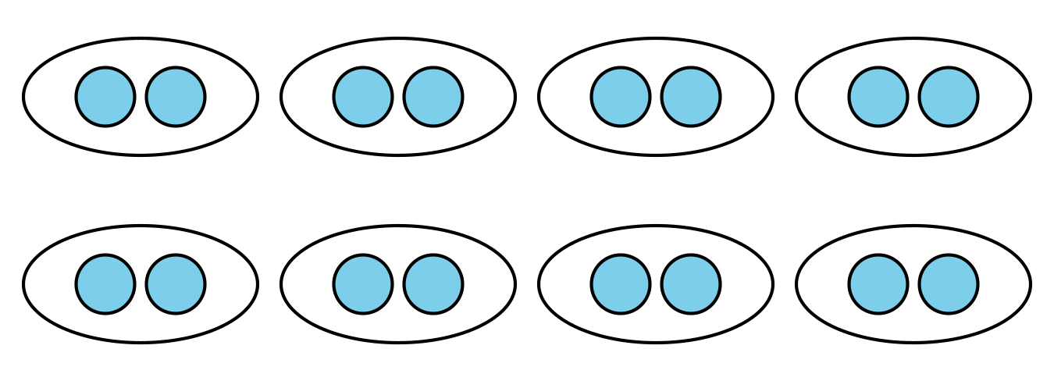
diagram
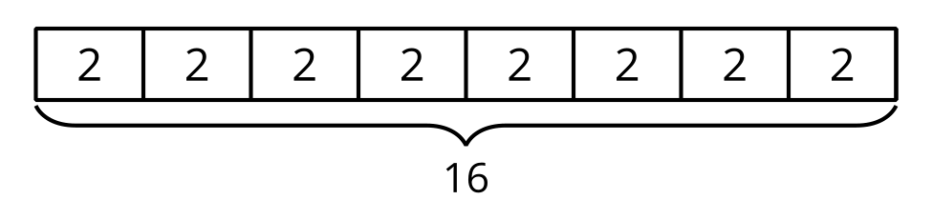
We wrote multiplication expressions and equations to represent equal groups.
expression
$8×2$
equation
$8×2=16$
We learned that the numbers that are multiplied are called factors and the number that is the result of multiplying is called a product. In the equation $8×2=16$, the numbers 8 and 2 are the factors and 16 is the product.
© CC BY 2021 Illustrative Mathematics®

