Lesson 2: Representations of Fractions (Part 2)

Standards Alignments
Building On | 3.NF.A.1
Building Towards | 4.NF.A, 4.NF.A.1

Teacher-facing Learning Goals
- Make sense of the numerator and denominator of unit fractions that have denominators 2, 3, 4, 5, 6, 8, 10, and 12.
- Use diagrams to represent fractions.

Student-facing Learning Goals
- Let’s name some other fractions and represent them with diagrams.

Lesson Purpose
The purpose of this lesson is for students to make sense of non-unit fractions (including those greater than 1) that have denominators 2, 3, 4, 5, 6, 8, 10, and 12.
In the previous lesson, students made sense of the meaning of numerator and denominator in unit fractions. They identified fractions represented by diagrams, and partitioned diagrams to represent given fractions. In this lesson, they reason in similar ways—using numerical and visual representations—about non-unit fractions and fractions that are greater than 1.
Students are reminded of what they learned in grade 3: that a non-unit fraction $\frac{a}{b}$ can be understood as $a$ parts of a unit fraction $\frac{1}{b}$, and that fractions with different numerators and denominators can be equivalent. Unlike in grade 3, the denominators they see here now include 5, 10, and 12.
As in the previous lesson, rulers can be provided to help students draw, extend, or align partition lines, but should not be used to measure the location of a fraction on any diagram.

Access for:

Students with Disabilities
- Representation (Activity 1)

English Learners
- MLR2 (Activity 2)

Instructional Routines
Which One Doesn’t Belong? (Warm-up)

Materials to Gather
- Materials from a previous lesson: Activity 2
- Straightedges: Activity 1, Activity 2

Lesson Timeline
Warm-up | 10 min
Activity 1 | 20 min
Activity 2 | 15 min
Lesson Synthesis | 10 min
Cool-down | 5 min

Teacher Reflection Question
Who participated in math class today? What assumptions are you making about those who did not participate? How can you leverage each of your students’ ideas to support them in being seen and heard in tomorrow’s math class?

Cool-down
(to be completed at the end of the lesson) 5min
What Do the Diagrams Show?

Standards Alignments
Building Towards | 4.NF.A

Student-facing Task Statement
Use a blank diagram to create a representation for each fraction. Both blank diagrams represent the same quantity.
- $\frac{5}{8}$
- 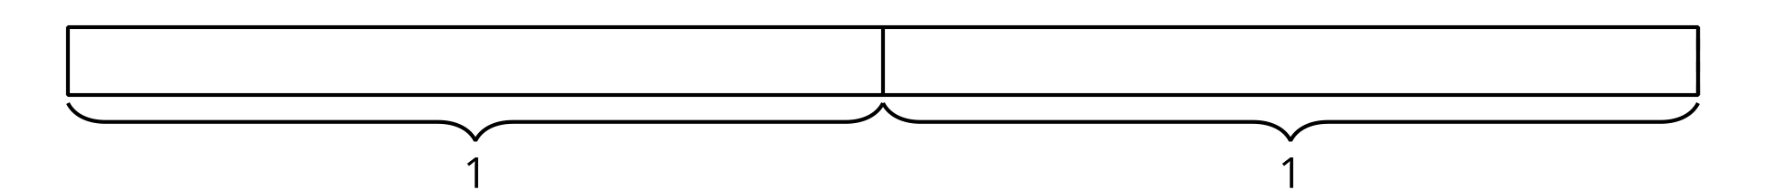
- $\frac{9}{8}$

Student Responses
Sample response:
- $\frac{5}{8}$
- $\frac{9}{8}$

