Unit 6 Lesson 5: Products Beyond 100

WU Number Talk: A Number Times Some Multiple of 10 (Warm up)

Student Task Statement
Find the value of each expression mentally.
- $8×30$
- $5×30$
- $10×30$
- $15×30$

1 Elena’s Sticky Gift

Student Task Statement
Elena receives a sheet of fancy stickers as a gift.
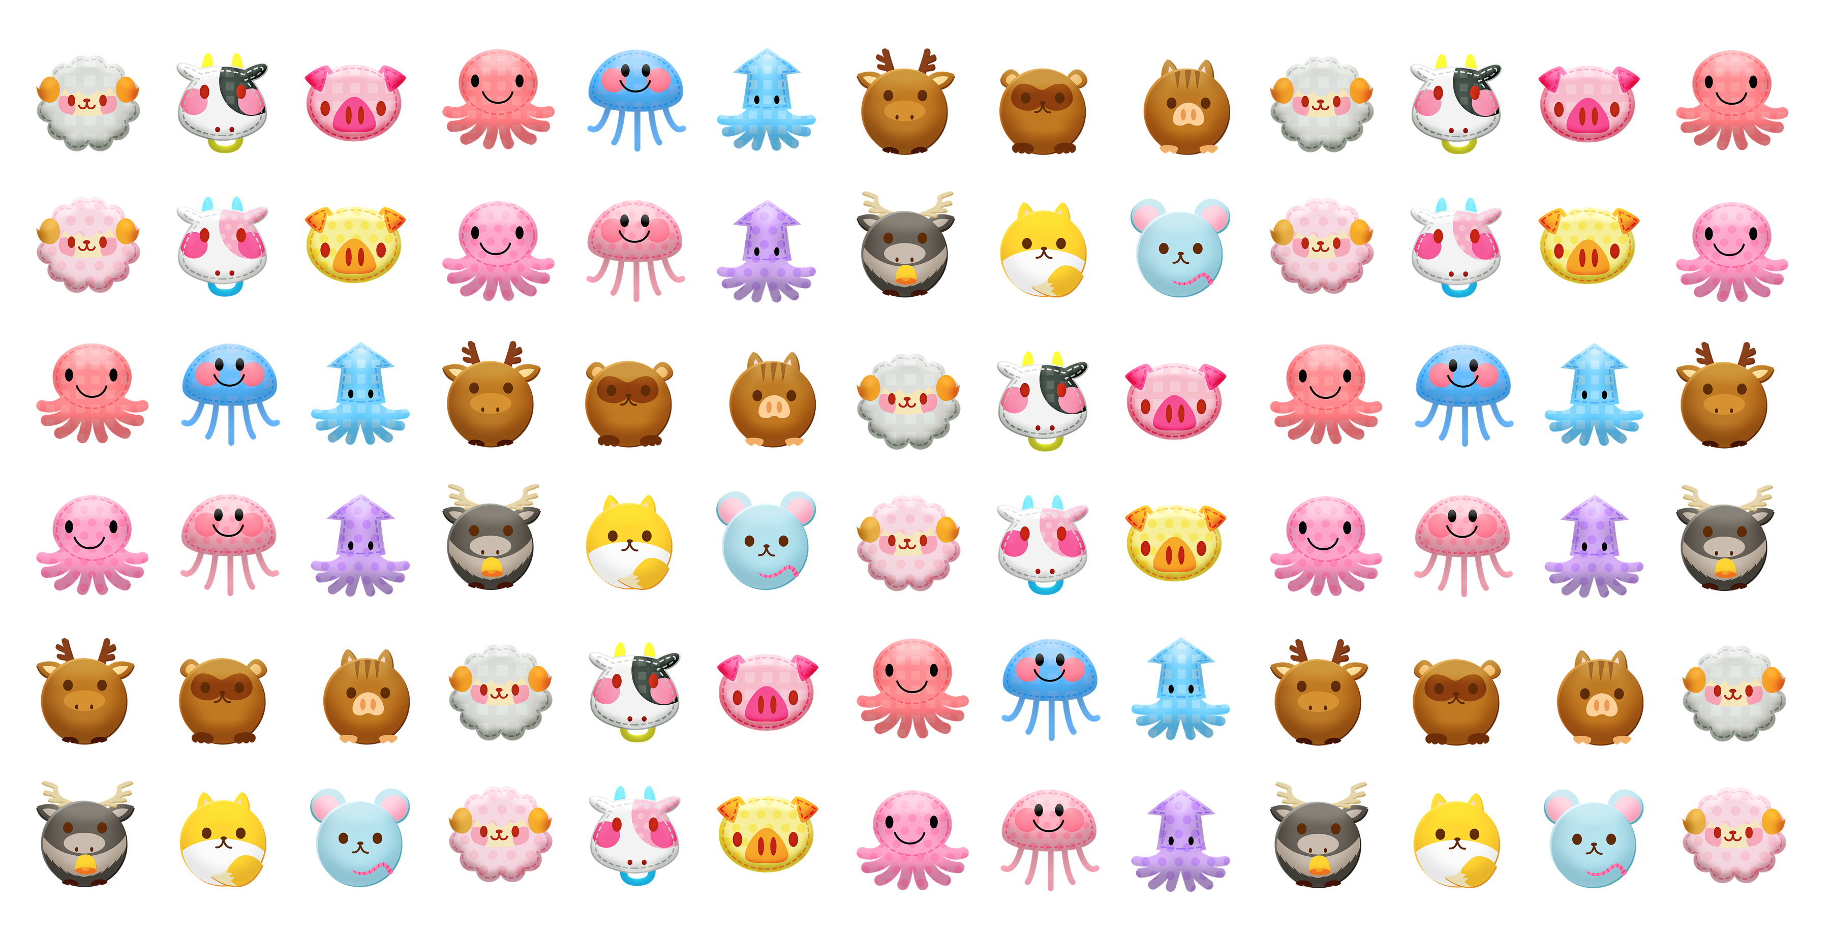
How many stickers are there? Explain or show how you would find out without counting every sticker.

2 More and More Stickers

Student Task Statement
- Elena has another sheet of stickers that has 9 rows and 21 stickers in each row. How many stickers does Elena have? Explain or show your reasoning.
- Noah’s sticker sheet has 3 rows with 48 stickers in each row. Andre’s sticker sheet has 7 rows with 23 stickers in each row.
- Who has more stickers? Explain or show your reasoning.
© CC BY 2021 Illustrative Mathematics®

