Unit 3 Lesson 16 Cumulative Practice Problems
- Write three numerical expressions that are equivalent to $(0.0004)⋅(0.005)$.
- Find each product. Show your reasoning.
  - $(1.2)⋅(0.11)$
  - $(0.34)⋅(0.02)$
  - $120⋅(0.002)$
- You can use a rectangle to represent $(0.3)⋅(0.5)$.
  - What must the side length of each square represent for the rectangle to correctly represent $(0.3)⋅(0.5)$?
  - What area is represented by each square?
  - What is $(0.3)⋅(0.5)$? Show your reasoning.
- 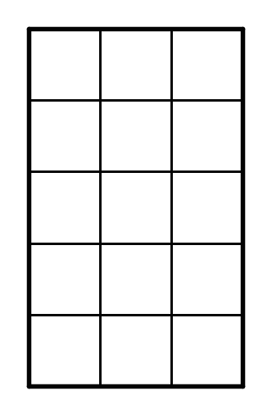
- Here is a rectangle that has been partitioned into four smaller rectangles.
- 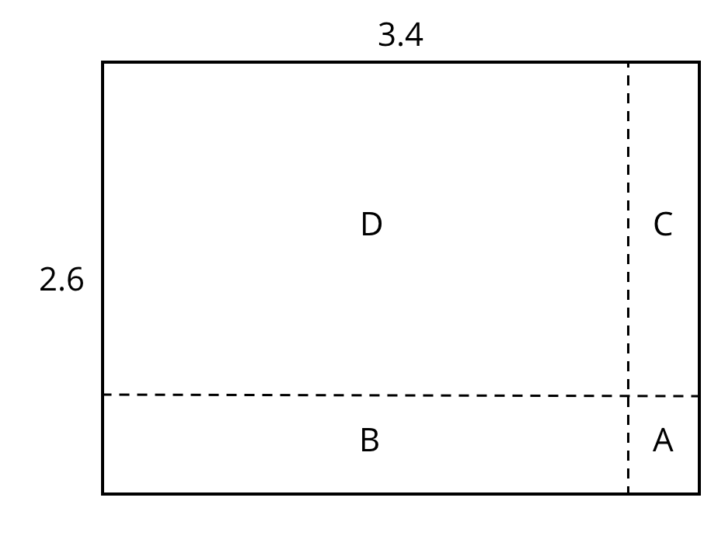
- For each expression, choose the sub-rectangle whose area, in square units, matches the expression.
  - $3⋅(0.6)$
  - $(0.4)⋅2$
  - $(0.4)⋅(0.6)$
  - $3⋅2$
- (From Unit 3, Lesson 17.)
- Find the value of $\frac{49}{50}÷\frac{7}{6}$ using any method.
- (From Unit 3, Lesson 7.)
- Calculate each difference. Show your reasoning.
  - $13.2−1.78$
  - $23.11−0.376$
  - $0.9−0.245$
- (From Unit 3, Lesson 15.)
© CC BY Open Up Resources. Adaptations CC BY IM.

