Lesson 12 Practice Problems
- The graphs below show some data from a coffee shop menu. One of the graphs shows cost (in dollars) vs. drink volume (in ounces), and one of the graphs shows calories vs. drink volume (in ounces).
- __________________ vs volume
- 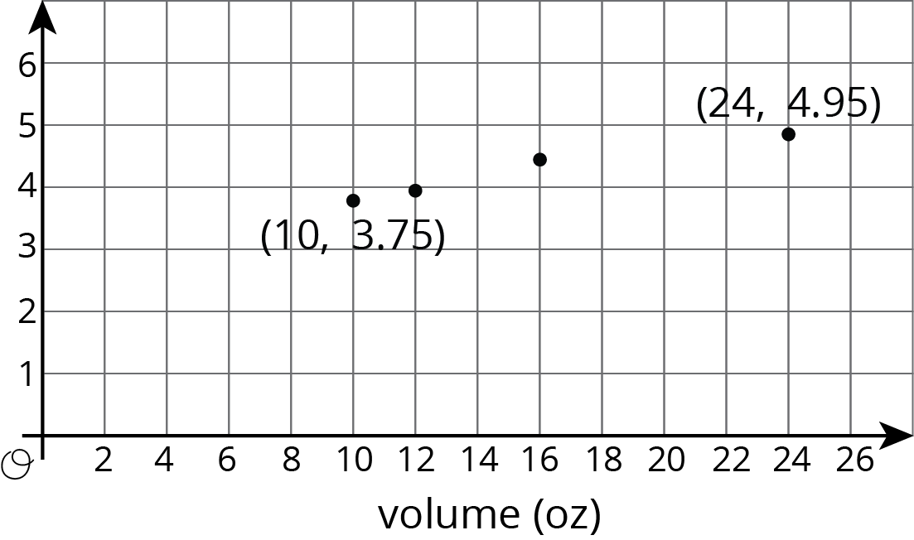
- _____________________ vs volume
- 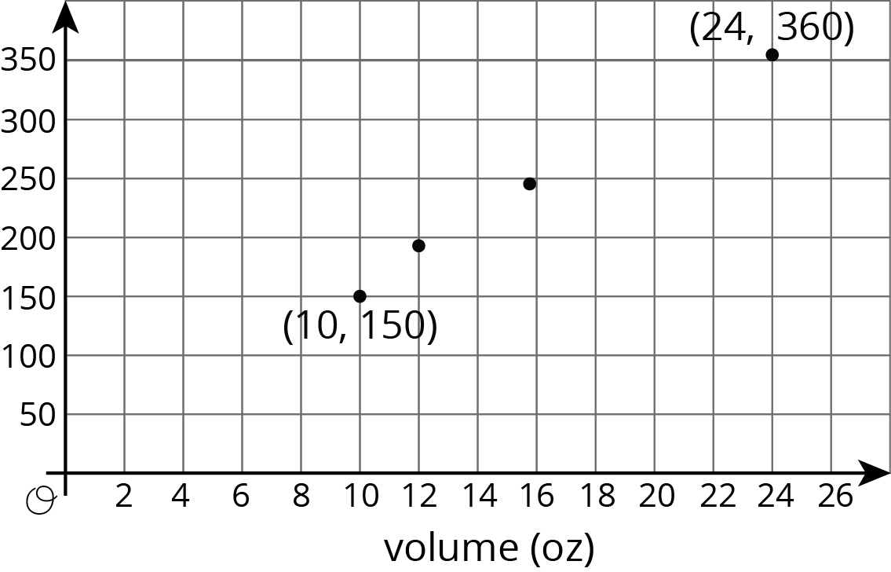
  - Which graph is which? Give them the correct titles.
  - Which quantities appear to be in a proportional relationship? Explain how you know.
  - For the proportional relationship, find the constant of proportionality. What does that number mean?
- Lin and Andre biked home from school at a steady pace. Lin biked 1.5 km and it took her 5 minutes. Andre biked 2 km and it took him 8 minutes.
  - Draw a graph with two lines that represent the bike rides of Lin and Andre.
  - For each line, highlight the point with coordinates $\left(1,k\right)$ and find $k$.
  - Who was biking faster?
- Match each equation to its graph.
  - $y=2x$
  - $y=\frac{4}{5}x$
  - $y=\frac{1}{4}x$
  - $y=\frac{2}{3}x$
  - $y=\frac{4}{3}x$
  - $y=\frac{3}{2}x$

- 1
- 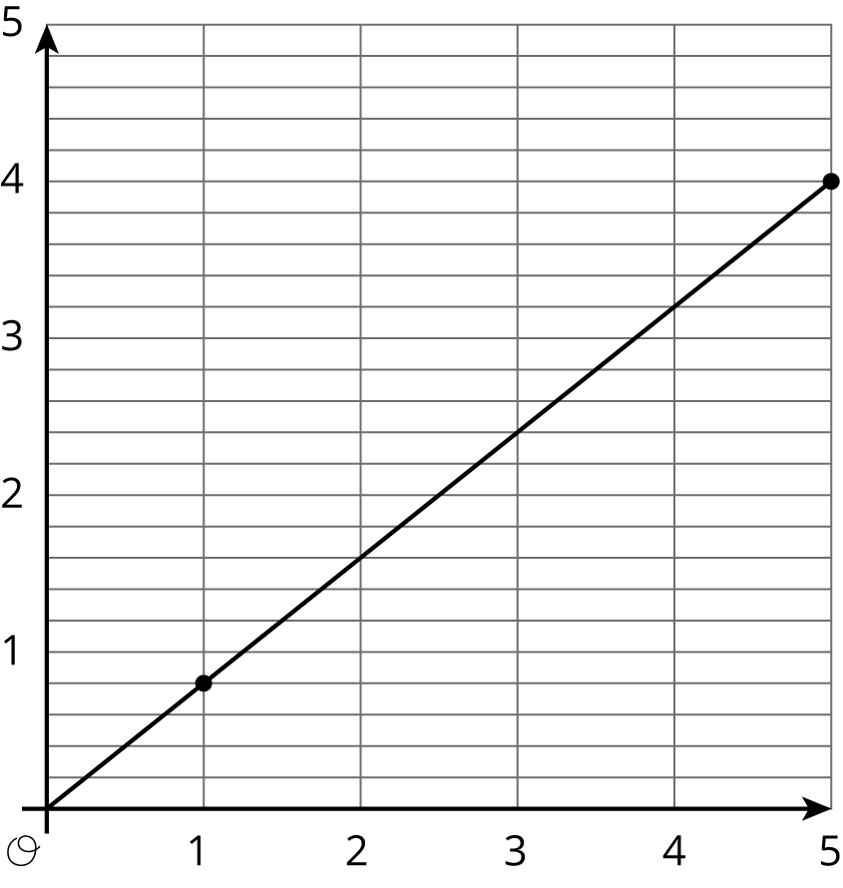

- 2
- 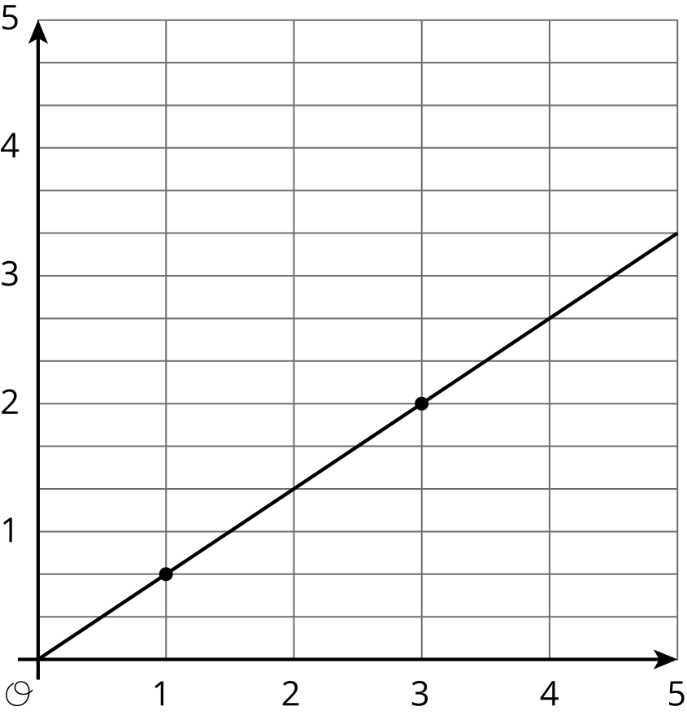

- 3
- 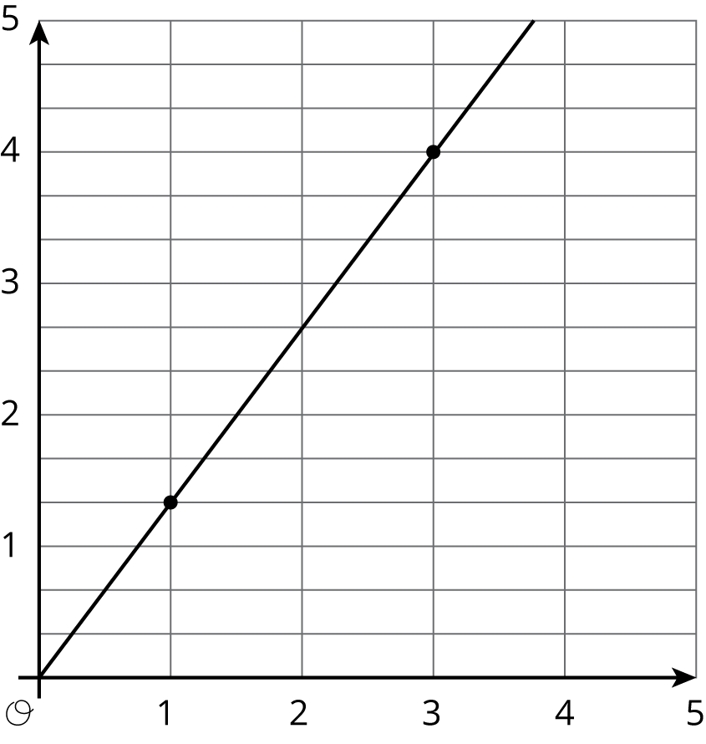

- 4
- 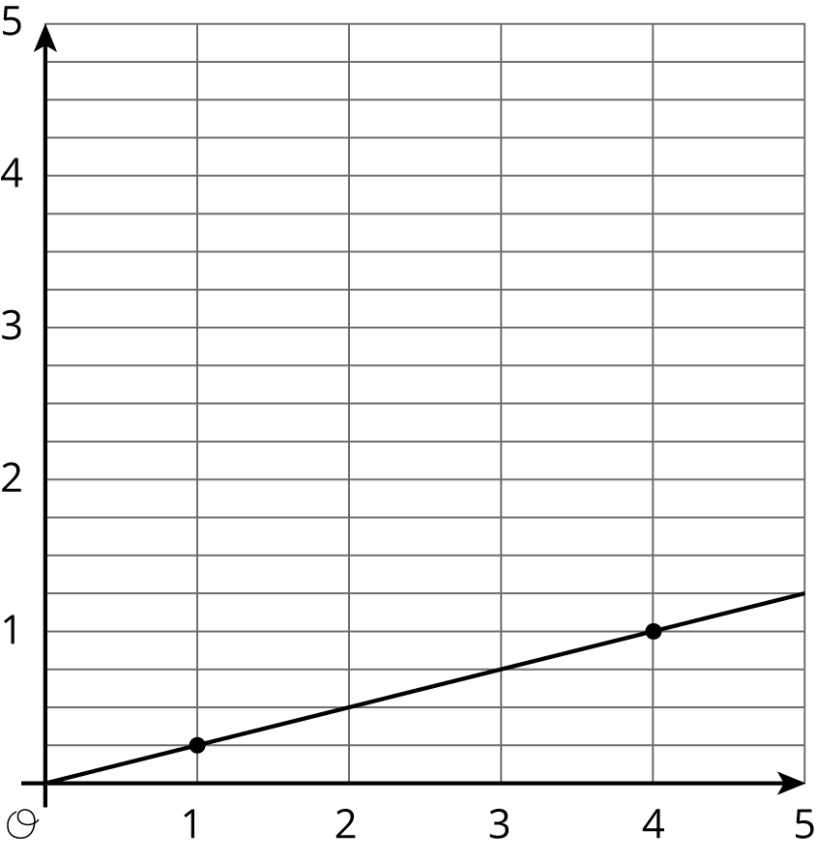

- 5
- 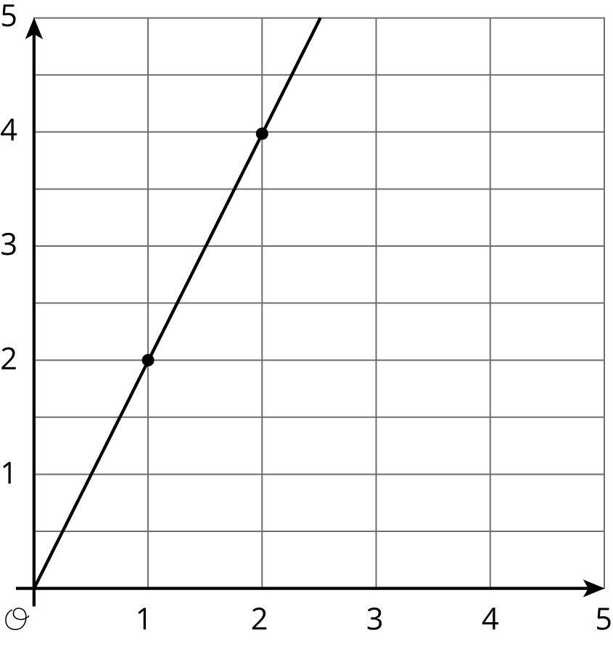

- 6
- 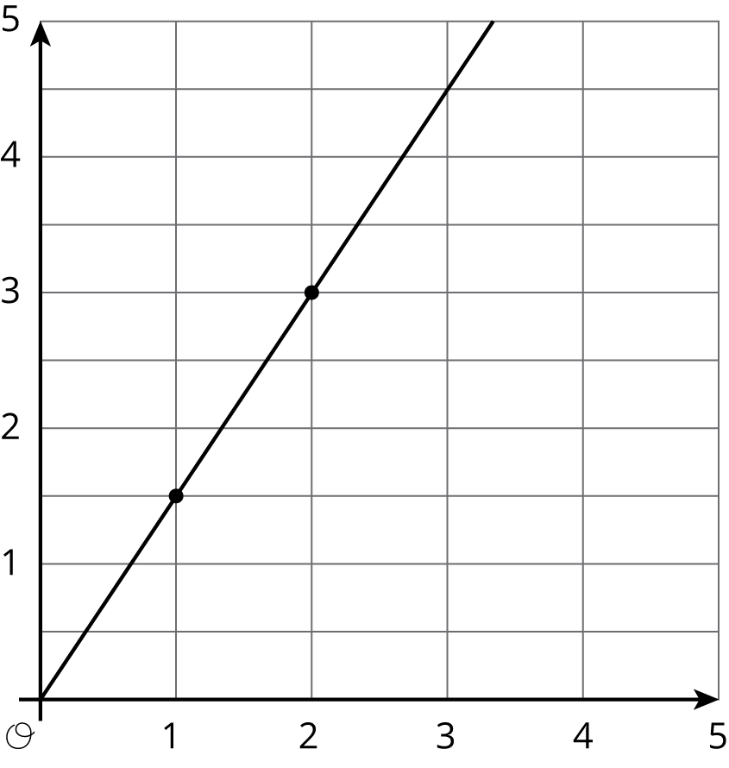
© CC BY Open Up Resources. Adaptations CC BY IM.

