Lesson 14 Practice Problems
- Evaluate each expression. Use scientific notation to express your answer.
  - $\left(1.5×{10}^{2}\right)\left(5×{10}^{10}\right)$
  - $\frac{4.8×{10}^{\text{-}8}}{3×{10}^{\text{-}3}}$
  - $\left(5×{10}^{8}\right)\left(4×{10}^{3}\right)$
  - $\left(7.2×{10}^{3}\right)÷\left(1.2×{10}^{5}\right)$
- How many bucketloads would it take to bucket out the world’s oceans? Write your answer in scientific notation.
- Some useful information:
  - The world’s oceans hold roughly $1.4×{10}^{9}$ cubic kilometers of water.
  - A typical bucket holds roughly 20,000 cubic centimeters of water.
  - There are ${10}^{15}$ cubic centimeters in a cubic kilometer.
- The graph represents the closing price per share of stock for a company each day for 28 days.
  - What variable is represented on the horizontal axis?
  - In the first week,
was the stock price generally increasing
or decreasing?
  - During which period did the closing price of the stock decrease for at least 3 days in a row?
- 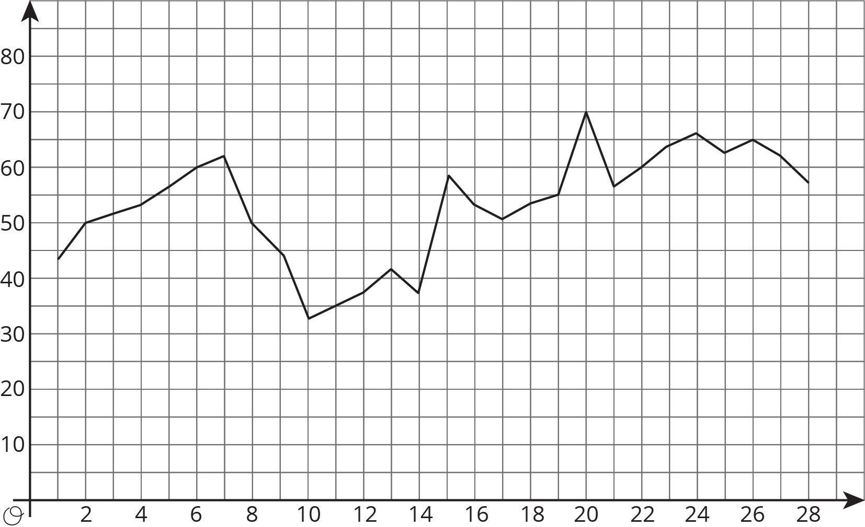
- (From Unit 5, Lesson 5.)
- Write an equation for the line that passes through $\left(\text{-}8.5,11\right)$ and $\left(5,\text{-}2.5\right)$.
- (From Unit 3, Lesson 11.)
- Explain why triangle $ABC$ is similar to triangle $CFE$.
- 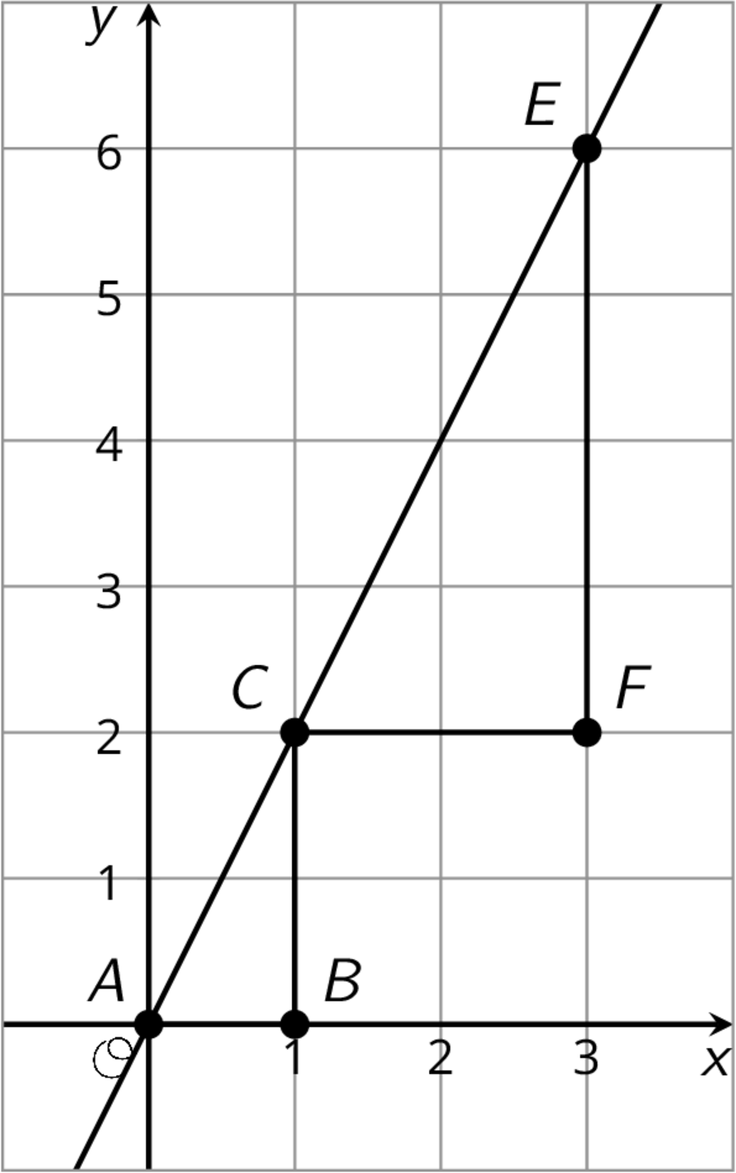
- (From Unit 2, Lesson 6.)
© CC BY Open Up Resources. Adaptations CC BY IM.

