Lesson 4: Reflecting Functions
- Let’s reflect some graphs.

4.1: Notice and Wonder: Reflections
What do you notice? What do you wonder?
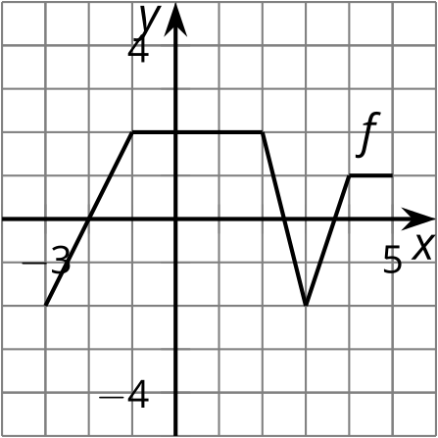
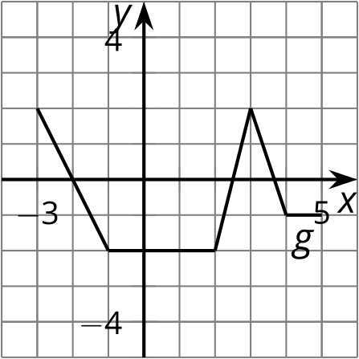
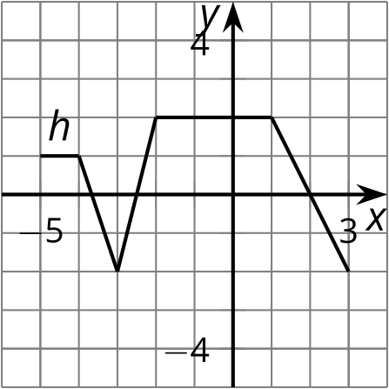

4.2: Reflecting Across
Here is the graph of function $f$ and a table of values.
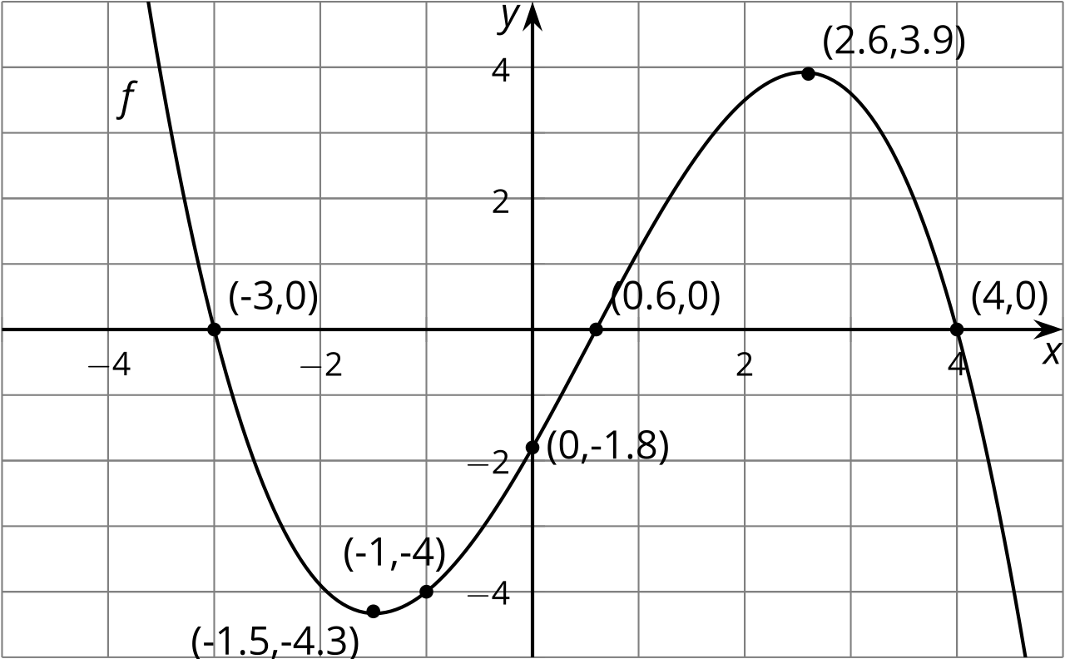
$x$ | $f\left(x\right)$ | $g\left(x\right)=\text{-}f\left(x\right)$
-3 | 0
-1.5 | -4.3
-1 | -4
0 | -1.8
0.6 | 0
2.6 | 3.9
4 | 0
- Let $g$ be the function defined by $g\left(x\right)=\text{-}f\left(x\right)$. Complete the table.
- Sketch the graph of $g$ on the same axes as the graph of $f$ but in a different color.
- Describe how to transform the graph of $f$ into the graph of $g$. Explain how the equation produces this transformation.

4.3: Reflecting Across a Different Way
Here is another copy of the graph of $f$ from the earlier activity. This time, let $h$ be the function defined by $h\left(x\right)=f\left(\text{-}x\right)$.
- Use the definition of $h$ to find $h\left(0\right)$. Does your answer agree with your prediction?
- What does your prediction tell you about $h\left(\text{-}0.6\right)$? Does your answer agree with the definition of $h$?
- Complete the tables. The values for $x$ will not be the same for the two tables.
- $x$ | - $f\left(x\right)$
- -3 | - 0
- -1.5 | - -4.3
- -1 | - -4
- 0 | - -1.8
- 0.6 | - 0
- 2.6 | - 3.9
- 4 | - 0

- $x$ | - $h\left(x\right)=f\left(\text{-}x\right)$
- Sketch the graph of $h$ on the same axes as the graph of $f$ but in a different color.
- Describe what happened to the graph of $f$ to transform it into the graph of $h$. Explain how the equation produces this transformation.

Are you ready for more?
- Describe how the graph of $h$ relates to the graph of $g$ defined in the earlier activity.
- Write an equation relating $h$ and $g$.

Lesson 4 Summary
Here are graphs of the functions $f$, $g$, and $h$, where $g\left(x\right)=\text{-}f\left(x\right)$ and $h\left(x\right)=f\left(\text{-}x\right)$. How do these equations match the transformation we see from $f$ to $g$ and from $f$ to $h$?

$f\left(x\right)$
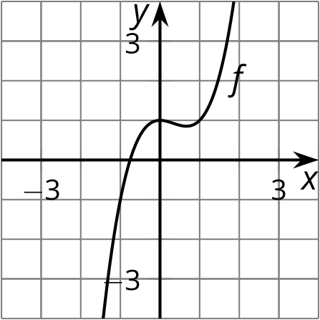

$g\left(x\right)=\text{-}f\left(x\right)$
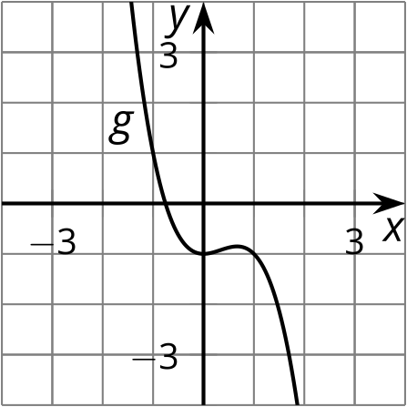

$h\left(x\right)=f\left(\text{-}x\right)$
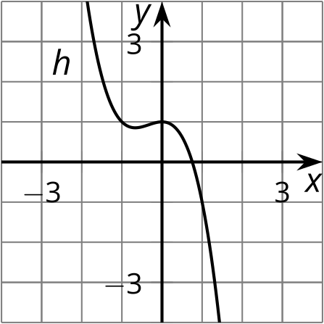
Considering first the equation $g\left(x\right)=\text{-}f\left(x\right)$, we know that for the same input $x$, the value of $g\left(x\right)$ will be the opposite of the value of $f\left(x\right)$. For example, since $f\left(0\right)=1$, we know that $g\left(0\right)=\text{-}f\left(0\right)=\text{-}1$. We can see this relationship in the graphs where $g$ is the reflection of $f$ across the $x$-axis.
Looking at $h\left(x\right)=f\left(\text{-}x\right)$, this equation tells us that the two functions have the same output for opposite inputs. For example, 1 and -1 are opposites, so $h\left(1\right)=f\left(\text{-}1\right)$ (and $h\left(\text{-}1\right)=f\left(1\right)$ is also true!). We can see this relationship in the graphs where $h$ is the reflection of $f$ across the $y$-axis.
© CC BY 2019 by Illustrative Mathematics®

